Name ____________________________

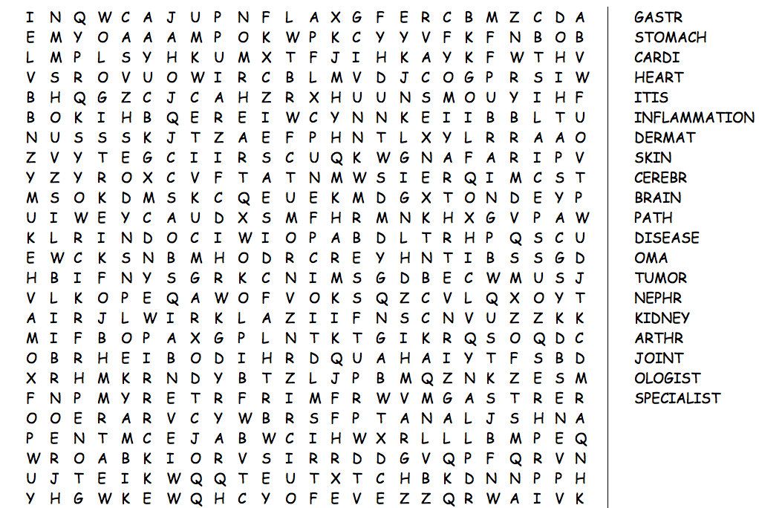
Medical Terminology

