**Word Definition Example Picture**

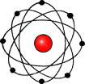

A gold atom cannot be made smaller and still be gold.

smallest identifiable part of matter

Atom