Background Information – read and study diagrams

Small molecules move in and out of cells by diffusion through the cell membrane. They will slip through little holes in the cell membrane. Cells also contain and need large molecules such as salt. Large molecules are too big to fit through the holes in the cell membrane so water will move in or out of the cell to try and even out the proportion of water and large molecules inside and outside of the cell. If cells are placed in salt water that has more salt than the cell then water will diffuse (move) out of the cell. If cells are placed in salt water that has less salt than the cell then water will diffuse into the cell.
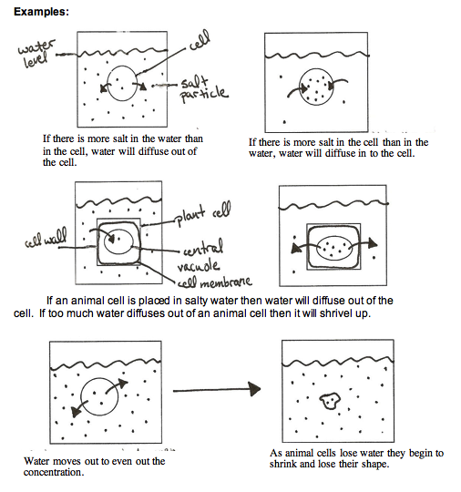

If a plant cell is placed in salty water then water will diffuse out of the cell. If too much water diffuses out of a plant cell the central vacuole will shrink and the cell membrane will pull away from the cell wall, but the cell will not shrivel because the cell wall holds its shape. This makes plants wilt or feel soft.

