Name_________________________
Title: Density of a gas

Purpose: To learn how to measure the density of gases and see how it compares to solids and liquids.

Materials: ring stand, clamp, test tube, glass tubing, plastic tubing, graduated cylinder, bucket, goggles, ½ seltzer tablet, beaker, balance

Procedure:
1. Fill the test tube about 1/3 full with water.
2. Mass the test tube, beaker, water, 1//2 seltzer tablet.
3. Set up the equipment as pictured below. The graduated cylinder needs to be full of water and upside down. First fill it, then hold your hand over the top and put it in the bucket.
4. Drop the alka seltzer in the test tube and put on stopper. Wait for bubbles to stop.
5. Write down where the water level is in the graduate and turn right side up.
6. Mass the test tube, beaker, water mixture.

Prediction: (what do you think the density of this gas will be?)
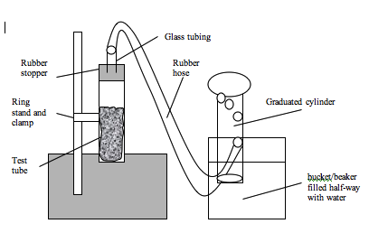

Data:
1. mass of beaker, test tube and seltzer table before.............______g
2. mass of beaker, test tube and seltzer table after .............______g
3. change in mass..______g
4. volume of gas....______ml
5. density.............______g/ml

Analysis:
1. What is the class average for dry ice and alka seltzer gas?

2. Why did you have to mass the materials before and after the gas escaped?

3. Why was there less mass after the experiment was over?

4. The correct value for the density of this gas is .002. The density of air is about .0013. If we let this gas out, would it rise or sink?

5. Describe all the characteristics of this gas that you know. (color, smell, density)

6. This gas is carbon dioxide. How is it different from air?

Conclusion:

