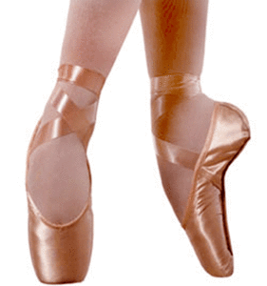
Name _____________________
Date ___________ Period _____
Getting to the Pointe
Write a summary of the article.
________________________________________________________________________________________________________________________________________________________________________________________________________________________________________________________________________________________________________________________________________________________________________________________________________________________________________________________________________________________

Evaluate the structure and unity of the article.
- Which structure was used?
_________________________________________________________________________________________________________________________________________________________________________________
- Was it effective? Why or why not?
_________________________________________________________________________________________________________________________________________________________________________________
- Was there unity in the article? Explain.
_________________________________________________________________________________________________________________________________________________________________________________
Is this a credible source of information? Explain your answer, giving at least two specific reasons.
_________________________________________________________________________________________________________________________________________________________________________________

Now, watch the video “Anaheim Ballet: Your Point Shoe Questions, Answered.”
This video gives similar information as the article “Getting to the Pointe.” What are the advantages and disadvantages of using a video to present information?
Advantages of Video | Disadvantages of Video

Is this video a credible source of information? Explain your answer, giving at least two specific reasons.
_________________________________________________________________________________________________________________________________________________________________________________

Now, watch the slideshow “Ballerina Pointe Shoes.”
What are the advantages and disadvantages of using a slide show to present information?
Advantages of a Slideshow | Disadvantages of a Slideshow

Is this slideshow a credible source of information? Explain your answer, giving at least two specific reasons.
_________________________________________________________________________________________________________________________________________________________________________________

Of the three formats, which one was the most effective at presenting information? Explain.
________________________________________________________________________________________________________________________________________________________________________________________________________________________________________________________________________________________________________________________________

