Ice Breaker Activities

Comic Strip Chaos:

Equipment: Comic strips (attached), you can also pick any sequence of pictures

Time: 20 minutes

Instructions: Each participant takes a turn at picking a comic frame out of the large container. After the entire group has each chosen one, the participants begin to search for others with the same comic strip sequence. After the participants have found everyone in their group, they must arrange themselves so that the sequence of frames are in chronological order to form the comic strip correctly. Upon completion of sequence, the newly formed group sits down together. Great game to break large group into smaller groups.

Submitted by: Fun-Attic, Inc.

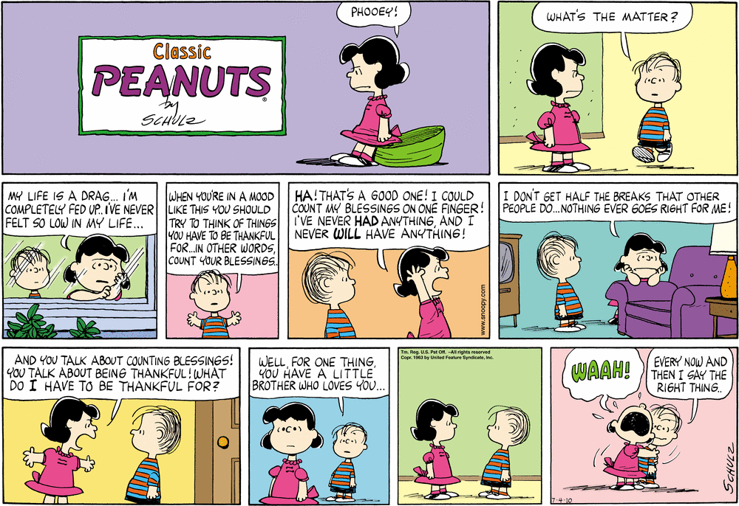

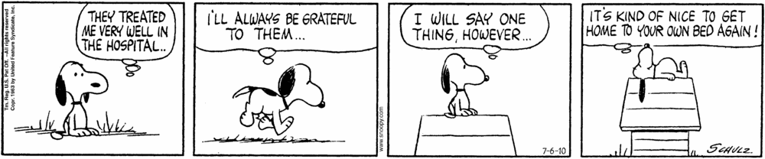

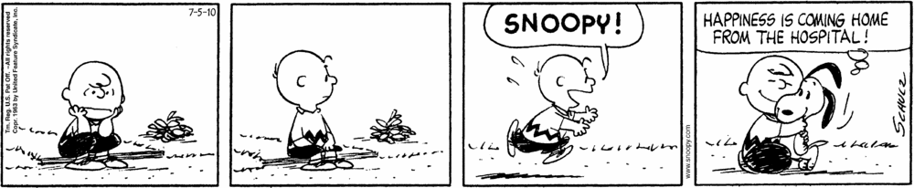

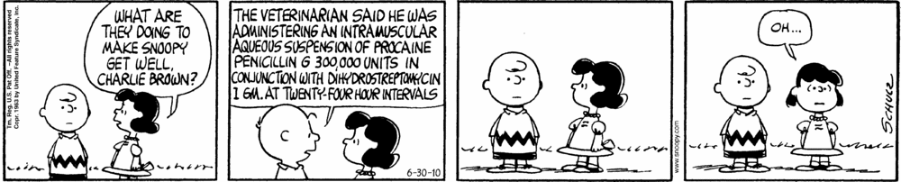

Human Taco Activity

Equipment: Notecards with taco ingredients and tape

Players: Entire class

Instructions: Stick labeled note card (with taco ingredient) on the back of everyone’s shirt. (i.e. the word meat printed on a note card). Have each player mingle around asking yes/no questions to find out the taco ingredient that is on their back. Explain the correct order of ingredients in a Human Taco: shell, meat, cheese, lettuce, tomato, salsa, and then give the start command, “I’m Hungry! Let’s Eat! Run for the Border!” Each individual must find out which ingredient they are and then find enough to form a complete Human Taco.

Submitted by: Fun-Attic, Inc.

Places I've Been
Equipment: One chair for each participant, arranged in a circle, the leader will start off standing

Size of Group: 8-20

Objective: Socialization, Reminiscing

Description: Each participant sits in one of the arranged chairs. The leader starts off by naming one place that they have visited in the past, for example on vacation. All the participants that have visited that location, must rise out of their chairs and find a new chair somewhere else in the circle. The leader finds himself or herself a chair and now there is a new person in the circle. This participant now must name a place they have visited. This continues until everyone has had a chance to be in the center of the circle or until time expires. The leader makes sure that on the last turn, he or she is left in the circle in order to bring the group to a close with discussion or processing.
Submitted by: Dennis Klenow CTRS of Havenwych Hospital on March 15, 1999

