Kindergarten Writing Checklist

Opinion writing - standards
☐ | State the topic/name of the book they are writing about
☐ | State an opinion or preference about the topic

opinion writing - conventions
☐ | Capitalizes the first word in a sentence and the pronoun I
☐ | Spells simple words phonetically  Drawing Scribble Directional Scribble Symbolic/Mock Letters  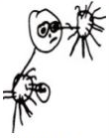 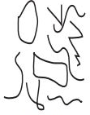 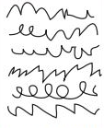 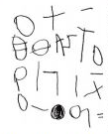  Random Letters Letter Strings Letter Groupings Environmental Print  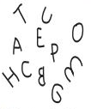 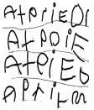 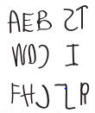 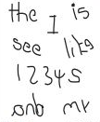  Beginning Sounds Beginning & Ending Sounds Phonetic Spelling Writing  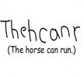 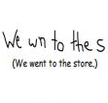 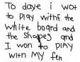 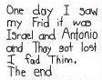

Kindergarten Writing Checklist

Informative writing - standards
☐ | State the topic
☐ | Supply 1-2 pieces of information about the topic

Informative writing - conventions
☐ | Capitalizes the first word in a sentence and the pronoun I
☐ | Spells simple words phonetically
Drawing | Scribble | Directional Scribble | Symbolic/Mock Letters
Random Letters | Letter Strings | Letter Groupings | Environmental Print
Beginning Sounds | Beginning & Ending Sounds | Phonetic Spelling | Writing

