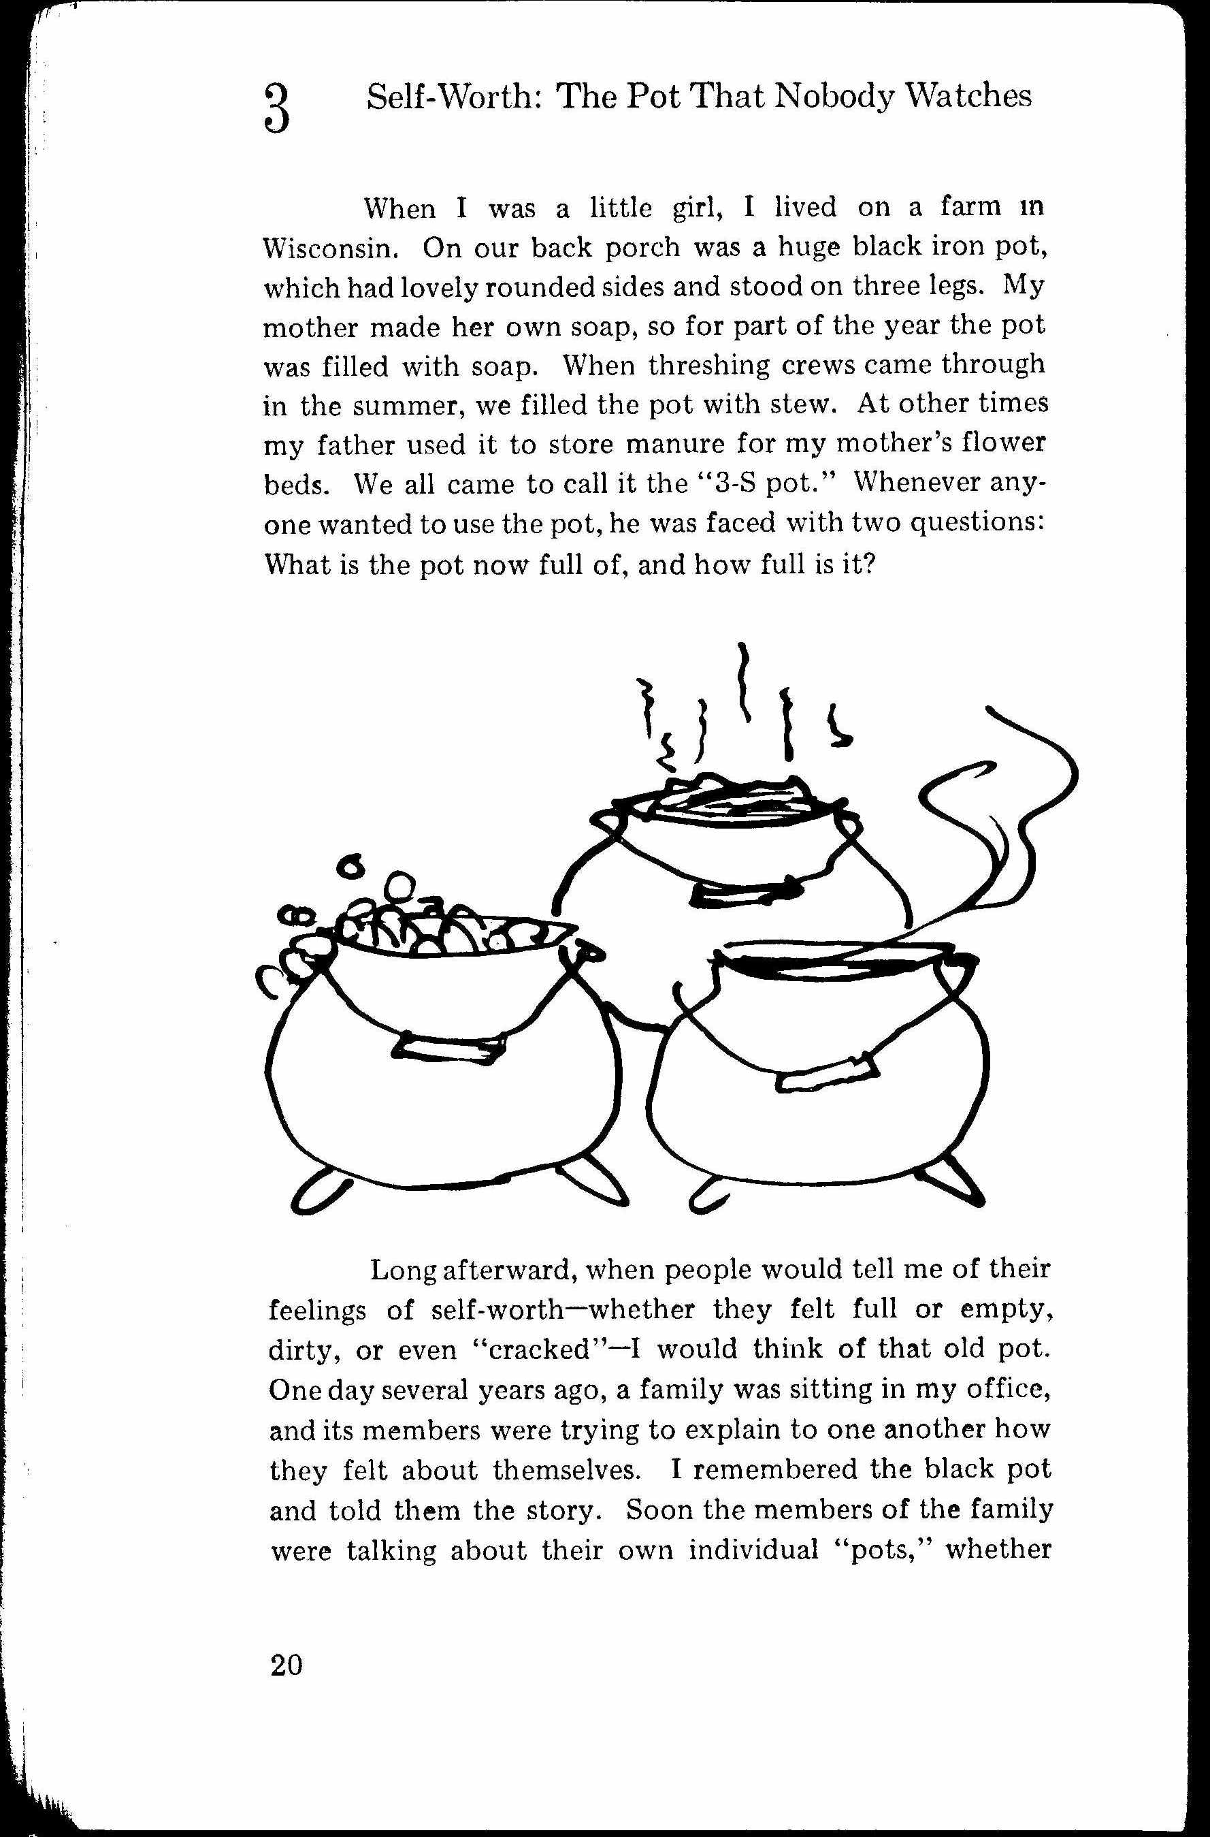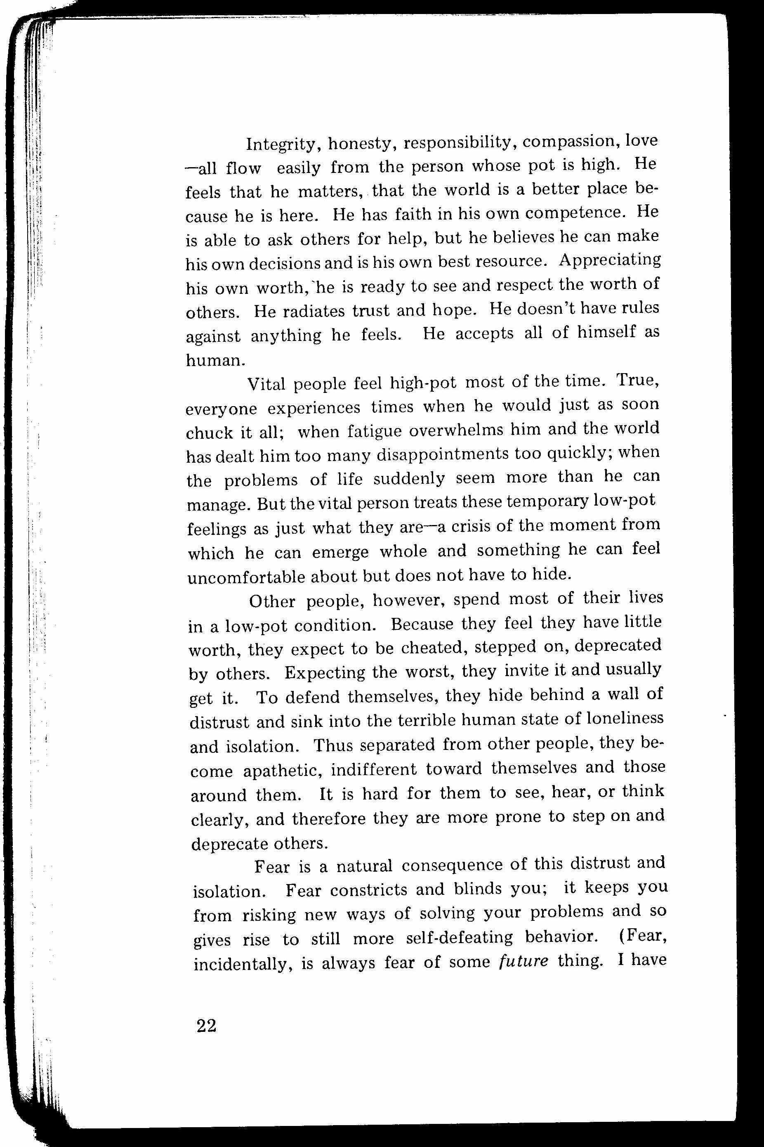[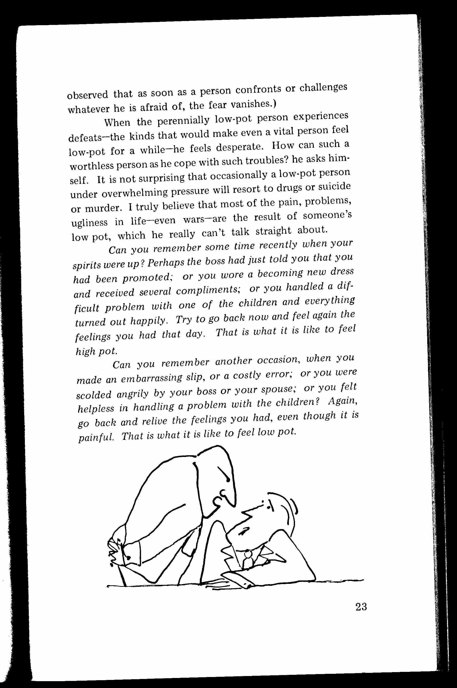](http://jamescolincampbell.com/wp-content/uploads/2011/03/self-worth-pot-41.jpg)[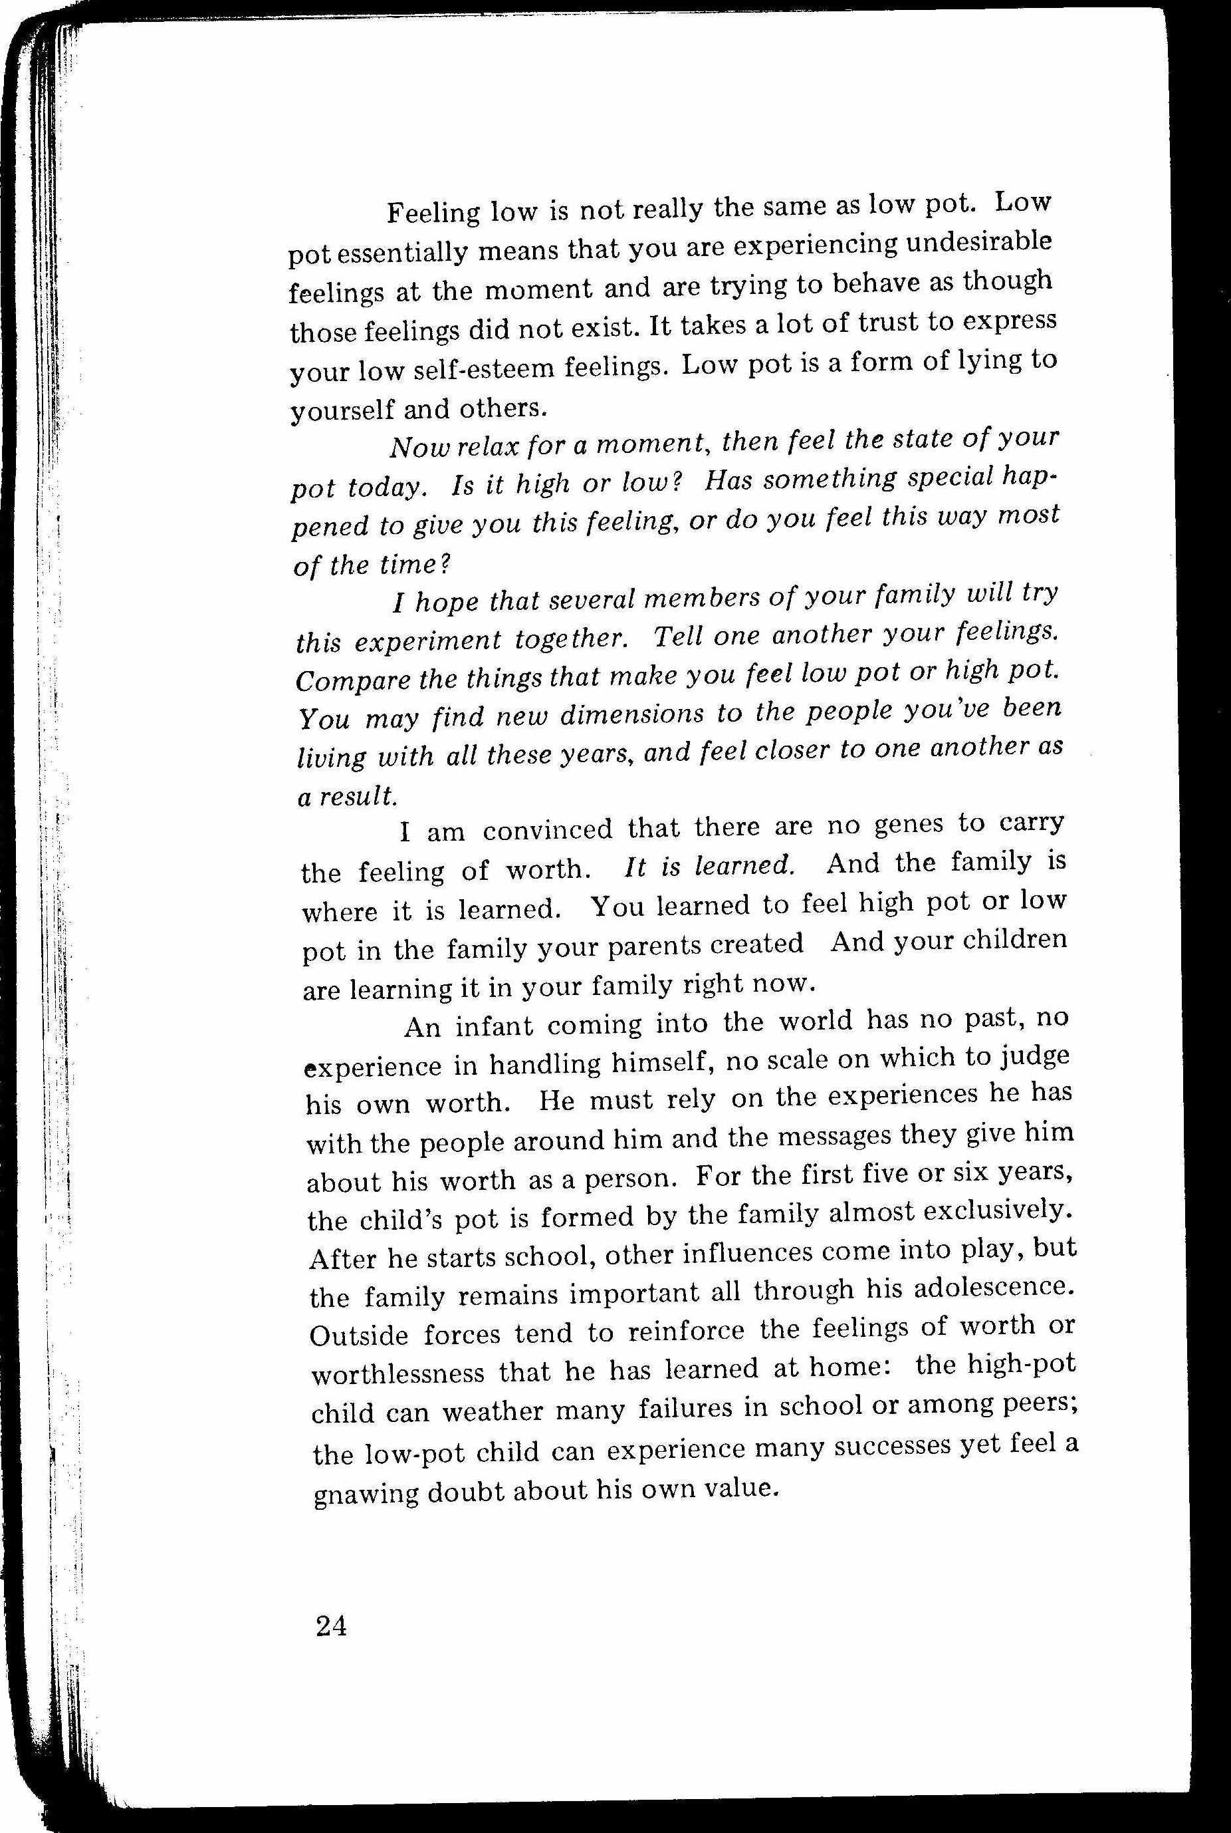](http://jamescolincampbell.com/wp-content/uploads/2011/03/self-worth-pot-51.jpg)[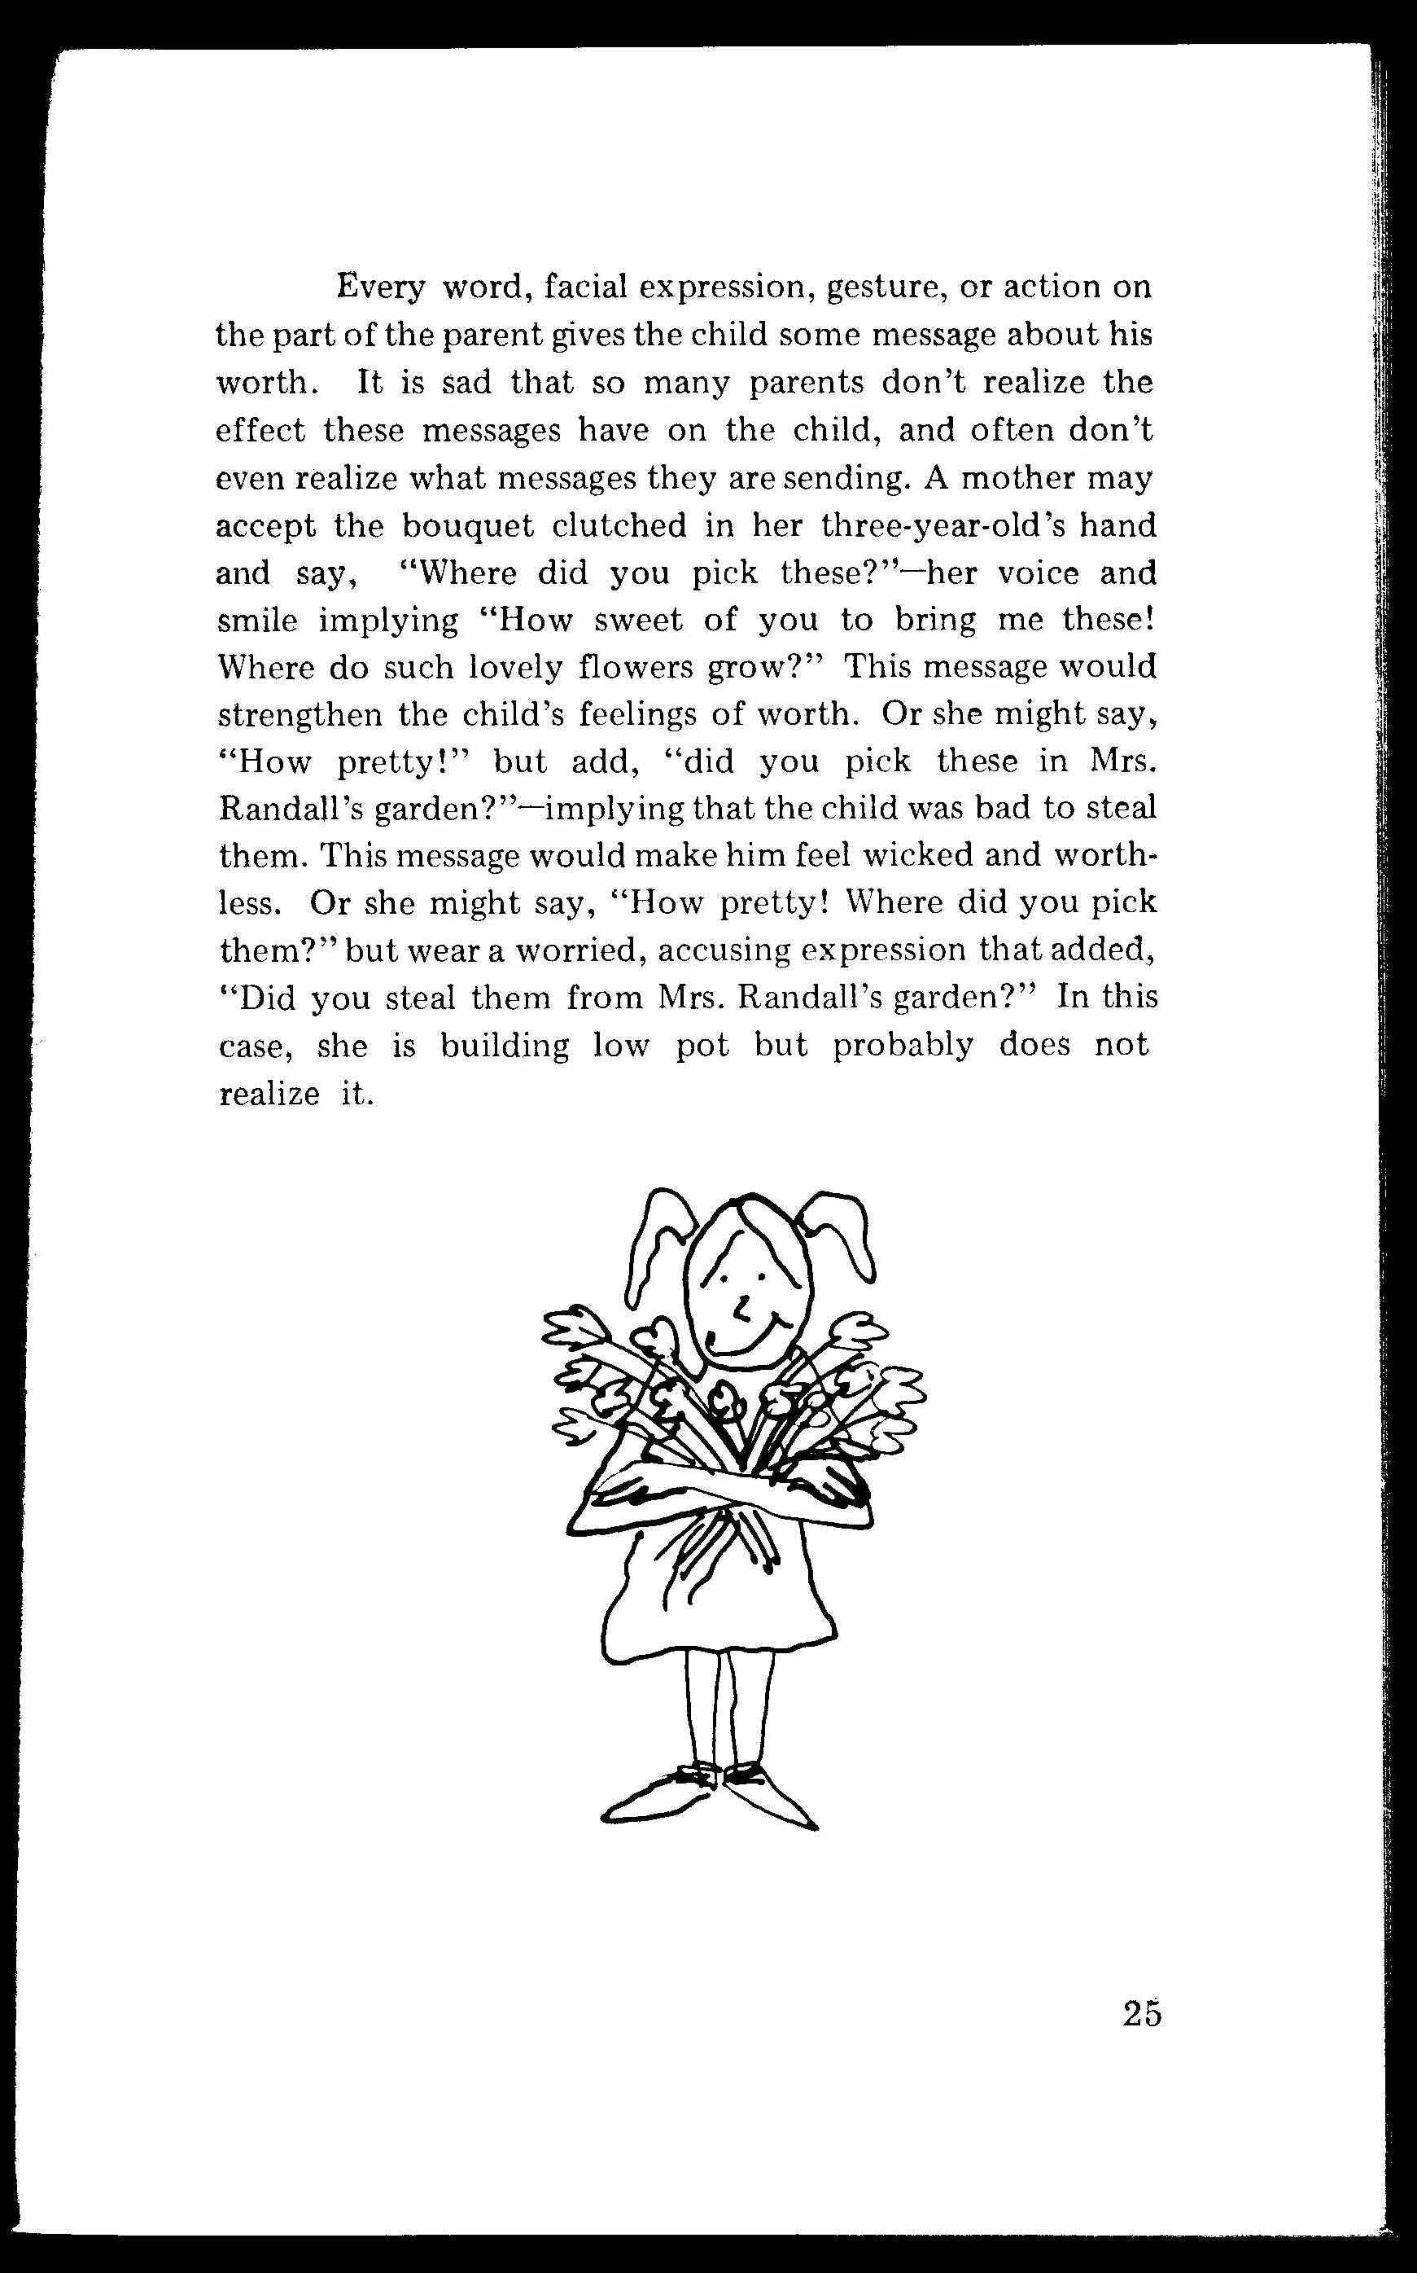](http://jamescolincampbell.com/wp-content/uploads/2011/03/self-worth-pot-61.jpg)