Note from the author/teacher

In my Child Development classes I have students complete PO 4, 5, 6 on their unit test day. After students finish the test they complete the attached worksheet describing how the developmental domain is strengthened by each activity. Then when everyone is finished I have the students rotate through each of the activities and do them themselves. The students enjoy doing the activities and it provides a good chance to discuss and reinforce how they are developmentally appropriate.

Nicole Manwaring
Jordan High School

Name:___________________________________________________Period:_______________________
Performance objective #6: Evaluate three age-appropriate activities for preschoolers and explain how each activity stimulates the preschooler’s development (physical, social, emotional, cognitive).
Activity | Physical | Social | Emotional | Cognitive

Candy Land

Lego/Duplos

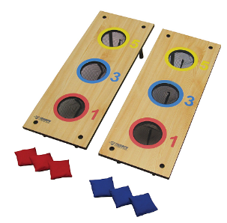

Bean Bag Toss

