Name: ____________________________

Class: ______________

Fabric File
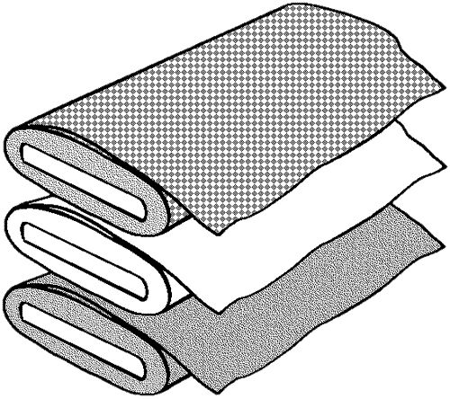

Directions

Visit each station around the classroom. In each station, you will:
- Read the information on the card.
- Copy any information needed into your Fabric File booklet.
- Glue or staple a sample of each fabric into your Fabric File.

After visiting each station, check off your completed booklet with your teacher.

Fiber, Yarn & Fabric
Fiber
Fiber
The basic unit from which fabric is made. They can be natural or manufactured.

Yarn

Yarn
A continuous length of interlocking fibers that have been twisted together.

Fabric

Fabric
The textile produced by weaving or knitting yarns together.

Types of Fabric

Woven Fabric
Woven Fabric
Created by the interlocking of warp and weft yarns at right angles.

Knit Fabric

Knit Fabric
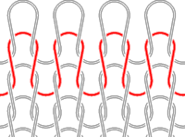
Created by the continuous interlocking or looping of yarn.

Non-Woven/Felted Fabric

Non-Woven/Felted Fabric
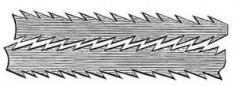
Created by interlocking and shrinking a mass of fibers together with heat, moisture and pressure.

Woven Fabrics

Denim
Denim
Fabrication:
Woven (Twill Weave)
Fiber Content:
Usually Cotton
Intended Use:
____________________________
____________________________

Flannel
Flannel
Fabrication:
Woven
Has been brushed on one or both sides to create a nap for a soft texture.
Fiber Content:
Usually Cotton
Intended Use:
_____________________________
____________________________

Canvas
Canvas
Fabrication:
Woven (Plain Weave)
Extremely Durable
Fiber Content:
Usually Cotton
Intended Use:
____________________________
____________________________

Calico
Calico
Fabrication:
Woven (Plain Weave)
Has an all-over print, usually a floral design.
Fiber Content:
Usually Cotton or Cotton/Polyester Blend
Intended Use:
____________________________
____________________________

Satin
Satin
Fabrication:
Woven (Satin Weave)
Smooth, Lustrous and Shiny Surface
Fiber Content:
Usually Silk, Polyester, Acetate and/or Rayon
Intended Use:
____________________________
____________________________

Knit Fabrics

Rib Knit
Rib Knit
Fabrication:
Double Knit
Great Stretch
Fiber Content:
Usually Cotton or Cotton/Polyester Blend
Intended Use:
____________________________
____________________________

Single Knit
Single Knit
Fabrication:
Knit
Can be Made Lightweight to Heavyweight
Fiber Content:
Usually Cotton, Wool, Silk, Nylon or Fiber Blends
Intended Use:
____________________________
____________________________

Polar Fleece
Polar Fleece
Fabrication:
Knit
Soft, Napped and Insulating
Fiber Content:
Usually Polyester
Intended Use:
____________________________
____________________________

Sweatshirt Fleece
Sweatshirt Fleece
Fabrication:
Knit (Plain Knit)
Stretchy and Soft
Fiber Content:
Usually Polyester
Intended Use:
____________________________
____________________________

Non-Woven/Felted Fabrics

Felt
Felt
Fabrication:
Non-Woven/Felted
Fiber Content:
Usually Wool, Cotton, Polyester, Rayon or Fiber Blends
Intended Use:
____________________________
____________________________

Interfacing
Interfacing
Fabrication:
Non-Woven/Felted
Some are Fusible
Used to Strengthen and Stabilize other Fabrics
Fiber Content:
Usually Wool, Cotton, Polyester, Rayon or Fiber Blends
Intended Use:
____________________________
____________________________

