

Textiles

Apparel Design & Production 1



Lesson Plan Notes

This lesson is meant to take place over 3 or 4 class periods. Each lesson should take approx. 20 min or less. Students will be given a handout booklet to take notes in. Textiles PPT, Fashion! Textbook and a couple of hands on activities.

Day 1, Introduce the fibers. Day 2, Review Fibers and discuss application/use, Stain Removal notes and discussion. Day 3, Notes and Discussion on Woven and Knit Fabrics, Stretch activity. Day 4, Notes and Discussion on Nonwoven, wool beads felting activity, Fabric sorting activity.

See Notes in PPT slides for additional details. My students are also working on their final project during this time. They get 20 min of instruction and 60 to sew on their projects.

November 2015

Amber Willaims

amwilliams@dsdmail.net

**TEXTILES**

Student Name

Definition Here:

Define Here

Natural

Manufactured



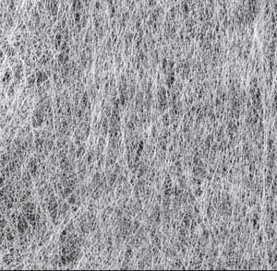

Nonwoven Fabric

Additional Notes:

Fabric Construction

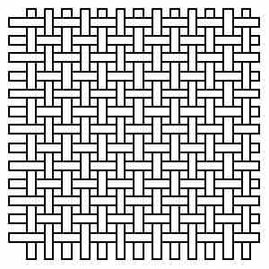

Woven Fabric

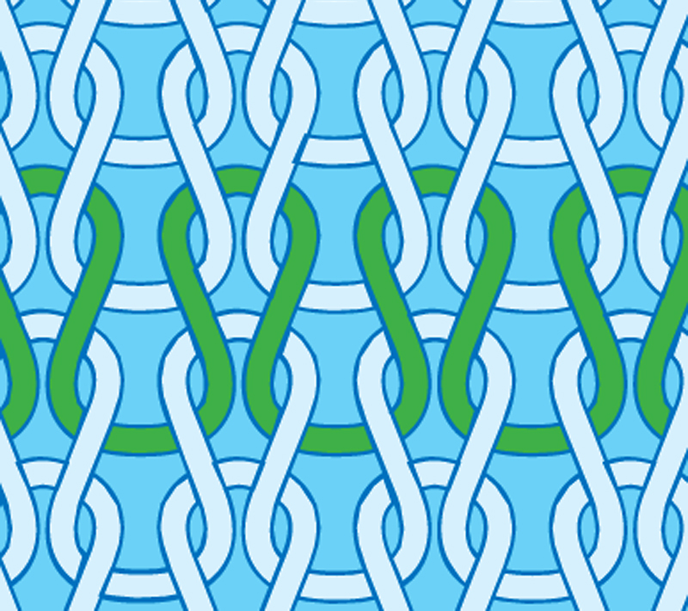

Knit Fabric

Using the FASHION! Textbook, copy the characteristics of the following fibers into the chart below:

|  |  |
| --- | --- |
| Cotton |  |
| Wool |  |
| Linen |  |
| Silk |  |
| Nylon |  |
| Polyester |  |
| Spandex |  |
| Acetate |  |
| Acrylic |  |
| Rayon |  |

What is a Blended Fiber?

|  |  |
| --- | --- |
| Picture | Function:  What Fiber will provide the function/needs? |
| 1. |  |
| 2. |  |
| 3. |  |
| 4. |  |
| 5. |  |
| 6. |  |

 Prewashing: *(when and why)*