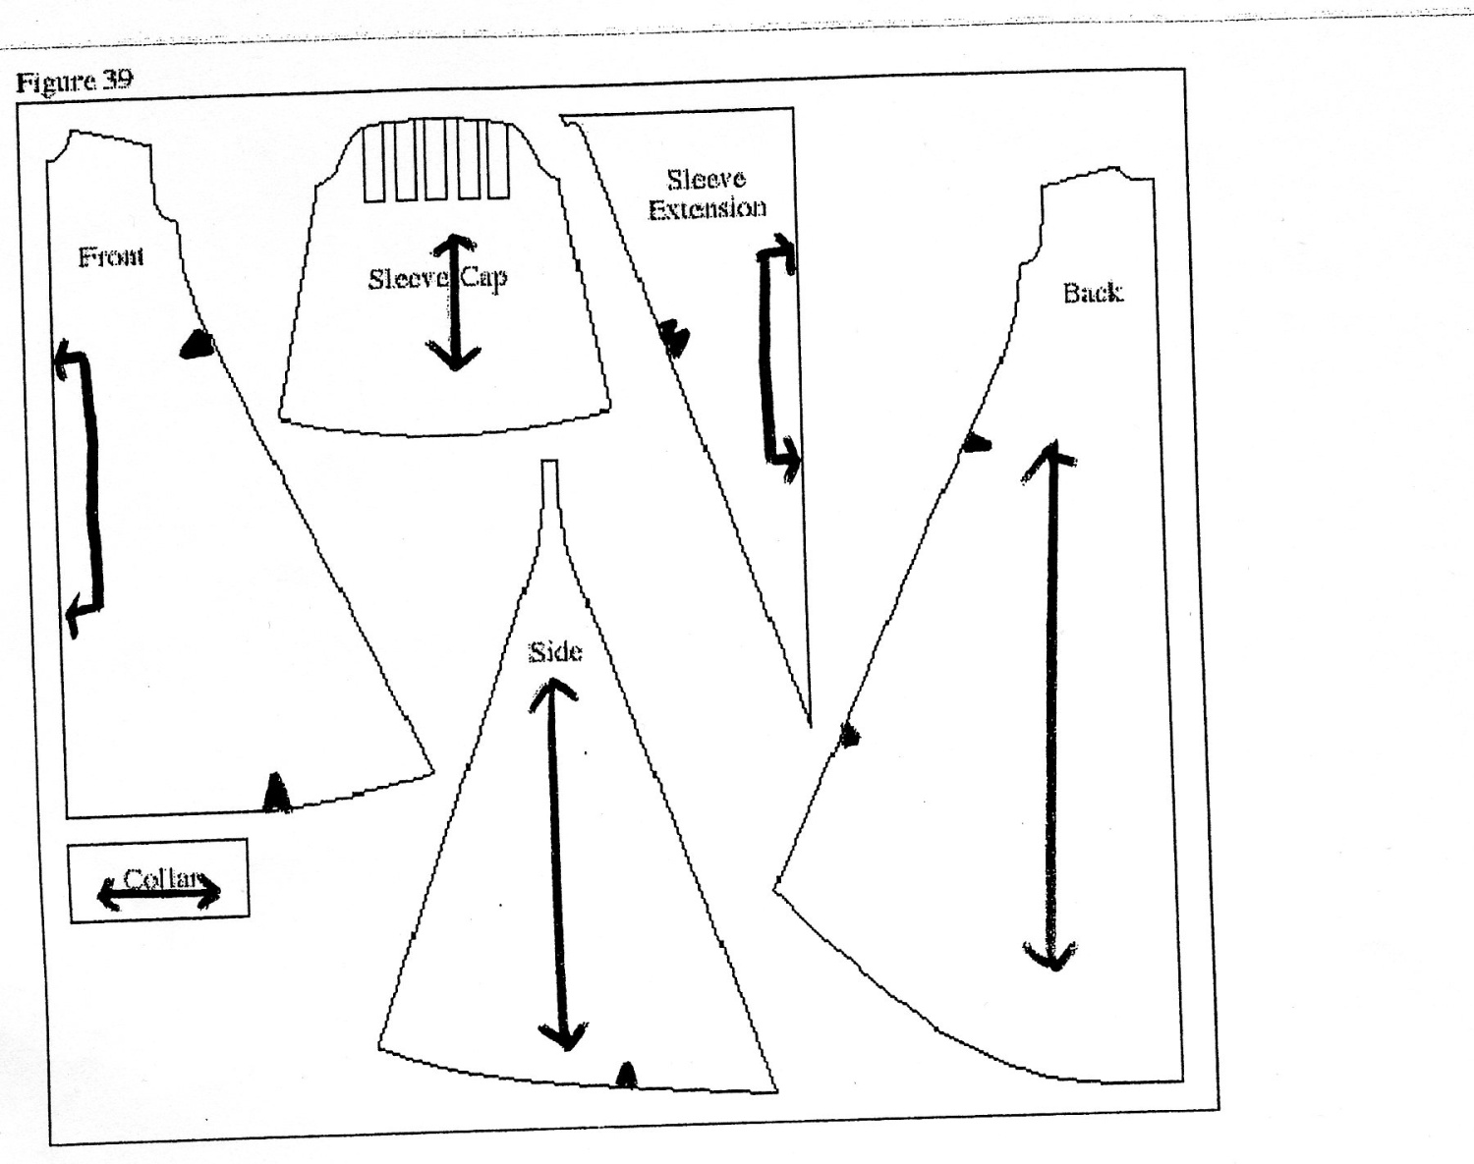

Directions: Now that you have watched the video to see how to cut out and lay out a pattern onto fabric, it’s time to practice before starting on our pajama pants! Cut out the pattern pieces in the picture above. Fold a piece of colored construction paper in half lengthwise (hot dog style). The construction paper represents your fabric. Across from your fold label the edges “Selvages” Using your knowledge of the symbols on the pattern pieces and a ruler, glue your pattern pieces on your construction paper. If you have any questions, ask Mrs. Melson!

