Apps for the FACS Classroom
- How Safe is my Food?
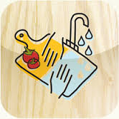
Platform: Android Platform – Free
Standard 2, Objective 4: Methods that prevent food-borne illnesses and contamination
About: “Is it done yet” function show user the appropriate cooking times for different food items. “Time to toss” function lets user scroll through food items and lists appropriate times to keep items in the fridge or freezer. Also includes kitchen quiz.

- Afit
Platform: Apple – Free (pro version $2.99)
Standard 3, Objective 2: Demonstrate knowledge of myplate and track diet
About: Interactive diet tracker linked to myplate. Illustrates the plate and glass filling as foods in each category and beverages are consumed. Awards points for filling myplate categories. Classroom function allows teachers to monitor student’s intake (pro version). Links to USDA for more resources.

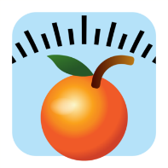
- Fooducate
Platform: All – Free
Standard 3, Objective 3: Demonstrating knowledge of healthy eating patterns
About: Search or scan products to see “grade” of nutritional value. Complete nutritional content for each product and alternative products assigned a better grade.

- Food Diary: AKA Food Instagram
Platform: Android – Free
Standard 3, Objective 3: Demonstrating knowledge of healthy eating patterns
About: Choices to follow categories such as organic, vegetarian, gluten free, healthy foods, etc. This is the Instagram of food with pictures of food dishes that include recipes. Allows you to manage a profile and submit photos and information about dishes.

- How to set the table
Platform: Android - Free
Standard 9, Objective 5: Identify and demonstrate proper table setting and etiquette.
About: Casual and formal place settings for breakfast, lunch, dinner, and dessert.

- Set A Table
Platform: Apple – Free
Standard 9, Objective 5: Identify and demonstrate proper table setting and etiquette.
About: Information about setting the table for breakfast, lunch, dinner, at a banquet and brunch.

- Fiber Tracker – Kellogg’s
Platform: Android - Free
Standard 4, Objective 2: Identify fiber, its sources and functions
About: Tracks fiber intake. See how your food choices contribute to your daily fiber intake. Learn about fiber serving sizes

- Grocery IQ
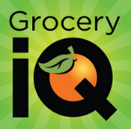
Platform: Android and Apple - Free
Standard 3, Objective 3: Demonstrating knowledge of healthy eating patterns
About: Grocery shopping made quick and easy. Find coupons, make grocery lists using text, barcodes or voice search. Can share lists with others.

- my Food – Grocery Planner
Platform: Android – Free
Standard 3, Objective 3: Demonstrating knowledge of healthy eating patterns
About: Easily create shopping lists, recipes and meal plans. Can add ingredients to recipes, and then click on recipe and generate list for items to buy.
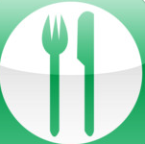
- Lunch Facts Nutrition Data
Platform: Apple – Free
Standard 3, Objective 2: Track diet
About: Nutritional information for menu items at popular restaurants.

- Big Fork Little Fork – by Kraft Foods
Platform: Apple – Free
Standard 3, Objective 3: Demonstrating knowledge of healthy eating patterns
About: Recipes, cooking video how-to’s and educational games.

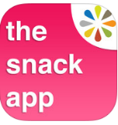
- Snack App
Platform: Apple – Free
Standard 3, Objective 3: Demonstrating knowledge of healthy eating patterns
About: Nutrition information for popular snack items.

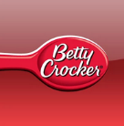
- Betty Crocker Cookbook
Platform: Apple and Android
Standard 3, Objective 3: Demonstrating knowledge of healthy eating patterns
About: More than 2,500 recipes at your fingertips. Can search by ingredients and find recipes based on the ingredients you have available. Recipe details with photos. Coupons for general mills products.

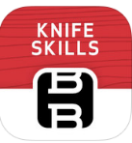
- Kitchen Knife Skills
Platform: Apple – $4.99
Standard 1, Objective 1: Identify types, use and care of selected kitchen equipment
About: Learn knife skills from a pro on the Food Network.

- Harvest Mark Food Traceability
Platform: Apple – Free
Standard 3, Objective 3: Demonstrating knowledge of healthy eating patterns
About: Trace your food back to the farm to learn when, where and how it was grown. Find out instantly if fresh foods are subject to a recall.

- Kitchen Calculator
Platform: Android
Standard 1, Objective 3: Identify appropriate abbreviations, food-measurement terminology, techniques, equivalents, and calculate recipe-size adjustments and demonstrate proper measuring techniques.
About: Convert between cooking measurements such as: cups to teaspoons, and grams to ounces.

