# Calculating the percentage of fat in food

Use the information on the package labels to calculate the percentage of fat in the foods.

**Example:**  Food/Product: **Fudge Cookie (one cookie)**

Total fat grams: 5 grams

Total calories: 100 calories

a) To calculate the **total calories from grams of fat** in a food:

*Remember: There are 9 calories per each 1 gram of fat: * ( ___ grams of fat) x  = ____ calories

b) To calculate the **percentage of calories from fat** in a food:

  *Remember: *

**

# Calculating the percentage of fat in food

Name: ________________________

period: ______

1. Food/ Product Name:

Fat Grams:

Total Calories:



a) ( _____ grams of fat) x  = ____ calories from fat

b) **

2. Food/ Product Name:

Fat Grams:

Total Calories:

a) ( _____ grams of fat) x  = ____ calories from fat



b) **

3. Food/ Product Name:

Fat Grams:

Total Calories:

a) ( _____ grams of fat) x  = ____ calories from fat



b) **

4. Food/ Product Name:

Fat Grams:

Total Calories:

 a) ( _____ grams of fat) x  = ____ calories from fat

b) **

5. Food/ Product Name:

Fat Grams:

Total Calories:

a) ( _____ grams of fat) x  = ____ calories from fat



b) **

6. Food/ Product Name:

Fat Grams:

Total Calories:

 a) ( _____ grams of fat) x  = ____ calories from fat

b) **

7. Food/ Product Name:

Fat Grams:

Total Calories:

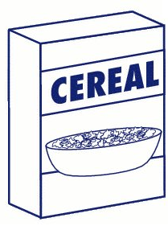 a) ( _____ grams of fat) x  = ____ calories from fat

b) **

8. Complete the bar chart:

a) Write in the food items from lowest to highest percentage of fat.

b) Draw a bar for each food item representing the percentage of fat in the food.

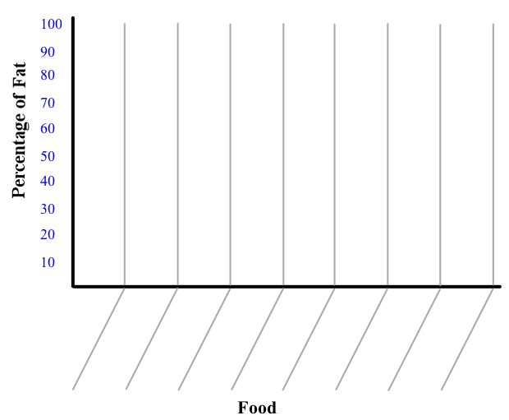

**Other Applications**

9. Last month your paycheck was $1,200 you spent $300 on food. What percent of your income was spent on food?

10. Charlie started on a diet in January at that time he weighed 280 pounds.

In October of that year he weighed 250 pounds.

a) How much weight did Charlie lose?

b) What percent of his original weight did he lose?

11. A screen printing business has a monthly allotment of $10,000 for operating cost. They plan to spend $3,300 for rent and utilities, $2,200 for advertising and $4,500 for supplies.

What percent of their budget do they plan to spend in each area?

_________ Rent/Utilities ____________ Advertising ___________ Supplies

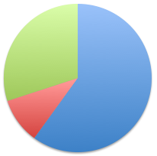12. Total calories consumed in one day: 2,500

Calories consumed from carbohydrates 1,500

Calories consumed from proteins 250

Calories consumed from fats 750

What percent of calories were spent in each area?

A problem you might see on the ACT Test

A company makes a profit equal to 25% of its sales. The profit is shared equally among the 4 owners of the company. If the company generates sales of $5,000,000, how much money does each one of the owners get?

A) 12,500   B) 312,500   C) 500,000   D) 1,250,000   E) 12,500,000