# Calculating the percentage of fat in food

Use the information on the package labels to calculate the percentage of fat in the foods.

**Example:**  Food/Product: **Fudge Cookie (one cookie)**

Total fat grams: 5 grams

Total calories: 100 calories

a) To calculate the **total calories from grams of fat** in a food:

*Remember: There are 9 calories per each 1 gram of fat: * ( _5_ grams of fat) x  = _45_ calories

b) To calculate the **percentage of calories from fat** in a food:

  *Remember: *

45

**

45

.45

100

# Calculating the percentage of fat in food

Name: ________________________

period: ______

1. Food/ Product Name: Peanut Butter (2 Tbsp.)

Fat Grams: 16

Total Calories: 190

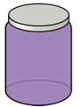

a) ( __16___ grams of fat) x  = _144___ calories from fat

144

b) **

190

76

.76

2. Food/ Product Name: Olives (5)

Fat Grams: 2.5

Total Calories: 25

a) ( __2.5___ grams of fat) x  = __22.5__ calories from fat



22.5

b) **

90

.90

25

3. Food/ Product Name: Golden Raisins (4 Tbsp.)

Fat Grams: 0

Total Calories: 120

a) ( __0___ grams of fat) x  = __0__ calories from fat



0

b) **

0

0

120

4. Food/ Product Name: Creamy Italian Dressing

Fat Grams: 11

Total Calories: 100

1.  ( __11__ grams of fat) x  = _99_ calories from fat

99

b) **

.99

99

100

5. Food/ Product Name: Black Beans ($\frac{1}{2}$ cup)

Fat Grams: .5

Total Calories: 110

a) ( __.5___ grams of fat) x  = __4.5__ calories from fat



4.5

b) **

4

0.04

110

6. Food/ Product Name: Pretzel M&M

Fat Grams: 6

Total Calories: 180

 a) ( __6___ grams of fat) x  = __54__ calories from fat

b) **

30

.30

180

54

7. Food/ Product Name: Granola Cereal

Fat Grams: 8

Total Calories: 240

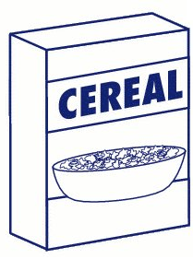 a) ( __8___ grams of fat) x  = __72__ calories from fat

72

b) **

30

.30

240

8. Complete the bar chart:

a) Write in the food items from lowest to highest percentage of fat.

b) Draw a bar for each food item representing the percentage of fat in the food.

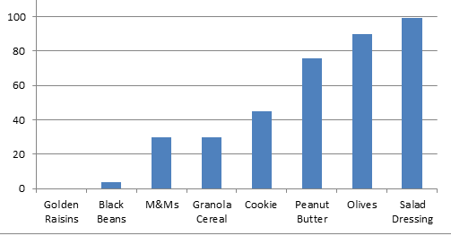

**Other Applications**

9. Last month your paycheck was $1,200 you spent $300 on food. What percent of your income was spent on food?

$$\frac{300}{1,200}= 0.25=25\%$$

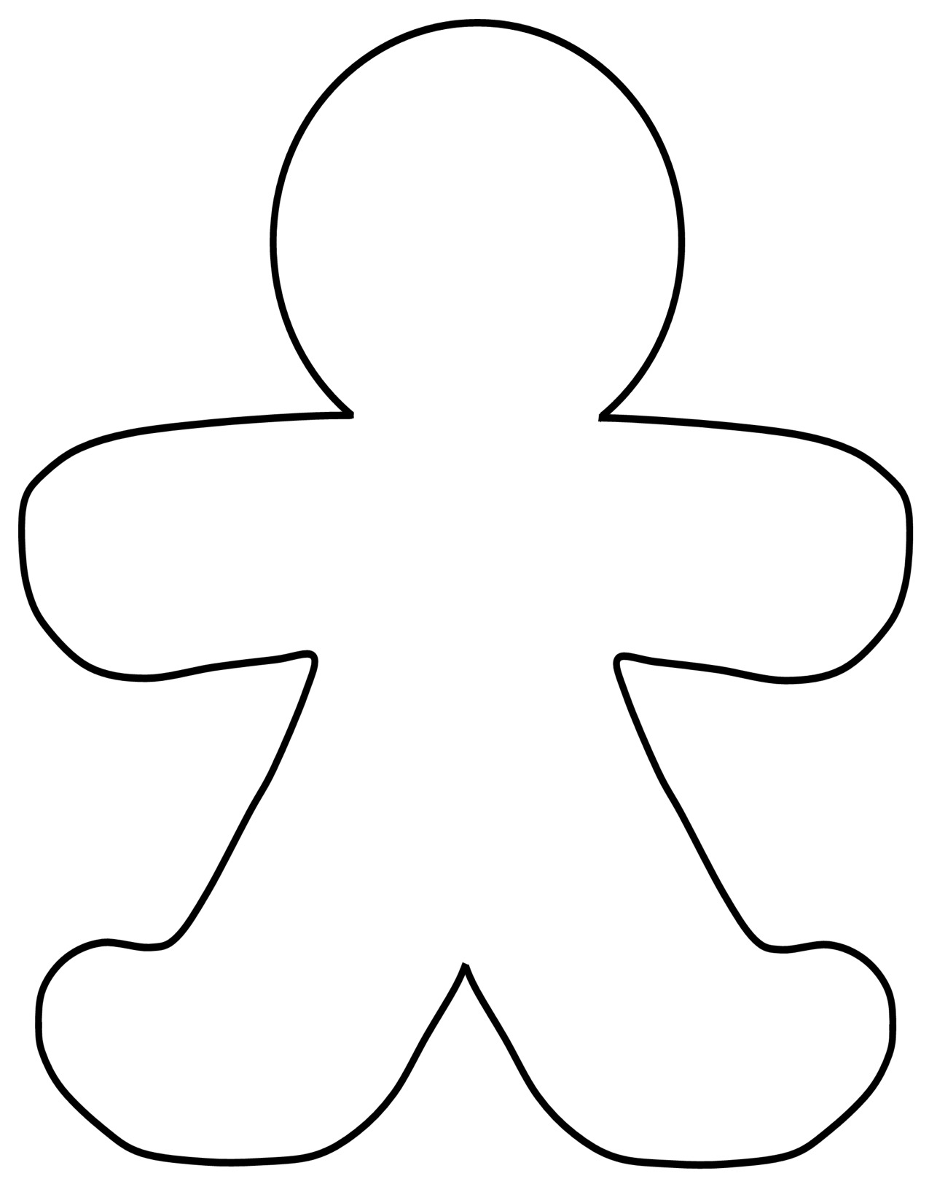10. Charlie started on a diet in January at that time he weighed 280 pounds.

In October of that year he weighed 250 pounds.

a) How much weight did Charlie lose? 280-250=30

b) What percent of his original weight did he lose?

11. A screen printing business has a monthly allotment of $10,000 for operating cost. They plan to spend $3,300 for rent and utilities, $2,200 for advertising and $4,5000 for supplies.

What percent of their budget do they plan to spend in each area?

$\frac{3,300}{10,000}=33\%$__ Rent/Utilities $\frac{2,200}{10,000}=22\%$__ Advertising $\frac{4,500}{10,000}=45\%$__ Supplies

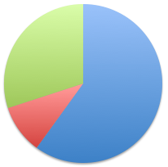12. Total calories consumed in one day: 2,500

Calories consumed from carbohydrates 1,500

Calories consumed from proteins 250

Fats 30%

Calories consumed from fats 750

What percent of calories were spent in each area?

Carbohydrates 60%

Protein 10%

A problem you might see on the ACT Test

A company makes a profit equal to 25% of its sales. The profit is shared equally among the 4 owners of the company. If the company generates sales of $5,000,000 how much money does each one of the owners get?

A) 12,500 B) 312,500 C) 500,000 D) 1,250,000 E) 12,500,000