Equivalents Experiments
Equivalents Experiment #1  A. Equipment: B. Method:  Answer: ______ Answer: _____ | Equivalents Experiment #9  A. Equipment: B. Method:  Answer: ______ Answer: ______
Equivalents Experiment #2  A. Equipment: B. Method:  Answer: ______ Answer: ______ | Equivalents Experiment #10  A. Equipment: B. Method:  Answer: ______ Answer: ______
Equivalents Experiment #3  A. Equipment: B. Method:  Answer: ______ Answer: ______ | Equivalents Experiment #11  A. Flour  Equipment: ______________________________  Method: _________________________________  B. Sugar/Salt  Equipment: ______________________________  Method: _________________________________  C. Brown Sugar  Equipment: ______________________________  Method: _________________________________  D. Shortening  Equipment: ______________________________  Method: _________________________________  E. Oil/Water  Equipment: ______________________________  Method: _________________________________  F. Margarine/Butter  Equipment: ______________________________  Method: _________________________________  G. Eggs  Equipment: ______________________________  Method: _________________________________
Equivalents Experiment #4
A. Equipment: B. Method:
Answer: ______ Answer: ______
Equivalents Experiment #5
A. Equipment: B. Method:
Answer: _____ Answer: ______
Equivalents Experiment #6
A. Equipment: B. Method:
Answer: ______ Answer: ______
Equivalents Experiment #7
A. Equipment: B. Method:
Answer: ______ Answer: ______
Equivalents Experiment #8
A. Equipment: B. Method:
Answer: ______ Answer: ______

Know Your Abbreviations
T., Tbsp. | = | ____________________ |  | lb., # | = | ____________________
oz. | = | ____________________ |  | pkg. | = | ____________________
c. | = | ____________________ |  | pt. | = | ____________________
t., tsp. | = | ____________________ |  | gal. | = | ____________________
qt. | = | ____________________ |  | hr. | = | ____________________

It All Measures Up
It All Measures Up #1  A. How many Tbsp. are in ½ c.? ________  B. 1/8 c. = _______ Tbsp.  C. 1/4 c. = _______ Tbsp.  D. 3/4 c. = _______ Tbsp.  E. 1 c. = _______ Tbsp. | It All Measures Up #5  A. How many Tbsp. in 1/8 c.? ________  B. 3 tsp. = ________ Tbsp.  C. 1/8 c. = ________ Tbsp.  D. 1/4 c. = ________ Tbsp.  E. 1/3 c. = ________ Tbsp.
It All Measures Up #2  A. What is this measuring method called? ___________________________________________  B. List two other ingredients that could be measured using this method:  1. 2.  C. What is one advantage of using this method? ___________________________________________ | It All Measures Up #6  A. How many times did you use the 1/2 c.? ____  B. How many times did you use the 1/4 c.? _____  C. 1/4 c. = _________ Tbsp.  List the 4 standard sizes of measuring cups:  1. _______________ 3. ______________  2. _______________ 4. ______________
It All Measures Up #3  A. How many ¼ tsp. are in 1 ½ tsp.? _______  B. List the 4 standard sizes of measuring spoons:  1. _________________ 3. ________________  2. _________________ 4. ________________ | It All Measures Up #7  A. How many tsp. in 2 Tbsp.? ________  B. 1 Tbsp. = ______ tsp.  C. 1 c. = _________ tsp.  D. 1 c. = _________ Tbsp.
It All Measures Up #4  A. How many c. of water in 1 qt.? _______  B. 1 pt. = ________ c.  C. 1 qt. = ________ pt.  D. 1 gal. = _______ qt. | It All Measures Up #8  A. How many c. in 48 fl. oz.? ________  B. 1 c. = _______ oz.  C. 1 qt. = ______ oz.  D. 1 gal. = _____ oz.

Know Your Equivalents
1 Tbsp. | = | ________ tsp. |  | 1/2 c. | = | ________ Tbsp.
1 c. | = | ________ Tbsp. |  | 12 Tbsp. | = | ________ c.
1/3 c. | = | ________ Tbsp. |  | 8 oz. | = | ________ c.
1 stick/cube butter | = | ________ c. |  | 1 stick/cube butter | = | ________ Tbsp.
1/4 c. | = | ________ Tbsp. |  | 16 oz. | = | ________ lb.
2 Tbsp. | = | ________ c. |  | 2 pt. | = | ________ qt.
1 pt. | = | ________ c. |  | 1 gal. | = | ________ qt.
1 gal. | = | ________ c. |  | 1 gal. | = | ________ pt.

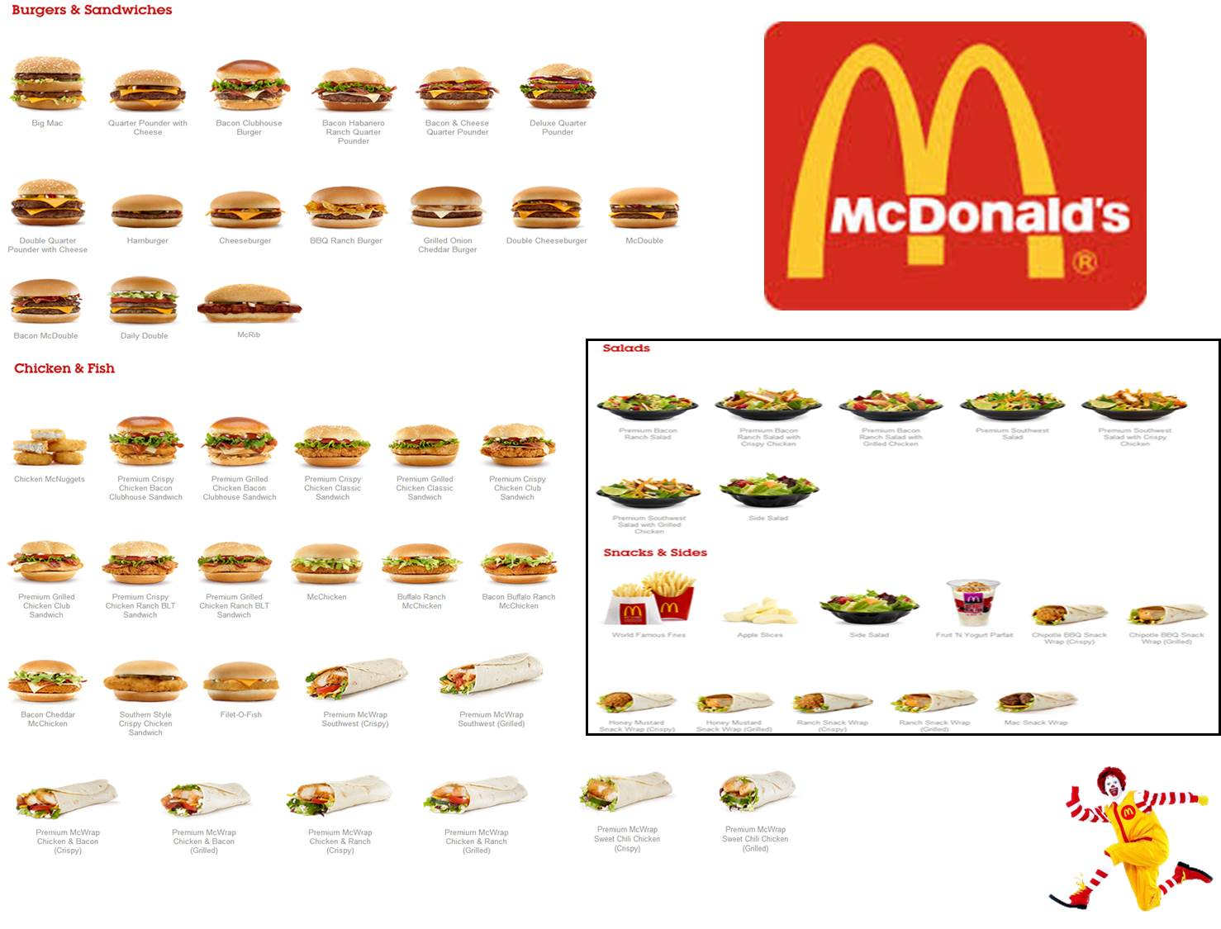
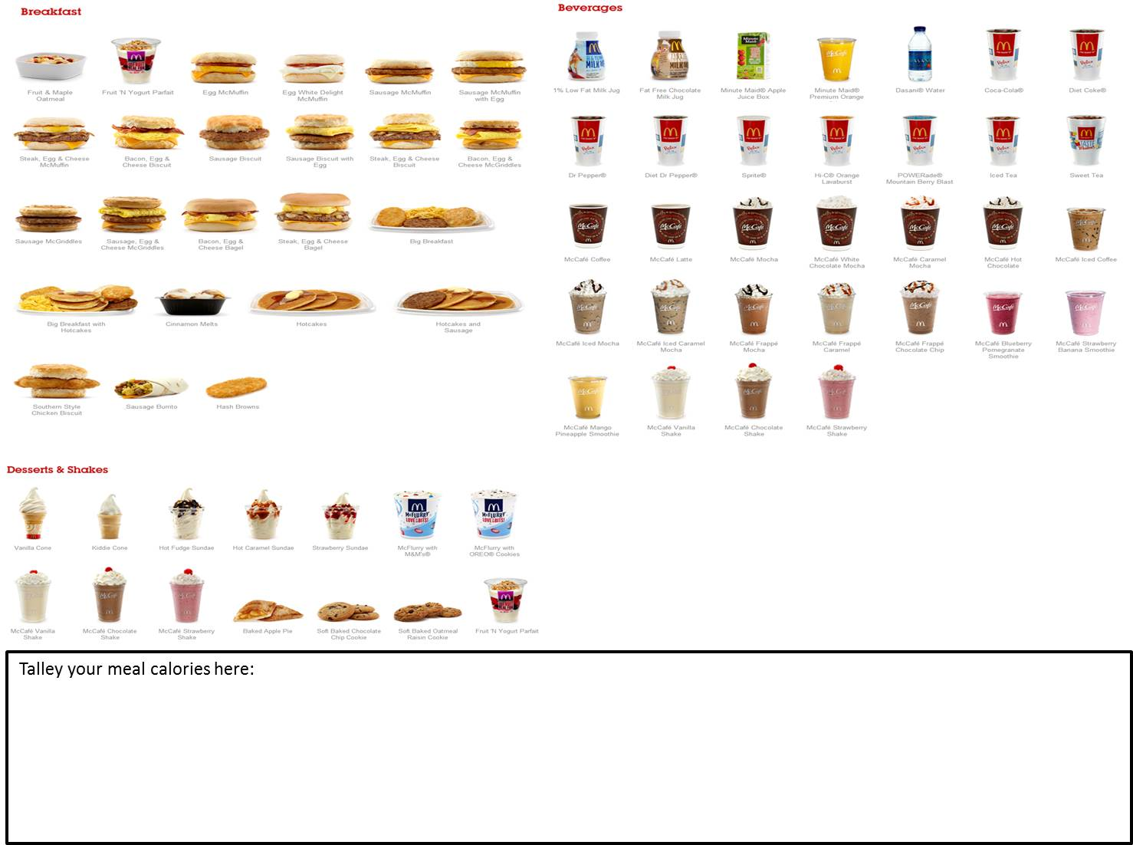

Name: __________________________________________________________________________ Date: _______________________________________ Period: ______________
Quesadilla Worksheet

# of Girls | # of Boys | # of Quesadillas (girls + 2×boys)

Ingredient | For 1 | Total | Package | Buy | Price | Cost
Flour tortillas | 2 ea. |  | 12 count |  | $1.79
Chicken | 3 oz. |  | 1.25 lb. |  | $1.99/lb
Cheese | 1/3 c. |  | 2 c. |  | $1.89
Onion | 1/2 small green |  | 12 per bundle |  | $0.55
Bell Pepper | 1 strip |  | 32 per pepper |  | $0.79
Green Chiles | 1 t. |  | 10 tsp. per can |  | $0.97
Picante Sauce | 2 T |  | 16 oz. |  | $2.50
Sour Cream | 1 T |  | 16 oz |  | $1.25
Cost per quesadilla: $

Name _________________________________________________________________ Period _____

How Much Water Do You Need?
The amount of water you need depends on several factors.
- Normal Activity Level - needs 1/2 ounce of water per pound of Body Weight,
    - multiply 1/2 by your body weight over one

    - $\frac{1}{2}∙\frac{body weight}{1}$ = number of ounces of water you need
- Multiply the numerators and then the denominators. Reduce your answer and round to the nearest whole number.
For example, Ms. Pearson weighs 145 pounds and is moderately active. How many ounces of water does she need to drink every day?
$\frac{1}{2}∙\frac{145}{1}= \frac{145}{2}=72.5$ So, she needs 73 ounces of water every day.

- Active Activity Level - needs 2/3 ounce of water per pound of Body Weight,
    - multiply 2/3 by your body weight over one

    - $\frac{2}{3}∙\frac{body weight}{1}$ = number of ounces of water you need
- Multiply the numerators and then the denominators. Reduce your answer and round to the nearest whole number.
For example, Ms. Pearson weighs 145 pounds and is moderately active. How many ounces of water does she need to drink everyday?
$\frac{2}{3}∙\frac{145}{1}= \frac{290}{3}=96.66$ So, she needs 97 ounces of water everyday.

What is your activity level? ____________
Your Body Weight _________
How much water do you need? ANSWER_________
Do your calculations here.

