Names:____________________________________________________________________

__________________________________________ Period:_______ Kitchen:________
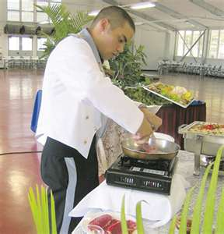
French Service Cooking
French style service is typically considered the most elegant, but is very expensive. Servers present food to guests from a tableside cart called a gueridon. This cart holds, food, beverages, dishes and a rechaud to keep food warm. Tableside cooking is an art that shows great craftsmanship in both culinary arts and in service. Think about an experience you’ve had at Teppanyaki or Benihanas. It’s similar.

In your group will take turns doing the food preparation at the “tableside”. Please plan what needs to be prepped and how you will do this. Assign a person to each cooking task.

Crepes:
2 eggs, lightly beaten
½ cup + 3 tbsp milk
1 tbsp butter, melted
1/2 cup flour
1 tbsp sugar
¼ tsp salt

In a large bowl, whisk together eggs, milk, melted butter, flour, sugar and salt until smooth. Heat a medium-sized skillet over medium heat. Grease a pan with a small amount of oil. Ladle about 3 tbsp of batter into hot pan, tilting the pan so the bottom is evenly coated. Cook 1-2 minutes on each side. Serve with lemon and sugar or berries and cream.

Whipping Cream:
½ c. heavy whipping cream
½ tsp vanilla
1 ½ Tbsp sugar

Combine all ingredients together. Whip until light and fluffy. Do not over whip. Tip: Put your metal bowl and beaters in the freezer to chill them. This will help make your whipping cream better.

Equipment Needed:

Note: Crepes are a quick bread. The type of batter you are using is a Pour Batter which is 1 part flour to 1 part liquid.

