Culinary Management Test #1 – Strands 1-3
DO NOT WRITE ON THIS TEST
44 Questions Total

Match the following with the picture: (1.2)
- Mandoline
c. 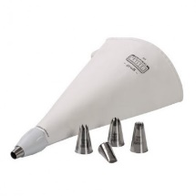
b.
a.
d.
- Parisian Scoop
- Piping Tools
- Scale

Match the following with the picture: (1.3)
- Chafing Dish
b.
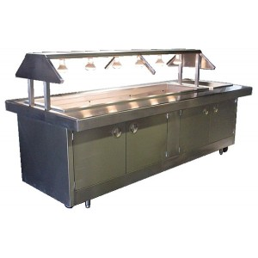
a. 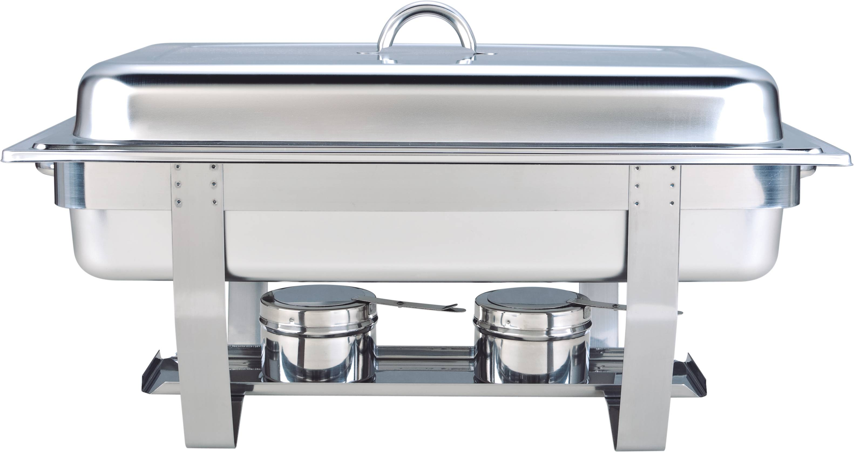
c. 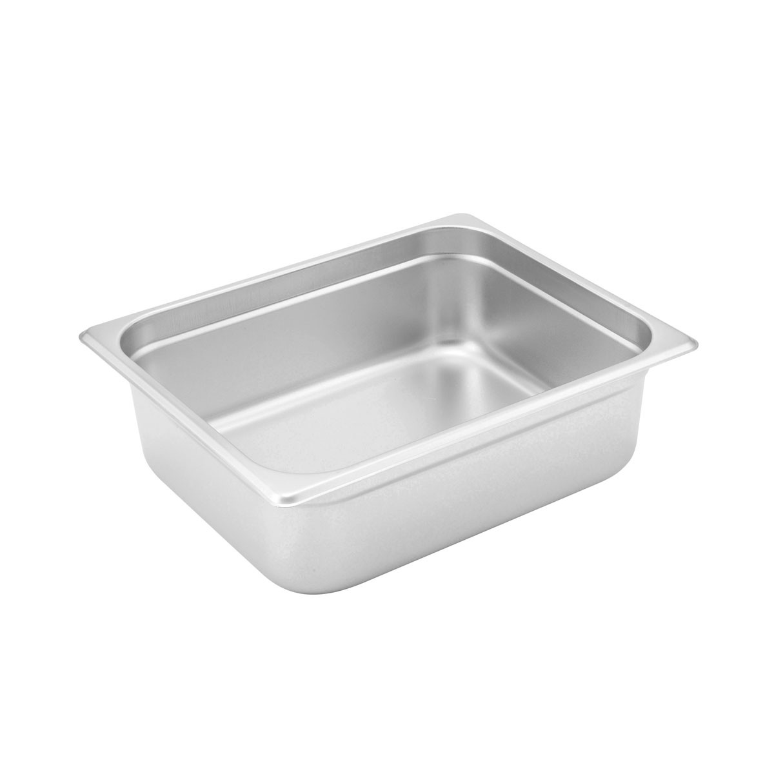
d.
- Hotel Pan
- Steam Table
- Sheet Pans

Match the following knife cuts: (1.4)
a. 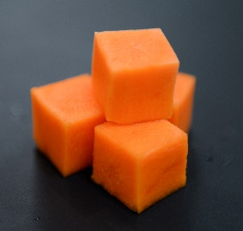
d. 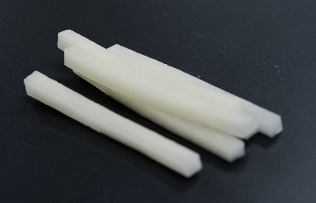
b. 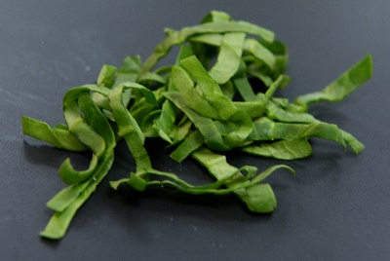
c. 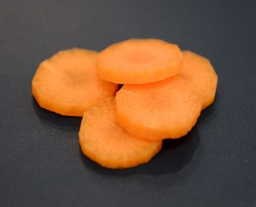
- Rondelle
- Dice
- Julienne
- Chiffonade

- Which oven cooks food using a fan to blow hot air throughout the oven? (1.3)
  - Conveyor oven
  - Conventional oven
  - Deck oven
  - Convection oven

- What is the term used for organizing equipment and preparing ingredients before you being cooking? (1.5)
  - Batonnet
  - Cuisine
  - Mise en place
  - Garde manger

- What system is in place to identify and monitor critical control points to keep food safe? (2.1)
  - FIFO
  - HACCP
  - FATTOM
  - SDS

- What system is in place to ensure that the oldest items in your inventory get used first? (2.1)
  - FIFO
  - TCS
  - RTE
  - HACCP

- What temperature should you hold hot food at? (2.1)
  - 135 for 4 hours
  - 145 for 2 hours
  - 155 for 4 hours
  - 165 for 2 hours

- What temperature should you reheat food to? (2.1)
  - 135 for 30 seconds
  - 145 for 15 seconds
  - 155 for 30 seconds
  - 165 for 15 seconds

- What is the correct order for washing dishes in a three-compartment sink? (2.3)
  - Wash, sanitize, rinse, towel dry
  - Rinse and scrape, wash, rinse, air-dry, sanitize
  - Sanitize, wash, rinse, air-dry
  - Rinse and scrape, wash, rinse, sanitize and air-dry

- What happens when one food containing an allergen comes in contact with a surface or food, thereby posing a hazard for those with allergies? (2.3)
  - Ready-to-eat
  - Cross-contamination
  - Cross-contact
  - HACCP

- Identify the missing condition for bacteria growth: Food, temperature, time, oxygen, moisture… (2.4)
  - Age
  - Al dente
  - Aroma
  - Acidity

Match the following with the definition: (2.4)
- Bacteria a. spore producing organism including yeast and mold
- Viruses b. tiny single cell-micro-organism including salmonella and E.coli
- Parasites c. simple organism responsible for most food-bourne illnesses
- Fungi d. organism that must live in or a on a host to survive

- RICE a. foods that needs special care to prevent growth of microorganisms
- RTE b. safety and first-aid information about chemicals
- SDS c. food that is ready to serve
- TCS d. how to treat any sprain or strain

- A pan of lasagna cost $7.00 to prepare. It makes 10 servings. What is the portion cost? (3.2)
  - $7.00
  - $3.50
  - $1.40
  - $0.70

- Chef was preparing stir-fry. He needs 30 lbs EP of carrots for his recipe. With a percentage yield of 60%, how much does the chef need to use? (3.3)
  - 50 lbs
  - 180 lbs
  - 20 lbs
  - 30 lbs

- Chef prepared a menu item and the food cost was $3.00. On the menu, it was priced at $10.00. After the cost of the food what was the additional money used for? (3.4)
  - Profit
  - Insurance
  - Labor
  - All of the above

- The bodies inability to break-down or process food is considered a(n)… (4.1)
  - Diabetes
  - Intolerance
  - Anemia
  - Allergy

- Common food allergens include: (4.1)
  - Eggs, milk, nuts
  - Soy, wheat, onions
  - Seafood, broccoli, eggs
  - Milk, wheat, oranges

- Lipid is another name for… (4.1)
  - Protein
  - Carbohydrates
  - Fats
  - Fiber

Match the following with the definition: (4.2)
- Static, fixed a. non-commercial segment
- Cycle b. food available in the market
- Market c. still or unchanging

- Table d’ hote/Prix Fixe a. all items offered daily
- A la Carte b. complete meal at one price
- California c. all items prices and ordered separately

- The action or business of promoting and selling products or services is…(5.1)
  - Clearance sale
  - Marketing
  - Retail
  - Wholesale

Read the scenario and answer the questions below:
In November 2011, Adam Terry had a dream of opening a restaurant. He had a small van and a kitchen. He has since turned this into over 9 brick and mortar restaurants and a fleet of food trucks called Waffle Love. Since 2012, the food truck industry has grown from a $615 million-dollar industry to a $2.7 billion-dollar industry.

- One of the reasons Waffle Love was so successful was the novelty of a food truck of Utah County. This is an example of a…(5.2)
  - Demographic
  - Trend
  - Farm to table restaurant
  - Rewards or loyalty program

- Another reason Waffle Love was so successful was the high number of college students that live in and around Utah County. These students were looking for new and innovate food experiences. This is an example of being aware of…(5.2)
  - Demographics
  - Community outreach
  - Schematic
  - Delineation

- Waffle Love uses social media to post locations of their food trucks and the hours of their store weekly. This is an example of…(5.2)
  - Demographics
  - Trends
  - Community Outreach
  - Advertising

