Test #___________

Culinary Management Test #2 – Strand 4, 5 and 7
DO NOT WRITE ON THIS TEST
43 Questions Total

Match the following with the picture: (1.2)
- Mandoline
c. 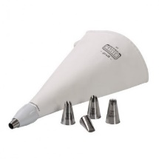
b.
a. 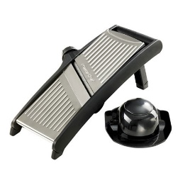
d.
- Parisian Scoop
- Piping Tools
- Scale

Match the following with the picture: (1.3)
- Chafing Dish
b.
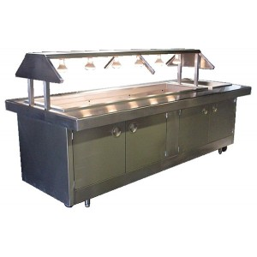
a. 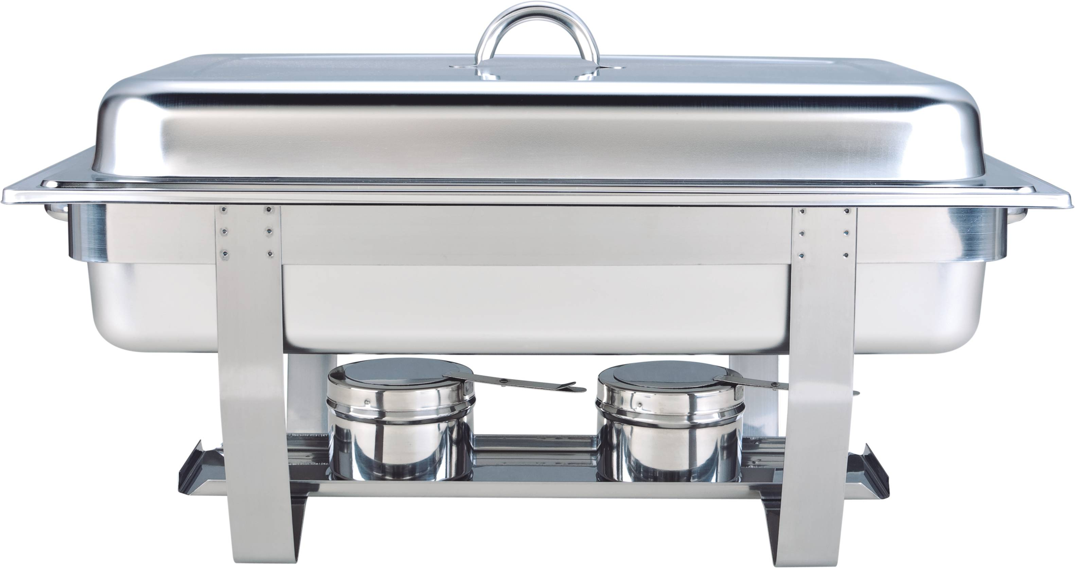
c. 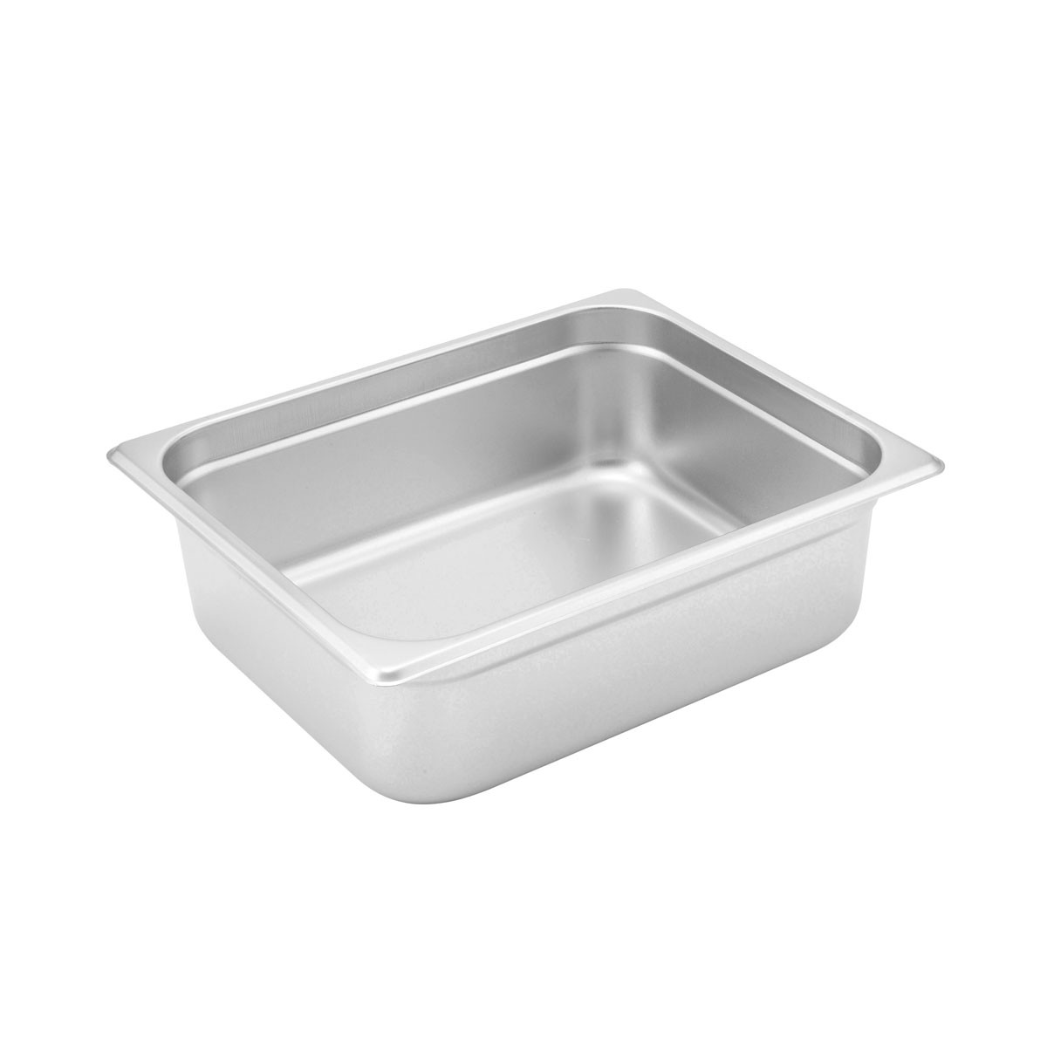
d.
- Hotel Pan
- Steam Table
- Sheet Pans

Match the following knife cuts: (1.4)
a. 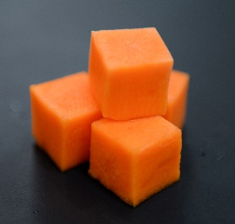
d.
b. 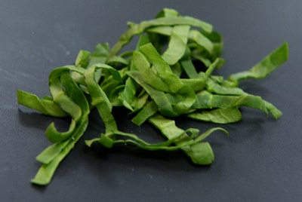
c. 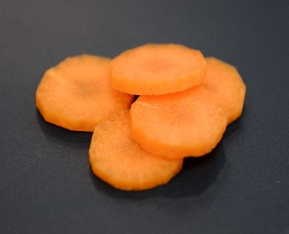
- Rondelle
- Dice
- Julienne
- Chiffonade

- The bodies inability to break-down or process food is considered a(n)… (4.1)
  - Diabetes
  - Intolerance
  - Anemia
  - Allergy

- Common food allergens include: (4.1)
  - Eggs, milk, nuts
  - Soy, wheat, onions
  - Seafood, broccoli, eggs
  - Milk, wheat, oranges

- Lipid is another name for… (4.1)
  - Protein
  - Carbohydrates
  - Fats and Oils
  - Fiber

Match the following with the definition: (4.2)
- Static, fixed a. non-commercial segment, rotates
- Cycle b. food available in the market
- Market c. still or unchanging

- Table d’ hote/Prix Fixe a. all food items offered all day
- A la Carte b. complete meal at one price
- California c. all items priced and ordered separately

- The action or business of promoting and selling products or services is…(5.1)
  - Clearance sale
  - Marketing
  - Retail
  - Wholesale

Read the scenario and answer the questions below:
In November 2011, Adam Terry had a dream of opening a restaurant. He had a small van and a kitchen. He has since turned this into over 9 brick and mortar restaurants and a fleet of food trucks called Waffle Love. Since 2012, the food truck industry has grown from a $615 million-dollar industry to a $2.7 billion-dollar industry.

- One of the reasons Waffle Love was so successful was the novelty of a food truck of Utah County. This is an example of a…(5.2)
  - Demographic
  - Trend
  - Farm to table restaurant
  - Rewards or loyalty program

- Another reason Waffle Love was so successful was the high number of college students that live in and around Utah County. These students were looking for new and innovate food experiences. This is an example of being aware of…(5.2)
  - Demographics
  - Community outreach
  - Schematic
  - Delineation

- Waffle Love uses social media to post locations of their food trucks and the hours of their store weekly. This is an example of…(5.2)
  - Demographics
  - Trends
  - Community Outreach
  - Advertising

- What food is prepared in the garde manger station of the kitchen? (7.1)
  - Pastries and desserts
  - Salads and sandwiches
  - Soups and sauces
  - Deep-fried and pan-fried foods

- True or False. For best quality, potatoes should be stored in the fridge. (7.1)
- True
- False

- True or False. To finish ripening fruits and vegetables, store at room temperature. (7.1)
- True
- False

- True or False. Most produce will last about a week if stored properly. (7.1)
- True
- False

- True or False. Wash your berries before you store them in the fridge. (7.1)
- True
- False

- Which of the following is NOT a method to prevent enzymatic browning? (7.1)
- Submerged in water
- Lemon juice/ascorbic acid
- Covered in salt
- Blanching

Match the cooking method with the cooking technique: (7.2)
- Boiling a. Dry heat
- Deep frying b. Moist heat
- Braising
- Sautéing
- Blanching

Match the types of salads with their uses: (7.2)
- Appetizer a. This should have a variety of nutrients
- Accompaniment b. A light salad served after the main course
- Main Dish c. A salad served at the end of the meal
- Separate-course/intermezzo d. Served with and compliments the main dish
- Dessert e. Served before the meal, this is designed to whet the
appetite.

- Which of the following is an example of an emulsifier in a salad dressing? (7.2)
- Mustard
- Egg whites
- Vinegar
- Oil

- Which of the following types of garnishes does NOT follow the proper garnishing techniques? (7.3)
  - Parsley
  - Bamboo stick
  - Chocolate curls
  - Carrot rosettes

