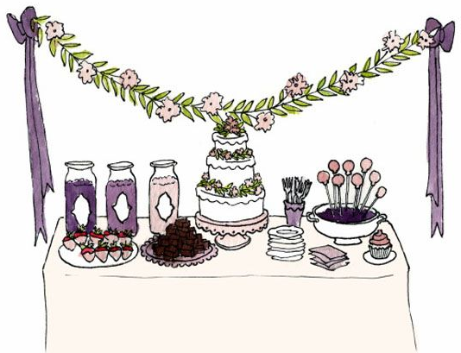
Performance Objective
Bakery Production Activity
Culinary Management

Period |  | Kitchen(s)
Team Members
You will need to come up with a bakery item to prepare and present to the faculty. Your group will need to create 30 bakery items – all the same using the concepts you learned in class.
Brainstorm
List all the ideas
presented by the group
Narrow it down
Choose the best 1-3 items from the list

Discuss the pros and cons of the items listed above. Can the item be made in the time frame of class? Does it require out of season food items? Do you think it will be enjoyed by the masses??

Choose your best food item to be prepared during class.
Teacher approval

Costing: Using the internet come up with the cost of item you are wanting to prepare.
Food Item | Amount Needed | Food Cost
TOTAL COST

Total cost ____________ divided by yield________ = cost per serving _____________

Supply List – include serving pieces, garnishes, etc….
Amount Needed | Food or supply item

Game plan – who is doing what on the day we prepare this food?

