Name:______________________________________ Period:_______

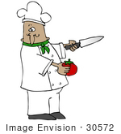

**Know your Knives!**

Match the knife type on the left with the common use on the right. Each letter will only be used once.

_____ 1. Fillet

_____ 2. Paring

_____ 3. Boning

_____ 4. Chef’s

_____ 5. Serrated

1. Separating raw meat from the bone
2. All-purpose especially for chopping slicing and mincing
3. Filleting fish
4. Peeling and trimming produce
5. Slicing bread, cake and similar items

Describe the following cuts:

Batonnet: __________________________________________________

Julienne: __________________________________________________

Brunoise: __________________________________________________

Dice: __________________________________________________

Chiffonade:__________________________________________________

Diagonal: __________________________________________________

Rondelle: __________________________________________________

Mince: __________________________________________________

Chop: __________________________________________________

|  |  |  |  |
| --- | --- | --- | --- |
| **In the following boxes show paper examples of all the cuts except mince and chop. Label each correctly.** |  |  |  |
|  |  |  |  |

Identify the following parts of this knife:

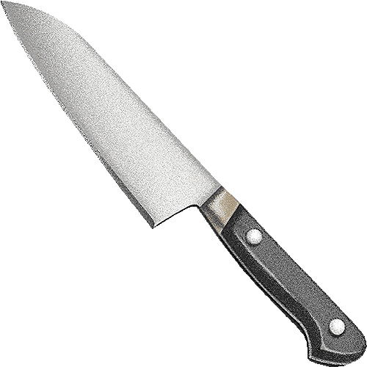_____________________________ A

_____________________________ B C _____________________________

D ____________________________

___________________________E F ____________________

_____________________________ G

____________________________ H

_____________________________ I

What are the 9 guidelines for knives?

1. _______________________________________________________

2. ______________________________________________________

3. _______________________________________________________

4. ______________________________________________________

5. _______________________________________________________

6. ______________________________________________________

7. _______________________________________________________

8. ______________________________________________________

9. ______________________________________________________