Names:____________________________________________________

Pastry Chef
Fill in the garnishing specifications for each of the three dessert items listed below. Include the type of plate or bowl to be used, how the food should be arranged, and any garnish you would use and where. Include a sketch of the dessert including the garnish and plate.

Chocolate Torte  Plate or Bowl?  Arrangement?  Garnish? Where? | Sketch
Vanilla Ice Cream  Plate or Bowl?  Arrangement?  Garnish? Where? | Sketch
Strawberry Shortcake  Plate or Bowl?  Arrangement?  Garnish? Where? | Sketch
Names:____________________________________________________

Food Stylist

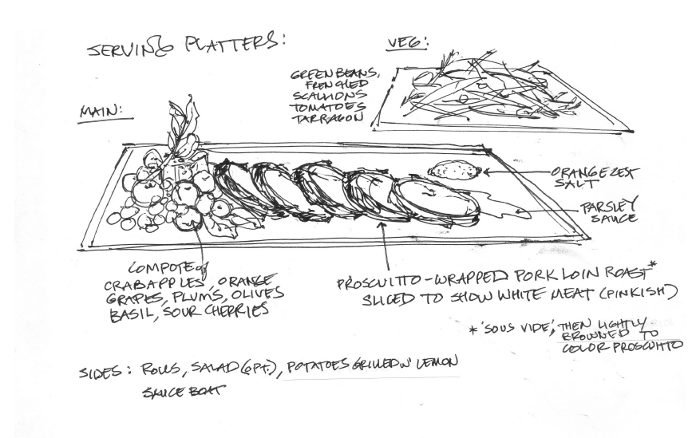
Using the food provided, style it and take a picture to be shared with the class. Submit your top 3 pictures to the teacher.
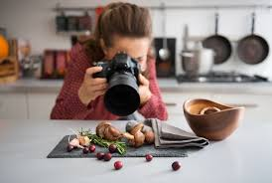

Names:____________________________________________________

Event Planner

You have been hired as an event planner to do a booth for FCCLA during club week at the school. You will need to design a booth for students to come and gather information about FCCLA. Your goal is to get students excited to join FCCLA. Your theme is _________________.

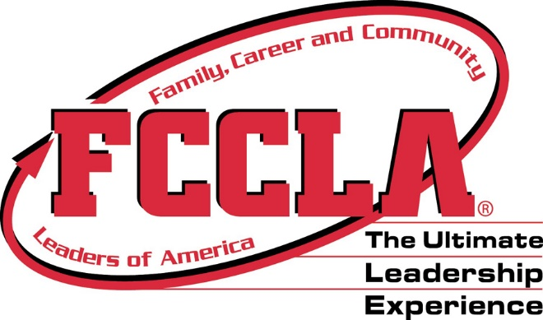
Guidelines and Supplies available:
6-8’ table
2 chairs
Poster board
Budget of $10.00
During lunch/FLEX
30-45 minute time period

In the given space below or on the back, create your design including all supplies needed.

Names:____________________________________________________

Registered Dietitian
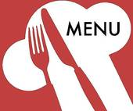
You have been hired to create a one-day meal plan for a diabetic. Your plan must include breakfast, lunch, dinner and a dessert snack. You will have the following food items that must be used somewhere in the meal: salmon, strawberries, salsa, spinach. Be creative!!!

Breakfast

Lunch

Dinner

Dessert Snack

Names:____________________________________________________

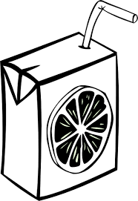
Food Scientist
Develop a 12-ounce beverage containing a minimum of ½ cup fruit or vegetables which appeals to high school students striving to incorporate more fruits and vegetables in their diet. Please include an ingredient list and produce the packaging for your product.

Supply list | Product Packaging
Names:____________________________________________________
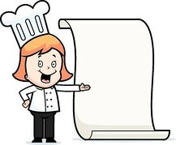
Executive Chef
As the executive chef you need to design and create a menu for an arena restaurant. You will need to include 2 appetizers, 2 entrée’s and 2 desserts. The food needs to be portable (able to eat in their laps) and made from scratch.

Appetizers | #1 | #2
Entrees | #1 | #2
Desserts | #1 | #2

