FOOD TRUCK FACE OFF

RECIPE BOOK

Competition Guidelines:
- Each group must use 15 Rhodes Rolls in their recipe.
- Each group will choose one recipe from this book.
- Each group must pass off their recipe choice and shopping list with the teacher.
- Each group may have up to 4 items purchased for their recipe from the grocery store, not including staple ingredients like sugar, flour, margarine and spices or the Rhodes Rolls. These items might include pizza sauce, frosting, cheese, beverages, etc. These ingredients will count toward the overall production cost.
- The group that earns the most profit from their business will win the competition.

Table of Contents

Cinnamon Snacks 3
Pizza Roll Ups 4
Cherry Kolachy 5
Snowflake Rolls 6
Cinnamon Crumble Pizza 7
Mini S’more Cupcakes 8
Honey Butter Rolls 9
Apple Turnovers 10
Cheesy Taco Flatbread 11
Yummy Mummy Dogs 12
Lemon Slice Cupcakes 13
Pumpkin Slice Cupcakes 14
Buttery Breadsticks 15
Soft Pretzels 16
Ham & Cheese Sliders 17
Personal Chicken Pot Pies 18
Breakfast Pizza 19
Lucky Lime Rolls 20
Butterscotch Bubble Bread 21
Mini Bear Claws 22
Basil Tomato Rolls 23
Butter Crumb Rolls 24
Cranberry Orange Sweet Rolls 25
Ham and Parmesan Rolls 26
Cheesy Bread Strips 27
Crunchy Chocolate Sticks 28
Meatball Muffins 29
Raspberry Cream Cheese Cupcakes 30

Cinnamon Snacks
Ingredients: | Type | Cost
15 Rhodes Rolls, thawed and risen | Staple | $1.65
1/2 c. margarine, melted | Staple | $0.25
1/2 c. brown sugar | Staple | $0.15
1 tsp. cinnamon | Staple | $0.04
1 tub vanilla frosting | Purchase From Store | $1.85
 | Total Cost: | $3.94

- Preheat the oven to 350°F.
- Cut each roll into 4 equal pieces. Roll each dough piece into a ball.
- Combine cinnamon and brown sugar in cereal bowl.
- Roll each dough ball in the melted butter. The, roll them in the cinnamon sugar mixture.
- Arrange each coated piece evenly on a sprayed cookie sheet.
- Bake at 350°F 20-25 minutes.
- While the cinnamon snacks are baking, place vanilla frosting in a cereal bowl and microwave for about 30 seconds, or until it reaches a glaze consistency.
- Remove the cinnamon snacks from the oven and drizzle glaze over warm cinnamon snacks, or use as a dip.

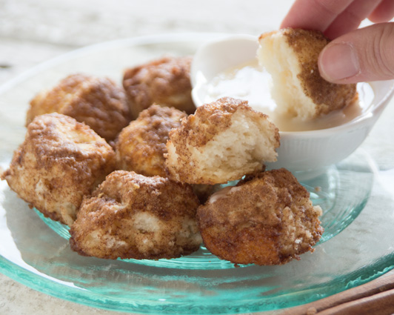

Pizza Roll Ups
Ingredients: | Type | Cost
15 Rhodes Rolls, thawed and risen | Staple | $1.65
8 string cheese sticks, cut into fourths | Purchase From Store | $2.64
1 pkg. pepperoni | Purchase From Store | $3.29
1 small jar pizza sauce | Purchase From Store | $1.99
1 tsp. Italian seasoning | Staple | $0.08
1/4 c. margarine, melted | Staple | $0.13
30 cupcake liners | Staple | $0.55
 | Total Cost: | $10.33

- Preheat the oven to 350°F.
- Place the cupcake liners in the muffin tins.
- Cut the string cheese sticks into 4 equal pieces.
- Using a pizza cutter, cut each Rhodes Roll in half. (You should now have 30 dough pieces.)
- Using a rolling pin, roll out each dough piece into a small circle.
- Spread a small amount of sauce in the center of the circle. Place 3 pieces of pepperoni and 1 small piece of cut string cheese in the center of the dough on top of the sauce.
- Bring the edges of the dough up and over the filling and then place the pizza roll ups open side down in the cupcake liners.
- Bake at 350°F 15-20 minutes or until golden brown.
- While rolls are baking, combine melted margarine and Italian seasoning in a custard cup.
- When rolls are finished baking, remove them from the oven and brush them with the melted margarine and Italian seasoning mixture.
- Serve with marinara or pizza sauce.

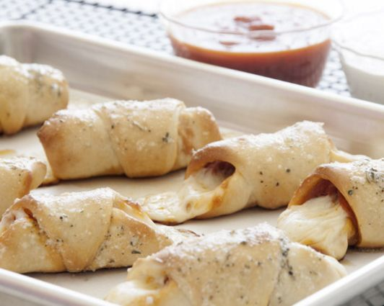

Cherry Kolachy
Ingredients: | Type | Cost
15 Rhodes Rolls, thawed and risen | Staple | $1.65
1 can cherry pie filling | Purchase From Store | $2.99
1 tub vanilla frosting | Purchase From Store | $1.85
 | Total Cost: | $6.49

- Preheat oven to 350°F.
- Cut each Rhodes Roll into two pieces. Flatten each dough piece into about a 2-inch circle. Place the circles on a large sprayed cookie sheet.
- With fingertips press indentation in the center of each roll. Spoon in about 1 tablespoon of pie filling into the center indentation of each roll.
- Bake immediately at 350°F for 15-20 minutes.
- Remove pan from oven and transfer the rolls to a cooling rack.
- Place vanilla frosting in a cereal bowl and microwave for about 30 seconds, or until it reaches a glaze consistency.
- Drizzle each roll with frosting glaze.

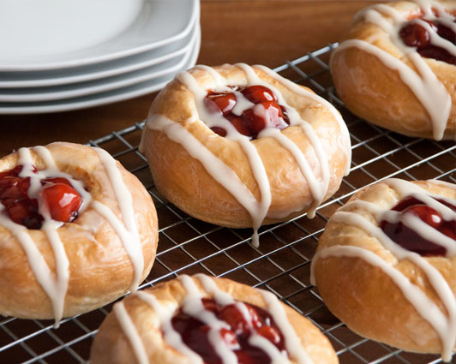

Snowflake Rolls
*Remind the teacher that your Rhodes Rolls must be placed on a regular cookie sheet to rise.
Ingredients: | Type | Cost
15 Rhodes Rolls, thawed and risen | Staple | $1.65
1/2 c. margarine, softened and divided in half | Staple | $0.25
1/4 c. flour | Staple | $0.05
1 Tbsp. water | Staple | FREE
 | Total Cost: | $1.95

- Preheat oven to 350°F.
- Allow the Rhodes Rolls to rise until doubled in size.
- In a cereal bowl melt 1/4 c. (half) of the margarine. Then, stir in flour and hot water and mix until smooth. Spoon mixture into a sandwich bag. Push the mixture down into one corner of the bag and snip off a very tiny corner.
- Draw a snowflake on the top of each roll with the margarine/flour mixture.
- Bake at 350°F for 15 minutes or until tops of rolls are golden.
- Melt the remaining 1/4 c. margarine in a custard cup. When the rolls are done baking and removed from the oven, brush the melted margarine on the top of the rolls.
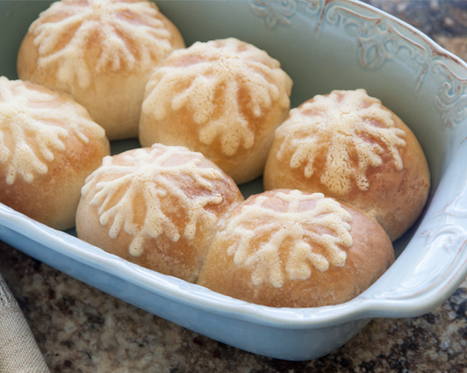

Cinnamon Crumble Pizza
Ingredients: | Type | Cost
15 Rhodes Rolls, thawed and risen | Staple | $1.65
1/4 c. margarine, divided in half | Staple | $0.13
1/2 c. sugar | Staple | $0.11
1 tsp. cinnamon | Staple | $0.06
1/4 c. flour | Staple | $0.03
1 tub of vanilla frosting | Purchase From Store | $1.85
 | Total Cost: | $3.83

- Preheat oven to 450°F.
- Combine sugar and cinnamon in a cereal bowl and mix together. Remove half of this mixture and put into a separate bowl and set aside.
- Combine all of the rolls and roll out into a large circle (about 12 inches). Place on a sprayed pizza pan.
- Cut the margarine in half and melt only 2 Tbsp. of it and brush it on the dough circle.
- Use one half of the cinnamon/sugar mixture and sprinkle over the melted margarine.
- To create the crumble topping, combine the remaining 2 Tbsp. of margarine (the margarine should still be solid, NOT melted), flour and cinnamon/sugar mixture. Use a pastry blender to cut in the margarine until the mixture is crumbly.
- Sprinkle the crumble topping over pizza and let rise for 10 minutes.
- Bake at 450°F 10-12 minutes.
- While the pizza is baking, place vanilla frosting in a cereal bowl and microwave for about 30 seconds, or until it reaches a glaze consistency.
- Transfer the frosting into a Ziploc bag and cut a small corner off to drizzle over the pizza when it is done baking.
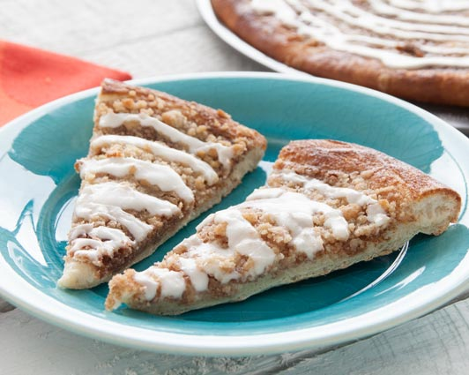

Mini S’more Cupcakes
Ingredients: | Type | Cost
15 Rhodes Rolls, thawed and risen | Staple | $1.65
1 c. milk chocolate chips | Purchase From Store | $1.24
2 c. mini marshmallows | Purchase From Store | $0.36
1/2 c. margarine | Staple | $0.25
15 cupcake liners | Staple | $0.28
 | Total Cost: | $3.78

- Preheat the oven to 350°F.
- Place the cupcake liners in the muffin tins.
- Cut the Rhodes Rolls into three pieces each. In a glass mixing bowl, melt only 1 cup of the mini marshmallows with the margarine in the microwave for 30 seconds. Set the other 1 cup of mini marshmallows aside.
- Stir the mixture. If all the marshmallows are not melted, put it back in the microwave for 15 more seconds. Remove and stir again until all of the marshmallows are melted and smooth.
- Put several roll pieces in the mixture and coat evenly. Repeat until all roll pieces are coated.
- Layer the S’mores Cupcakes with the following: 3 marshmallow coated roll pieces, chocolate chips, and miniature marshmallows.
- Pour any remaining marshmallow and butter mixture over each muffin cup.
- Bake at 350°F 12-15 minutes.
- Remove from oven and serve warm.
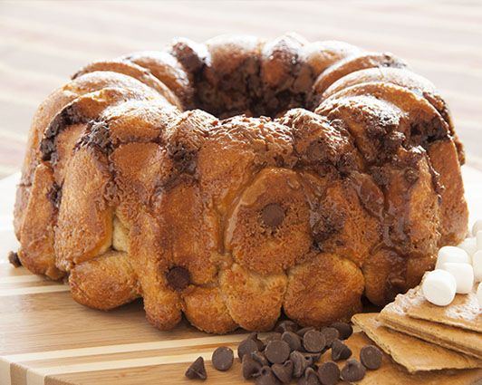

Honey Butter Rolls
Ingredients: | Type | Cost
15 Rhodes Rolls, thawed and risen | Staple | $1.65
1/2 c. margarine | Staple | $0.25
1/4 c. honey | Purchase From Store | $0.99
15 cupcake liners | Staple | $0.28
 | Total Cost: | $3.17

- Preheat the oven to 350°F.
- Place the cupcake liners in the muffin tins.
- Cut each roll into 3 pieces.
- In a small glass mixing bowl, melt the butter and honey together for about 30 seconds. Stir until smooth.
- Dip each dough piece into the honey butter mixture and place 3 pieces into each cup of a large sprayed muffin pan.
- Drizzle any leftover honey butter mixture over the rolls.
- Bake at 350°F 12-15 minutes.
- Remove from muffin pan and serve warm.
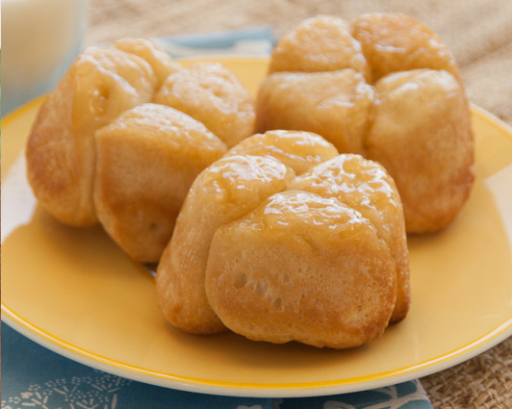

Apple Turnovers
Ingredients: | Type | Cost
15 Rhodes Rolls, thawed and risen | Staple | $1.65
1 can apple pie filling | Purchase From Store | $2.99
1/2 c. margarine | Staple | $0.25
1/2 c. sugar | Staple | $0.11
1 tsp. cinnamon | Staple | $0.06
 | Total Cost: | $5.06

- Preheat oven to 350°F.
- Cut each roll into two pieces. Using a rolling pin, roll each roll flat.
- Melt the margarine in a cereal bowl.
- Combine the sugar and cinnamon in separate cereal bowl.
- Spoon about 1 tablespoon of the pie filling into the center of each flattened roll. Fold one edge of the bread over the pie filling and the opposite edge over the first edge. Try to seal all the pie filling in the center so it doesn’t leak out while baking.
- Dip the filled rolls into the melted margarine, coating both sides then dip both sides into the cinnamon sugar mixture.
- Lay on sprayed cookie sheet with the seam side down.
- Bake at 350°F 15-20 minutes. Serve warm.
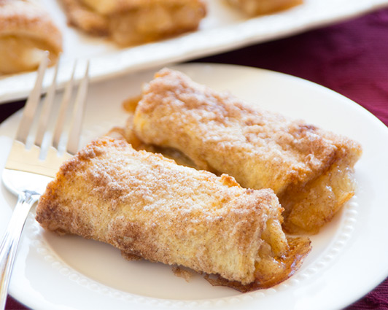

Cheesy Taco Flatbread
Ingredients: | Type | Cost
15 Rhodes Rolls, thawed and risen | Staple | $1.65
1/2 lb. ground beef | Purchase From Store | $1.99
1/2 pkg. taco seasoning | Purchase From Store | $0.34
1/2 c. water | Staple | FREE
1/2 c. grated cheddar cheese | Purchase From Store | $0.60
1/2 c. salsa | Purchase From Store | $0.49
 | Total Cost: | $5.07

- Preheat the oven to 350°F.
- Divide each roll into two pieces.
- Roll the dough pieces into circles with a rolling pin as thin as possible.
- Place the dough circles on a sprayed cookie sheet and bake for 10-15 minutes at 350°F.
- While the rolls are baking, brown hamburger meat in a large skillet. Drain the grease from the meat. Stir in taco seasoning and 1/2 c. water. Simmer for 5-10 minutes over low heat or until most of the water has cooked out.
- Top the flat bread circles with the warm meat mixture. Sprinkle the cheddar cheese and salsa on top of the meat and serve warm.

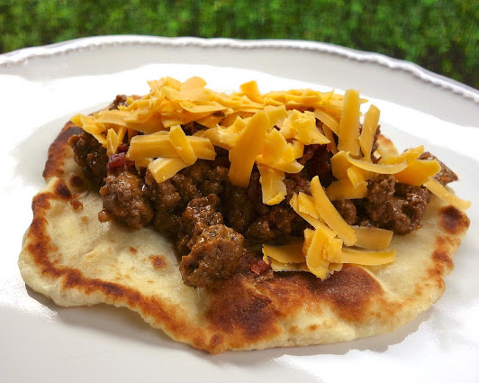

Yummy Mummy Dogs
Ingredients: | Type | Cost
15 Rhodes Rolls, thawed and risen | Staple | $1.65
2 pkg. hot dogs | Purchase From Store | $1.98
1/2 c. ketchup | Staple | $0.34
1/4 c. mustard | Staple | $0.17
 | Total Cost: | $4.14

- Preheat the oven to 350°F.
- For each Mummy Dog, cut each Rhodes Roll in half. Roll each half into a 22-24-inch rope.
- Cut a 1 1/2 inch piece off of the rope and wrap around the top of a hot dog.
- Wrap the long dough rope around the hot dog from the bottom up about 4 1/2 inches. Repeat this process for all hot dogs.
- Place Mummy Dogs on a sprayed baking sheet and bake at 350°F 10-15 minutes or until lightly browned.
- Remove from oven and cool slightly. Add mustard eyes and serve warm with ketchup and mustard.
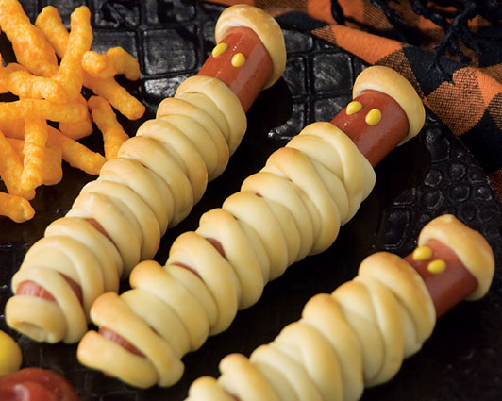

Lemon Slice Cupcakes
Ingredients: | Type | Cost
15 Rhodes Rolls, thawed and risen | Staple | $1.65
1/2 c. sugar | Staple | $0.11
3 lemons, zested and juiced | Purchase From Store | $2.07
1/4 c. margarine, melted | Staple | $0.13
2 oz. cream cheese, softened | Purchase From Store | $0.46
1/3 c. powdered sugar | Staple | $0.10
15 cupcake liners | Staple | $0.28
 | Total Cost: | $4.80

- Preheat oven to 350°F.
- Place the cupcake liners in the muffin tins.
- Cut each Rhodes Roll into three pieces and roll each piece into a ball.
- Using a zester, zest the lemons over a small plate. Be sure to only grate off the yellow part of the peel. Try to not to grate too much of the white part of the peel.
- In a cereal bowl, combine the sugar and lemon zest. Rub the sugar mixture with your fingers to distribute the lemon zest through the sugar.
- Melt the margarine in a custard cup.
- Dip each dough ball into the melted butter and then press into the sugar/zest mixture. Place three pieces of the dough into the cupcake liners of the muffin tin.
- Bake at 350°F 12-15 minutes. Cover the pan with foil for the last 5 minutes, if necessary, to prevent over browning.
- While cupcakes are baking, use and electric mixer to prepare the glaze by mixing the cream cheese, 2 to3 Tbsp. of the lemon juice and powdered sugar together until it forms a glaze consistency.
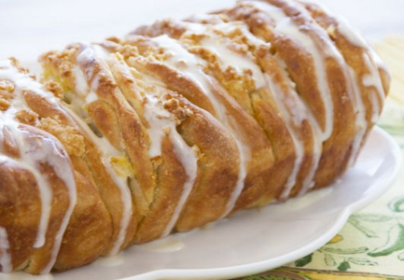
- When cupcakes are done, remove them from the oven and the pan and drizzle the glaze on top of each cupcake.

Pumpkin Slice Cupcakes
Ingredients: | Type | Cost
15 Rhodes Rolls, thawed and risen | Staple | $1.65
1/4 c. margarine, melted | Staple | $0.13
1/2 c. sugar | Staple | $0.15
1 tsp. cinnamon | Staple | $0.06
1/4 tsp. nutmeg | Staple | $0.03
3/4 c. canned pumpkin | Purchase From Store | $1.09
1 tub cream cheese frosting | Purchase From Store | $1.85
15 cupcake liners | Staple | $0.28
 | Total Cost: | $5.51

- Preheat the oven to 350°F.
- Place the cupcake liners in the muffin tins.
- Cut each Rhodes Roll into three pieces and roll each piece into a ball.
- Combine melted margarine, sugar, cinnamon and nutmeg in a cereal bowl.
- Place the canned pumpkin into a separate cereal bowl. Dip each dough ball into the pumpkin to coat all sides. Then, dip each pumpkin covered dough ball into the sugar mixture.
- Place 3 dough balls into the paper cupcake liners in the muffin tin.
- Bake at 350°F 12-15 minutes. Cover the pan with foil for the last 5 minutes, if necessary, to prevent over browning.
- While cupcakes are baking, place cream cheese frosting in a cereal bowl and microwave for about 30 seconds, or until it reaches a glaze consistency.
- When cupcakes are done baking, remove them from the oven and the muffin tins and drizzle with the glaze.
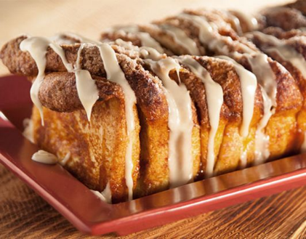

Buttery Breadsticks
Ingredients: | Type | Cost
15 Rhodes Rolls, thawed and risen | Staple | $1.65
1/2 c. margarine, melted | Staple | $0.25
1 c. parmesan cheese, grated | Purchase From Store | $2.52
1/2 tsp. garlic salt | Staple | $0.04
 | Total Cost: | $4.46

- Preheat oven to 350°F.
- Roll each Rhodes Roll into a 6-inch rope.
- Place margarine in a custard cup and melt. Place the parmesan cheese in a separate cereal bowl.
- Dip each rope into butter and then roll in the Parmesan cheese.
- Place the breadsticks on a sprayed backing sheet. Sprinkle each breadstick with the garlic salt.
- Allow the breadsticks to rise for about 10 minutes.
- Bake at 350°F for 15-20 minutes or until golden brown.

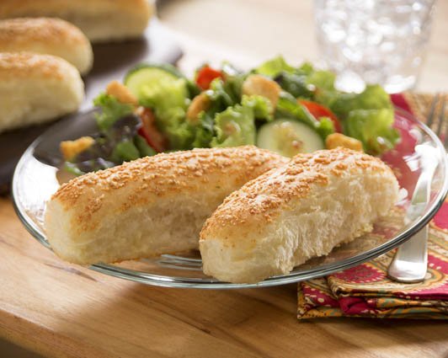

Soft Pretzels
Ingredients: | Type | Cost
15 Rhodes Rolls, thawed and risen | Staple | $1.65
1/4 c. margarine, melted | Staple | $0.13
1 Tbsp. coarse salt | Staple | $0.15
1 can of nacho cheese | Purchase From Store | $2.79
 | Total Cost: | $4.69

- Preheat the oven to 375°F.
- Roll each Rhodes Roll into a long rope. Form into a pretzel shape. Repeat with remaining rolls and place on large sprayed baking sheet.
- Melt margarine in a custard cup. Brush melted butter on top of each pretzel and then sprinkle with the coarse salt.
- Bake at 375°F for 15-20 minutes or until golden brown.
- Serve with nacho cheese.

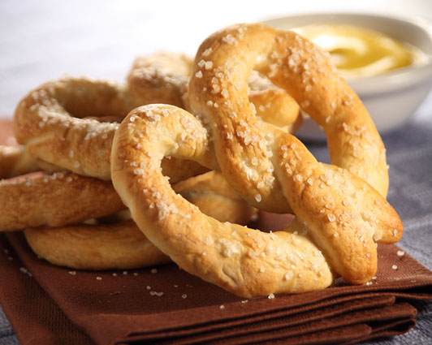

Ham & Cheese Sliders
*Remind the teacher that your Rhodes Rolls must be placed on a regular cookie sheet to rise.
Ingredients: | Type | Cost
15 Rhodes Rolls, thawed and risen | Staple | $1.65
8 slices of ham, cut in half | Purchase From Store | $2.69
8 slices of provolone cheese, cut in half | Purchase From Store | $2.69
1/4 c. mayonnaise | Staple | $0.20
2 Tbsp. margarine | Staple | $0.06
 | Total Cost: | $7.29

- Preheat the oven to 350°F.
- Allow the Rhodes Rolls to rise until doubled in size.
- Bake the Rhodes Rolls at 350°F for 15-20 minutes, or until golden brown.
- Cut each roll in half and spread the halves with the mayonnaise.
- Place the ham and cheese on one half of the roll and then place the other half of the roll on top.
- Melt the margarine in a custard cup and brush the tops of the sliders with the melted butter.
- Return the sliders to the oven for 3 more minutes to melt the cheese. Serve warm.

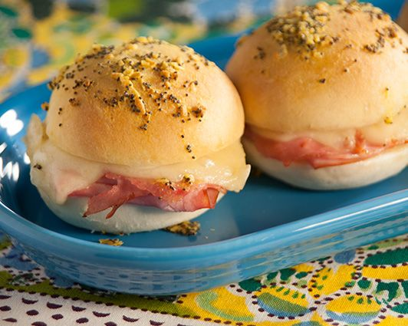

Personal Chicken Pot Pies
Ingredients: | Type | Cost
15 Rhodes Rolls, thawed and risen | Staple | $1.65
1 large can of chicken | Purchase From Store | $2.79
1 1/2 c. frozen vegetables | Purchase From Store | $0.44
1 can cream of chicken soup | Purchase From Store | $0.79
1/8 tsp. salt | Staple | $0.01
1/8 tsp. pepper | Staple | $0.01
1/2 c. shredded cheddar cheese | Purchase From Store | $0.60
15 cupcake liners | Staple | $0.28
 | Total Cost: | $6.57

- Preheat the oven to 350°F.
- Place the cupcake liners in the muffins tins.
- Flatten each roll into a 6-7 inch circle. Cover with plastic wrap and let rest.
- Open and drain the chicken. Place it in a large mixing bowl and use a fork to break up the chunks until the chicken is shredded.
- Add the vegetables and soup and mix well. Add the salt and pepper to season.
- Remove the plastic wrap from the dough and press each dough circle into the bottom and up the sides of the cupcake liners in the muffin tin.
- Divide the chicken mixture evenly between the dough cups. Sprinkle the tops with grated cheese.
- Slightly fold the edges of the dough back onto the filling.
- Bake at 350°F for 15-18 minutes. Remove from the muffin tins and serve warm.
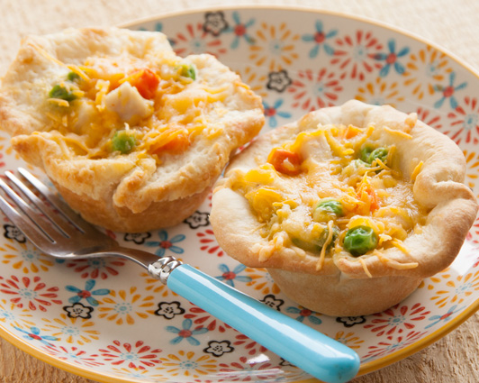

Breakfast Pizza
Ingredients: | Type | Cost
15 Rhodes Rolls, thawed and risen | Staple | $1.65
12 eggs | Purchase From Store | $1.99
2 c. shredded cheddar cheese | Purchase From Store | $2.40
1 pkg. bacon bits | Purchase From Store | $2.59
1/8 tsp. salt | Staple | $0.01
1/8 tsp. pepper | Staple | $0.01
1/2 c. salsa | Purchase From Store | $0.49
 | Total Cost: | $9.14

- Preheat the oven to 375°F.
- Flatten each Rhodes Roll into a 5-inch circle. Repeat with remaining rolls to make mini pizza crusts. Place the dough circles on a large sprayed baking sheet. Poke each one several times, with a fork, to prevent bubbles from forming.
- Bake at 375°F for 10-15 minutes or until lightly browned. Remove from oven and set aside, but keep them on the cookie sheet.
- In a small bowl, whisk the eggs, salt and pepper together. Spray cooking spray in a skillet and add the eggs. Sprinkle the bacon over the eggs.
- Cook and stir over medium heat until eggs are softly scrambled.
- Spread each mini pizza crust with 1-2 Tbsp. of salsa. Sprinkle each pizza. Spoon the scrambled eggs on top of the sauce and then sprinkle with the shredded cheese.
- Return the breakfast pizzas to the oven for about 5 minutes, or until the cheese is melted and bubbly. Remove from the oven and serve warm.

Lucky Lime Rolls
*This recipe requires additional rising time outside of class. Choose this recipe only if the entire group can commit to coming in early to prepare this recipe.
Ingredients: | Type | Cost
15 Rhodes Rolls, thawed and risen | Staple | $1.65
1 lime, zested and juiced | Purchase From Store | $0.29
1/2 c. sugar | Staple | $0.10
1/4 c. margarine, melted | Staple | $0.13
1 tub vanilla frosting | Purchase From Store | $1.85
2-3 drops green food coloring | Staple | $0.02
 | Total Cost: | $4.04

- Preheat the oven to 350°F.
- Using one roll, cut off a small piece of dough for the stem and press the rest of the roll into a 4-inch circle.
- Make 3 leaves by cutting the circle almost all the way through, into thirds like a pizza, leaving the pieces attached in the center. Clip each leaf at the top to make a dip in the top of the leaf. You want each roll to resemble a shamrock.
- Combine the lime zest and sugar in a cereal bowl. Melt the margarine in a separate cereal bowl. Dip the cut and clipped dough circle carefully in the melted margarine and then into the sugar/zest mixture.
- Place the dough circle on a sprayed baking sheet, separating the leaves so they don't touch. Roll the cut off piece into a stem and dip it in the margarine and sugar/zest. Place the stem under the center of the shamrock and press in place. Repeat the process with the remaining rolls.
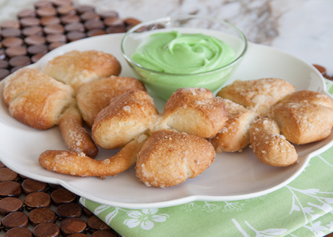
- Cover the rolls with plastic wrap and let rise about 45 minutes.
- Remove the plastic wrap and bake at 350°F for 10-12 minutes or until golden brown.
- While the rolls are baking, combine the vanilla frosting, lime juice and green food coloring together in a small mixing bowl. Serve the frosting as a dip.

Butterscotch Bubble Bread
Ingredients: | Type | Cost
15 Rhodes Rolls, thawed and risen | Staple | $1.65
1 box butterscotch pudding mix, non-instant | Purchase From Store | $1.29
1/2 c. brown sugar | Staple | $0.15
1/2 c. margarine | Staple | $0.25
15 cupcake liners | Staple | $0.28
 | Total Cost: | $3.62

- Preheat the oven to 350°F.
- Place the cupcake liners in the muffin tins.
- Cut each Rhodes Roll into 3 pieces. Dip each piece into the dry pudding mix to coat them.
- Place 3 roll pieces into each cupcake liner in the muffin tin. Sprinkle 1 tsp. of the pudding mix over the top of the rolls.
- Combine the brown sugar and margarine together in a cereal bowl and place in the microwave. Heat this mixture for about 1 ½ to 2 minutes until the butter is melted. Stir this mixture until a syrup is formed.
- Pour about 1 Tbsp. of this syrup over the rolls until it is evenly distributed.
- Bake at 350°F for 12-15 minutes. Cover with foil the last 5 minutes of baking to prevent overbrowning.
- Immediately after baking, loosen the rolls from sides of the muffin tin with a knife and serve warm.

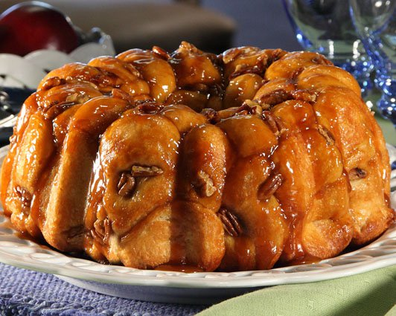

Mini Bear Claws
Ingredients: | Type | Cost
15 Rhodes Rolls, thawed and risen | Staple | $1.65
1/4 c. margarine, softened | Staple | $0.13
1/2 c. brown sugar | Staple | $0.15
1/2 c. semi-sweet chocolate chips | Purchase From Store | $0.74
1/4 c. shredded coconut | Purchase From Store | $0.26
1 egg, beaten | Staple | $0.16
 | Total Cost: | $3.09

- Preheat the oven to 350°F.
- Roll each roll out into a 3 to 4-inch circle.
- In a small mixing bowl, combine margarine and brown sugar until well combined and fluffy in texture. Add the chocolate chips and shredded coconut and stir together.
- Place about 1-2 tbsp. of the mixture in the middle of each roll.
- Moisten edges of the dough with a tiny amount of water. Fold the roll in half over the filling and press edges to seal tightly. Place the rolls on sprayed cookie sheet.
- Using kitchen scissors, snip the sealed edge of each roll 4-5 times to make claws. Try not to clip into the filling.
- In a custard cup, beat the egg and then brush the egg over the top of each roll.
- Bake at 350°F for about 12-15 minutes, or until golden brown.

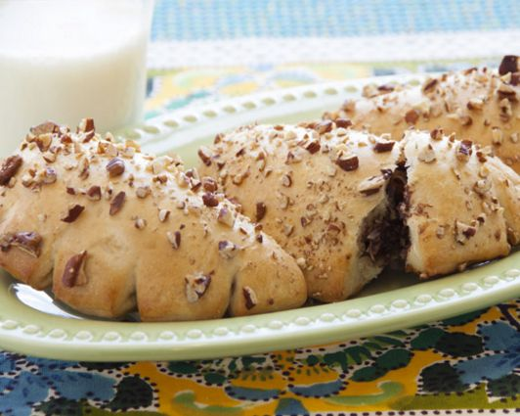

Basil Tomato Rolls
Ingredients: | Type | Cost
15 Rhodes Rolls, thawed and risen | Staple | $1.65
1/4 c. fresh basil, chopped | Purchase From Store | $2.99
1 c. Parmesan cheese, shredded | Purchase From Store | $2.38
1/4 c. olive oil | Staple | $0.79
2 tsp. pepper | Staple | $0.08
4 medium tomatoes, chopped and seeded | Purchase From Store | $1.29
1/4 tsp. sugar | Staple | $0.01
12 cupcake liners | Staple | $0.22
 | Total Cost: | $9.32

- Preheat the oven to 350°F.
- Place the cupcake liners in the muffin tin.
- Combine all the Rhodes Rolls together and roll out into a large rectangle about 12 x 18-inches. Let rest while you prepare the other ingredients.
- Cut each of the tomatoes into wedges and remove and discard the insides containing the seeds. Then, chop the rest of the tomato into small pieces.
- Place the chopped tomatoes, 1 tsp. of the pepper and the sugar in a small mixing bowl and stir to combine.
- Mince the fresh basil leaves until they are in very fine pieces.
- In a small mixing bowl, combine the basil, Parmesan cheese, olive oil and the other 1 tsp. of the pepper.
- Spread the basil mixture over the dough rectangle. Begin rolling one long edge of the dough jelly roll style and then cut the roll into 12 equal pieces.
- Distribute the tomato mixture in the paper liners of the muffin tin. Place the basil filled rolls, cut side down, on top of the tomato mixture in each cup of the paper liners.
- Bake at 350°F for about 15-20 minutes. Cover with foil the last 5 minutes of baking to prevent over browning.
- Cool for about 5 minutes and then serve warm.
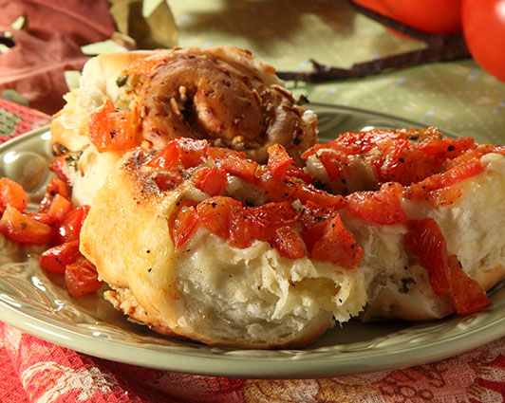

Butter Crumb Rolls
Ingredients: | Type | Cost
15 Rhodes Rolls, thawed and risen | Staple | $1.65
1/2 c. Italian style bread crumbs | Purchase From Store | $0.16
1/4 c. margarine, melted | Staple | $0.13
30 cupcake liners | Staple | $0.55
 | Total Cost: | $2.49

- Preheat the oven to 350°F.
- Place the cupcake liners in the muffin tins.
- Divide each roll into two pieces. Roll into round balls and place in the paper liner of the muffin tins.
- Allow the rolls to rise for about 10-15 minutes.
- Melt the margarine in a custard cup. Brush the melted margarine on the tops of each roll.
- Sprinkle the rolls with the Italian style bread crumbs.
- Bake at 350°F for 15-20 minutes, or until golden brown.

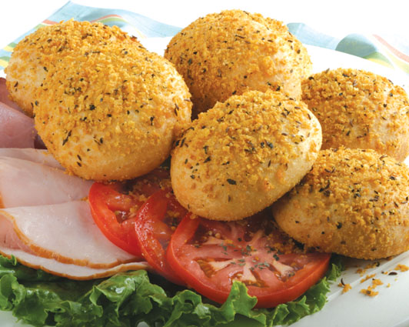

Cranberry Orange Sweet Rolls
Ingredients: | Type | Cost
15 Rhodes Rolls, thawed and risen | Staple | $1.65
3/4 c. orange marmalade | Purchase From Store | $1.70
1/2 c. dried cranberries | Purchase From Store | $1.24
1 c. powdered sugar | Staple | $0.19
1 orange, zested and juiced | Purchase From Store | $1.59
12 cupcake liners | Staple | $0.22
 | Total Cost: | $6.59

- Preheat the oven to 350°F.
- Place the paper cupcake liners in the muffin tin.
- Combine all the Rhodes Rolls together and roll out into a large rectangle about 12 x 18-inches.
- Spread the orange marmalade evenly over the dough. Then, sprinkle with the dried cranberries.
- Begin rolling one long edge of the dough jelly roll style and then cut the roll into 12 equal pieces.
- Place the cut side down into the cupcake liners in the muffin tin.
- Bake at 350°F for about 15-20 minutes or until golden brown.
- While the rolls are baking, combine the powdered sugar, orange zest and orange juice together in a cereal bowl. It should be the consistency of a light glaze. Add 1 tsp. of water if needed until the frosting is a glaze consistency.
- Remove the rolls from the oven and remove the rolls from the pan quickly. Drizzle the glaze over the rolls and serve warm.
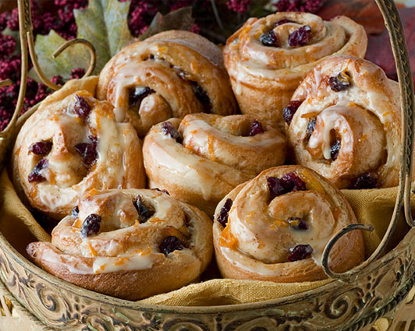

Ham and Parmesan Rolls
Ingredients: | Type | Cost
15 Rhodes Rolls, thawed and risen | Staple | $1.65
1 c. diced ham | Purchase From Store | $3.19
1 c. Parmesan cheese, grated | Purchase From Store | $2.52
1/2 tsp. salt | Staple | $0.02
2 Tbsp. margarine | Staple | $0.06
12 cupcake liners | Staple | $0.22
 | Total Cost: | $7.66

- Preheat the oven to 350°F.
- Place the cupcake liners in a muffin tin.
- Place diced ham, Parmesan cheese and salt together in a medium sized mixing bowl.
- Cut each Rhodes Roll into 4 pieces and add to the ham mixture.
- Once all rolls are cut, knead the mixture with your hands to thoroughly combine the dough with the ham mixture until it is evenly distributed.
- Combine the dough and roll it into a large log shape.
- Divide the dough into 12 pieces and roll each of the pieces into a ball.
- Place the dough balls into the cupcake liners of the muffin tin.
- Bake at 350°F for 15-20 minutes, or until golden brown.
- While the rolls are baking, melt the margarine in a custard cup.
- Remove the rolls from the oven and brush each roll with the melted butter. Serve warm.
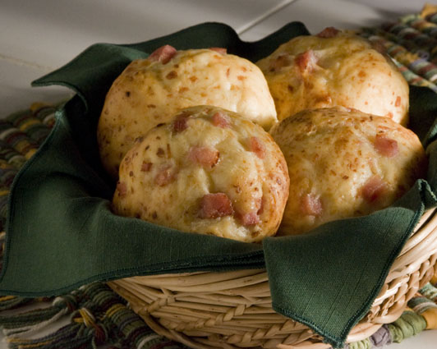

Cheesy Bread Strips
Ingredients: | Type | Cost
15 Rhodes Rolls, thawed and risen | Staple | $1.65
1/4 c. margarine, melted | Staple | $0.13
1 c. mozzarella cheese, grated | Purchase From Store | $1.19
1/3 c. parmesan cheese, grated | Purchase From Store | $0.94
1/2 tsp. red pepper flakes | Staple | $0.03
1 jar pizza sauce (for dipping) | Purchase From Store | $1.99
 | Total Cost: | $5.93

- Preheat the oven to 350°F.
- Combine all of the Rhodes Rolls and knead together. Roll the dough out into a 12 x 20 inch rectangle. Place the dough onto a sprayed cookie sheet.
- Melt the margarine in a custard cup. Brush the dough with the melted margarine.
- Sprinkle the mozzarella cheese, parmesan cheese and red pepper flakes on top of the dough evenly.
- Bake at 350°F for 12-15 minutes or until golden brown.
- Remove from the oven and cut into strips with the pizza cutter.
- Serve with the pizza sauce as a dip.

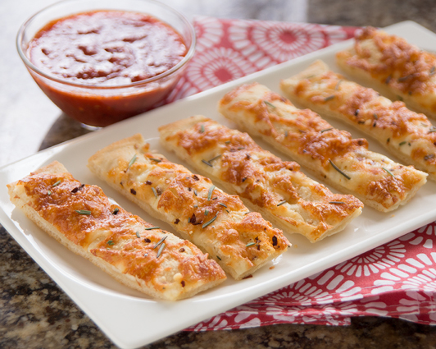

Crunchy Chocolate Sticks
Ingredients: | Type | Cost
15 Rhodes Rolls, thawed and risen | Staple | $1.65
1 pkg. milk chocolate chips, melted | Purchase From Store | $2.48
1 pkg. white chocolate chips, melted | Purchase From Store | $2.98
 | Total Cost: | $7.11

- Preheat the oven to 400°F.
- Cut each Rhodes Roll in half. Roll each piece of dough into a 10-inch stick.
- Place the breadsticks onto a sprayed cookie sheet. Do not allow the breadsticks to touch so that they become crispy all around.
- Bake at 400°F for 15-20 or until golden brown. Cool the breadsticks completely. (You might want to transfer the sticks to a large plate or tray and place them in the refrigerator to help them cool more quickly.)
- While the breadsticks are baking and cooling, place the milk chocolate chips and the white chocolate chips in separate small glass mixing bowls. Heat the chocolate in the microwave for about 30 seconds at a time until they begin to melt. Stir after every 30 seconds. Be careful not to burn the chocolate.
- When the breadsticks are cool, drizzle both of the melted chocolates over the breadsticks with a spoon.
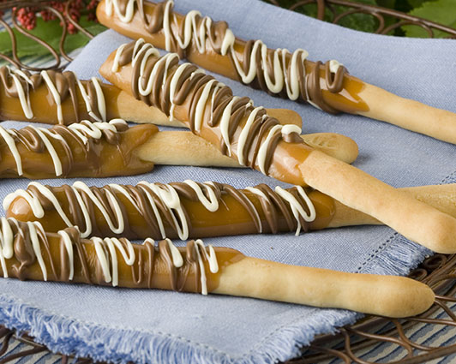

Meatball Muffins
Ingredients: | Type | Cost
15 Rhodes Rolls, thawed and risen | Staple | $1.65
15 frozen meatballs, cooked | Purchase From Store | $1.95
5 mozzarella string cheese, cut into thirds | Purchase From Store | $1.65
1 jar pizza sauce | Purchase From Store | $1.99
2 Tbsp. margarine | Staple | $0.06
1 tsp. Italian seasoning | Staple | $0.08
15 cupcake liners | Staple | $0.28
 | Total Cost: | $7.66

- Preheat the oven to 350°F.
- Place the cupcake liners in the muffin tins.
- Place the frozen meatballs on a large plate and place them in the microwave. Cook them on high for about 3-4 minutes, or until they are fully cooked.
- Cut the mozzarella string cheese sticks into 3 pieces each. Then, cut each piece in half lengthwise. (You should now have 30 pieces of cheese.)
- Flatten each Rhodes Roll into a 5 inch circle. Place 1 Tbsp. of pizza sauce in the center of each circle. Place a meatball on top of the sauce in the center of the dough circle.
- Place a piece of string cheese on each side of the meatball. Pull the dough up around the filling to completely enclose and pinch to seal shut.
- Place the dough balls seam side down into the paper liners in the muffin tins.
- Melt the margarine in a custard cup and stir in the Italian seasoning. Brush the margarine on the top of each dough ball.
- Bake at 350°F for 20-25 minutes. Serve with leftover pizza sauce as a dip.
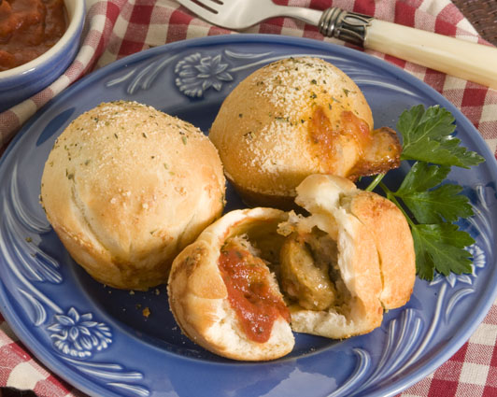

Raspberry Cream Cheese Cupcakes
Ingredients: | Type | Cost
15 Rhodes Rolls, thawed and risen | Staple | $1.65
8 oz. cream cheese, softened | Purchase From Store | $1.89
1/2 c. sugar | Staple | $0.11
1/2 tsp. almond extract | Staple | $0.10
1/2 c. raspberry jam | Purchase From Store | $1.06
1 1/2 c. powdered sugar | Staple | $0.29
2-3 tbsp. water | Staple | FREE
30 cupcake liners | Staple | $0.55
 | Total Cost: | $5.65

- Preheat the oven to 375°F.
- Place the cupcake liners in the muffin tins.
- Combine the cream cheese, sugar and almond extract and blend until smooth.
- Cut each Rhodes Roll in half. Roll each piece into a 5 inch circle. Evenly distribute the cream cheese filling in the center of each dough circle. Try to keep the filling away from the outside edges of the dough.
- Evenly distribute the raspberry jam on top of the cream cheese mixture for each roll. Pull the dough up around the filling to completely enclose and pinch to seal shut.
- Place the dough balls seam side down into the paper liners in the muffin tins.
- Bake 375°F for 15-20 minutes, or until golden brown.
- While cupcakes are baking, combine the powdered sugar and water, (one tbsp. at a time), in a small mixing bowl. Mix the icing until it reaches a thin consistency best to drizzle.
- Remove the cupcakes from the oven and remove from the muffin tins. Drizzle the tops with the icing.
