Create a complete clothing design for your model including shirt, pants, shoes, and/or accessories. Write a brief description of the clothing garment and a cost for the item. In the space below the description, create a design label/logo for your line. Do not include your name in it.
Item Description | Cost

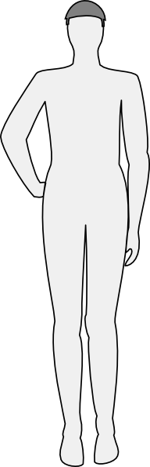
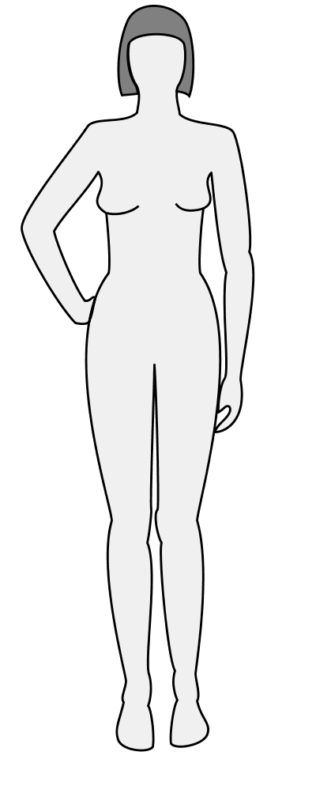
Create a complete clothing design for your model including shirt, pants, shoes, and/or accessories. Write a brief description of the clothing garment and a cost for the item. In the space below the description, create a design label/logo for your line. Do not include your name in it.
Item Description | Cost

