FCCLA MEMBER APPLICATION AND CONTRACT
As a member of Canyon View J.H. FCCLA, I agree to carry out the following responsibilities (check off):
Time Commitment
- Attend all meetings (1st and 3rd Tuesday) of each month
- FCCLA Opening Social (October)
- FCCLA Awards Gala (May)
- Complete a STAR Event for the 2013-2014 year**(optional, but strongly encouraged)
Code of Conduct Commitment
- Represent Canyon View FCCLA with pride and dignity. It is my responsibility to display a positive public image and promote the organization.
- Fulfill the duties of my membership by following through with assignments and participating in activities
- Be an example of an effective leader
- No N’s or U’s in Citizenship, and no D’s or F’s in my grades in order to participate in state or area activities that take me away from the classroom
- I will keep up with my school work if I miss class due to FCCLA trips
Professional Dress Commitment
I will follow the required dress code for all meetings as outlined below:
- Chapter Meetings: normal school clothes (Canyon View dress code)
- Chapter Activities: FCCLA t-shirt (school dress code)
- Area and State FCCLA meetings and trips: Business professional dress REQUIRED! No jeans, no flip flops, school appropriate
Membership Dues:
- I will pay the $20 dues by Nov 1, 2013 (privileges include t-shirt, official membership, local, state and national affiliation, Teen Times magazine subscription, chapter meetings and activities at the school, monthly newsletters, eligible to go on FCCLA trips)

MEMBER AGREEMENT
I have read and understand the information required for being a member of FCCLA and will carry out all responsibilities as outlined in this contract to the best of my ability.

__________________________________________________________________________Date:________________________
Member’s signature
Please circle your T-shirt size: S M L XL Other:_________
(If you want a sweatshirt, it is $20 extra)

PARENT AGREEMENT
I have reviewed this contract with my son/daughter and understand it. I will support my son/daughter as a member of Canyon View Jr. High FCCLA to carry out the above responsibilities and commitments.

__________________________________________________________________________Date:_________________________
Parent/Guardian’s signature
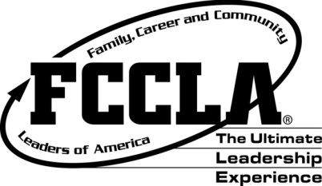
CANYON VIEW JUNIOR HIGH FCCLA
MEMBER APPLICATION

Welcome! We are so happy to have you as a member of FCCLA! Please note a few reminders:
- You can still participate in other school activities (sports, music, drama, etc…)
- If you sign up to help with something, please follow through
- All members will participate in at least one community service project, and complete a unit of Power of One (set a goal and achieve it!)
- You are a leader in this school, so represent FCCLA and Canyon View well
- Any work missed due to FCCLA activities or trips must be made up
- No D’s or F’s, and no U’s or N’s in citizenship
- You are going to have so much fun and do good things!
Name:
Grade:
Phone Number:
Parent/Guardian Name:
Parent/Guardian Phone Number:
Address:
Student Email:
Parent Email:

