Dear Potential FCCLA Member and Parents,
Family, Career and Community Leaders of America
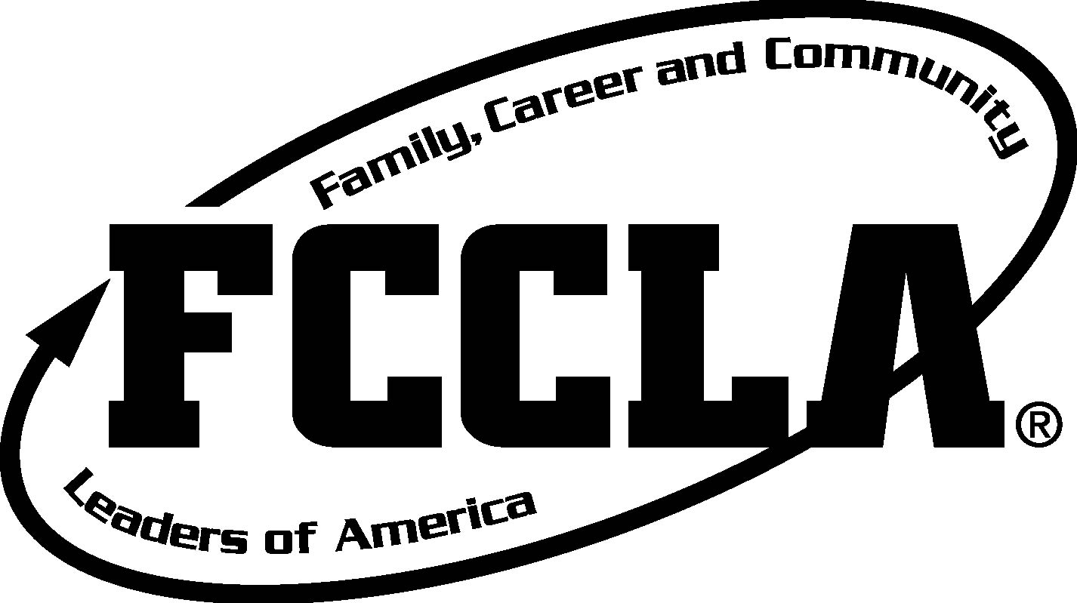
First of all, welcome to Canyon View Junior High’s FCCLA program. FCCLA is a Career and Technical Student Organization based on the Family and Consumer Science (FACS) curriculum. It is a national organization of over 200,000 members with the family as its focus.
Your student is interested in being a member of this fantastic organization. I can personally speak for its benefits to their educational career, because I, too, was a member of FCCLA—beginning in junior high. There are so many opportunities for leadership, character growth and development, community service and career preparation. I wouldn’t be who I am today or where I am today without my experiences in FCCLA.
As an added bonus, there are so many scholarships available with FCCLA, FACS Education and CTE (Career and Technical Education). I hope you and your student consider carefully what they can pursue in order to qualify for these financial opportunities.
There are a few financial costs related to membership in FCCLA:
- Dues: $20 (covers state and national dues, member t-shirt, Teen Times subscription, eligibility to compete in events, participate in members-only activities, etc…)
- *Fall Leadership: $20 (FCCLA officers will attend Fall Leadership in order to learn more about their roles as FCCLA chapter officers, leading a school organization, and helping make our chapter succeed)
- *Regionals/State STAR Events: the competitive portion of FCCLA is called STAR Events (Students Taking Action with Recognition). We do our best to fundraise in-school for the registration costs, but there are some other itinerant costs related. These will be addressed as students qualify for regionals/state competition.
I do not want you to see these costs and say “Nope! Not now!” Though I wish our school could afford to pay for everything all the time, we don’t have that luxury.
My parents taught me early on if I wanted to be involved in student organizations that required costs for different activities that I had to work for it. So I did. I encourage you to provide opportunities for your child to earn the money, instead of just giving it to them. It will make them more dedicated to the organization and feel the value of their hard work.
Thank you for your support, and please contact me if you have any questions!
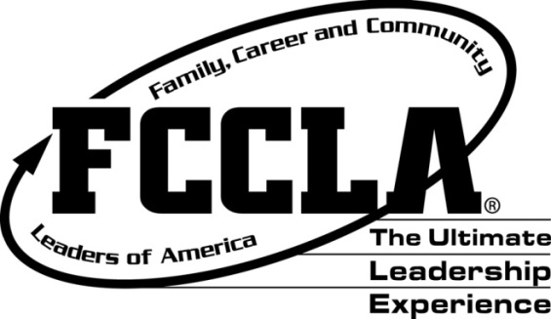
My cell phone # is: 385-208-1309. My email is mmilburn@alpinedistrict.org
Sincerely,
Mrs. Milburn

