Name:
Class:
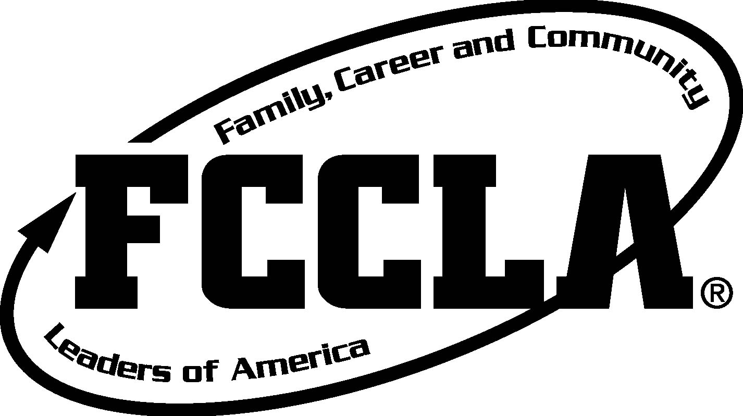
FINAL EVAL
POWER OF ONE
- What was your goal:

- Which POWER of ONE unit does your goal fall under? (circle)
A Better You Family Ties Working on Working
Take the Lead Speak Out for FCCLA
- Was your goal SMART? Describe how it meets the 5 criteria:
- Specific:
- Measurable:
- Attainable:
- Realistic:
- Timely:
- Did anyone help you with your goal? How did you treat them? Did anyone hinder you from achieving your goal?

- Describe your effort in achieving your goal:

- What challenges did you face with your goal?

- What successes did you experience with this goal?

- If you could do this project all over again, what would you do? (Be specific, tell me about the goal, how would you achieve it and why it’s important to you?)

- What advice do you have for future FACS students who will do the Power of One project?

