 Why Join

# C:\Users\shaylee\Pictures\FCCLA BROCHURE\logo.jpg

FCCLA?

* Develops career skills and learn to balance career and family responsibilities.
* Strengthen home and family life
* Prepare for community living as responsible citizens
* Improve self-esteem
* Practice and apply creative and critical thinking
* Understand themselves and their relationships with others.

Our mission is to promote personal growth and leadership development through family and consumer sciences education.

For more information contact your FCCLA state advisor or national FCCLA at…

[www.fcclainc.org](http://www.fcclainc.org)

For information on open positions or to submit your resume, please visit our Web site at: www.lucernepublishing.com

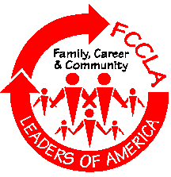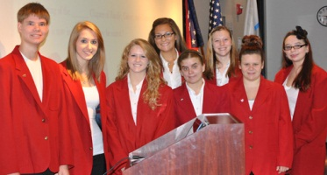

We are the Family, Career and Community Leader of America.

We face the future with warm courage and high hope.

For we have the clear consciousness of seeking old and precious values.

For we are the builders of homes, homes for America’s future. Homes where living will be the expression of everything that is good and fair.

Homes where truth and love and security and faith will be realities, not dreams.

We are the Family, Career and Community leaders of America.

We face the future with warm courage and hope.

FCCLA Nation Programs

* Career Connection
* Community Service
* Dynamic Leadership
* FACTS (Families Acting for Community Traffic Safety)
* Families First
* Financial Fitness
* Japanese Exchange
* Leaders at Work
* Power of One
* Star Events
* Stop the Violence
* Student Body

What is FCCLA?

FCCLA is a nonprofit national career and technology student organization for young men and women in family and consumer sciences education in public and private schools.