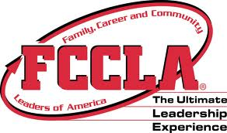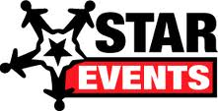

Mission

To promote personal growth and leadership development through family and consumer sciences education. Focusing on the multiple roles of family member, wage earner and community leader, members develop skills for life through: carater development, creative and critical thinking, interpersonal communication, practical knowledge and vocational preparation.

**F**amily

**C**areer

AND

**C**ommunity

**L**eaders

OF

**A**merica

Alexandra Hansen

FCCLA

# FCCLA is a non profit national career and technology student organization for young men and women in family consumer sciences education in public and private schools.

# FCCLA is great for students!!

# It helps develop career skills and learn to balance career and family

# Strengthen home and family life

# Prepare for living in a community as a responsible citizen

# Improve self esteem

# Practice and apply critical thinking

The Goals and Opportunities:

1. Provide opportunities for personal development and preparation for adult life.
2. Strengthen the function of the family as a unit of society
3. Encourage democracy through cooperative action in the home and community.
4. Encourage individual and group involvement in helping achieve global cooperation and harmony.
5. Promote greater understanding between youth and adults
6. Provide opportunities for making decisions and for assuming responsibilities
7. Prepare for the multiple roles of men and women’s in today’s society
8. Promote family and consumer sciences relation occupations

FCCLA has a variety of national programs to guide and motivate students as they develop projects related to the family and consumer sciences standards. It is the only in-school student organization with the family as its central focus. There goal is to get people out in the community.

http://fcclainc.org