

Why should you join FCCLA?

FCCLA National Headquarters

1910 Association Dr.

Reston, VA  20191

(703) 476-4900

www.fcclainc.org

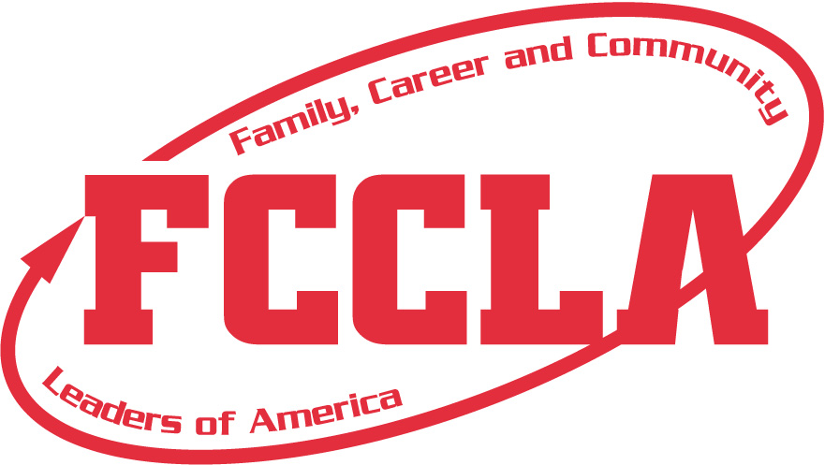

FCCLA offers many great opportunities for personal growth and improvement. You will have the chance to be in leadership positions and participate in many service projects. Your interpersonal skills will grow and you will be better prepared for job interviews. You will gain a greater knowledge of Family and Consumer Sciences and you will know how to make a difference in your community.





**Toward New Horizions**

What are star events?

STAR events (Students Taking Action with Recognition) offer individual skill development and application of learning through cooperative, individualized, or competitive activities. Some areas of STAR events include:

* Career Investigation
* Chapter Showcase
* Culinary Arts
* Early Childhood
* Entrepreneurship
* Environmental Ambassador
* Fashion Design
* Food Innovations
* Illustrated Talk
* Interior Design
* Interpersonal Communications
* Job Interview
* Leadership
* Life Event Planning
* Nutrition and Wellness
* Parliamentary Procedure
* Recycle and Redesign
* Teach and Train
* Applied Technology

What is fccla?

FCCLA stands for Family, Career and Community Leaders of America. FCCLA is a nonprofit national career and technology student organization for young men and women in family and consumer sciences education in public and private schools. It helps young men and women become leaders and address important personal, family, work and societal issues through family and consumer sciences education. Involvement in FCCLA offers members the opportunity to expand their leadership potential and develop skills for life-planning, goal setting, problem solving, decision-making and interpersonal communication-necessary in the home and workplace.

**What are the goals of FCCLA?**

* To provide opportunities for personal development and preparation for adult life
* To strengthen the function of the family as a basic unit of society
* To encourage democracy through cooperative action in the home and community
* To encourage individual and group involvement in helping achieve global cooperation and harmony
* To promote greater understanding between youth and adults
* To provide opportunities for making decisions and for assuming responsibilities
* To prepare for the multiple roles of men and women in today’s society
* To promote Family and Consumer Sciences and related occupations

What opportunities are offered through FCCLA?

FCCLA offers a variety of service opportunities, as well as competitive events which include: Family and Consumer Sciences Knowledge Bowl, Skill Demonstration Events and STAR Events. FCCLA also offers National programs to guide and motivate students as they develop projects related to the family and consumer sciences national standards. Some of the national programs are:

* Career Connection
* Community Service
* Dynamic Leadership
* The Power of 1
* Financial Fitness
* Leaders at work