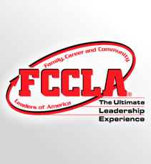
Join FCCLA!
By taking and Family and Consumer Sciences Education course, students are eligible to join. By joining, students are able to be in a leadership position and be apart of a club.

Teachers can join as well!
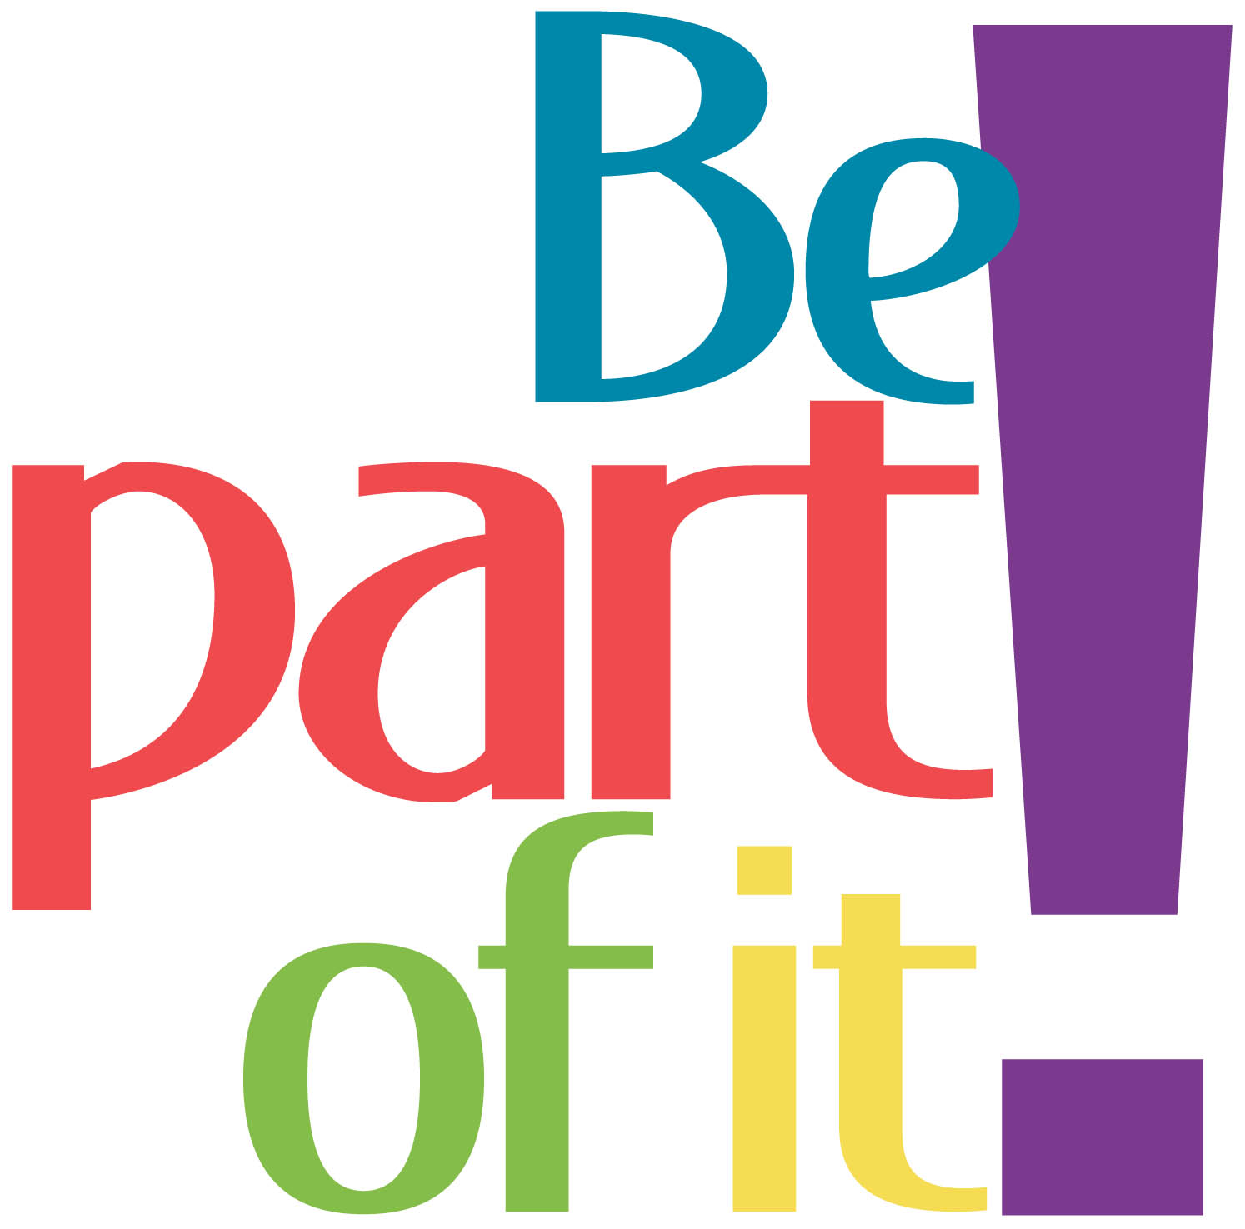
FCCLA National Headquarters
1910 Association Dr.
Reston, VA 20191
(703) 476-4900
(800) 234-4425
Fax: (703) 860-2713
www.fcclainc.org

FCCLA is a nonprofit national career and technology student organization for young men and women in family and consumer sciences education in public and private schools.

FCCLA helps students develop career skills and learn to balance career and family responsibilities, strengthen home and family, prepare for community living as responsible citizens, experience the connection between career and technical and academic skills improve self-esteem, practice and apply creative and critical thinking, and understand themselves and their relationships with others.

FCCLA
Family, Career and Community
Put yourself in charge of your future! Enhance your job skills and gain valuable on-site work experience.
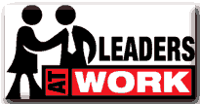
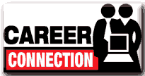
Learn how to explore career path ways and skills for success in families, careers, and communities.

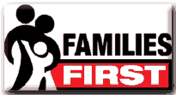
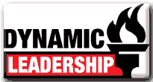
Take action in your community and discover the difference you can make.
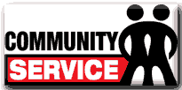
Ignite the fire of Dynamic Leadership! Try new leadership experiences and investigate exciting topics through interactive participation in various programs.
FCCLA is a dynamic and effective national student organization that helps young men and women become leaders and address important personal, family, work and societal issues through family and consumer sciences education.
Put the brakes on impaired driving and traffic crashes. Through peer education help your friends arrive alive and lower the number one cause of death for youth in America.

FCCLA is the only in-school student organization with the family as its central focus.
Discover how you can strengthen family relationships through FCCLA’s national peer education program, Families First

It provides opportunities for active student participation at local, state, and national levels.
Experience another culture and develop independence while living with a Japanese host family.

It’s goals are to: help youth become strong family members and leaders for today and tomorrow and strengthen the family as the basic unit of society.
Manage your money! Use this program to help you make, save, and spend your money wisely to be financially fit.
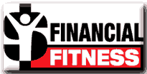

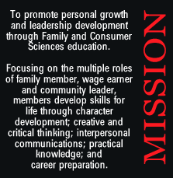
Empower youth with attitudes, skills, and resources to recognize report, and reduce youth violence.
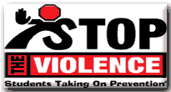
Give yourself the power to make a positive change in your families, careers, and communities, one goal at a time.

Eat right, be fit, and make healthy choices
