

Family, Career and Community Leaders of America

The Ultimate Leadership Experience

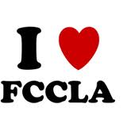

PLACE PHOTO HERE, OTHERWISE DELETE BOX

### It helps students:

* develop a personal leadership style
* have fun through shared group experiences
* understand themselves and their relationships with others
* develop a wider circle of friends
* prepare for community living as a responsible citizen
* experience the satisfaction of helping others
* develop employability skills
* identify concerns, make decisions, and carry out activities
* improve home and family ties
* explore the changing roles of men and women
* gain recognition for accomplishments
* work cooperatively with teachers in an informal atmosphere

So……. why join FCCLA?

More Questions?

**CONTACT US**

**Email us at:**

Affiliations - [affiliation@fcclainc.org](mailto:affiliations@fcclainc.org)

Comp. Events -[competitiveevents@fcclainc.org](mailto:competitiveevents@fcclainc.org)

Meetings - [meetings@fcclainc.org](mailto:meetings@fcclainc.org" \t "_blank)

Membership - [membership@fcclainc.org](mailto:membership@fcclainc.org" \t "_blank) Program Awards - [progawards@fcclainc.org](mailto:progawards@fcclainc.org) STAR Events - [starevents@fcclainc.org](mailto:starevents@fcclainc.org" \t "_blank)

Teen Times - [teentimes@fcclainc.org](mailto:teentimes@fcclainc.org)

1910 Association Dr.

Reston, VA  20191

(703) 476-4900

(800) 234-4425

Fax:  (703) 860-2713 [www.fcclainc.org](http://www.fcclainc.org/)

FCCLA National Headquarters

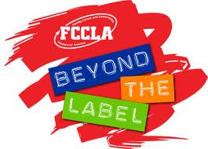

PLACE PHOTO HERE, OTHERWISE DELETE BOX

Kaitlin Durfey

FCSE 2510

MISSION

To promote personal growth and leadership development through Family and Consumer Sciences education. Focusing on the multiple roles of family member, wage earner and community leader, members develop skills for life through: character development, creative and critical thinking, interpersonal communication, practical knowledge, and career preparation.

PURPOSES

1. To provide opportunities for personal development and preparation for adult life.
2. To strengthen the function of the family as a basic unit of society.
3. To encourage democracy through cooperative action in the home and community.
4. To encourage individual and group involvement in helping achieve global cooperation and harmony.
5. To promote greater understanding between youth and adults.
6. To provide opportunities for making decisions and for assuming responsibilities.
7. To prepare for the multiple roles of men and women in today's society.
8. To promote Family and Consumer Sciences and related occupations.

JUST FYI

The colors are red and white. **Red** symbolizes strength, courage, and determination; personal qualities leading to happiness through a positive self-image. **White** symbolizes sincerity of purpose and integrity of action; qualities that help individuals build a better tomorrow.

The red rose represents the organization because it gives joy through its beauty and fragrance. It symbolizes a desire for beauty in everyday living.



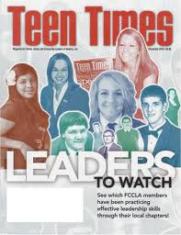

PLACE PHOTO HERE,

OTHERWISE DELETE BOX

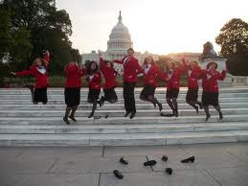

PLACE PHOTO HERE,

OTHERWISE DELETE BOX

Everyone requires different opportunities to help him/her discover their potential.   An assortment of programs and projects are available through FCCLA to provide these opportunities.

* Power of One
* Step One
* STAR Events - (Students Taking Action for Recognition)
* Honor Roll
* FACTS - (Families Acting for Community Traffic Safety)
* Financial Fitness
* Student Body
* Scholarships
* Families First
* Community Service
* Leaders at Work
* Japanese Exchange Program
* Career Connection
* Cluster Meeting
* National Leadership Conference

The possibilities are endless!