What is FCCLA?
Family, Career and Community Leaders of America is a nonprofit national career and technical student organization for young men and women in Family and Consumer Sciences education in public and private school through grade 12. Everyone is part of a family, and FCCLA is the only national Career and Technical Student Organization with the family as its central focus. Since 1945, FCCLA members have been making a difference in their families, careers, and communities by addressing important personal, work, and societal issues through Family and Consumer Sciences education. FCCLA provides opportunities for active student participation at local, state, and national levels.

Why Join FCCLA?
Here’s a list of what
we can do for you!
- Provide opportunities for personal development and preparation for adult life
- Strengthen the function of the family as a basic unit of society
- Encourage democracy through cooperative action in the home and community
- Promote greater understanding between youth and adults
- Provide opportunities for making decisions and for assuming responsibilities.
- Promote family and consumer sciences and related occupations

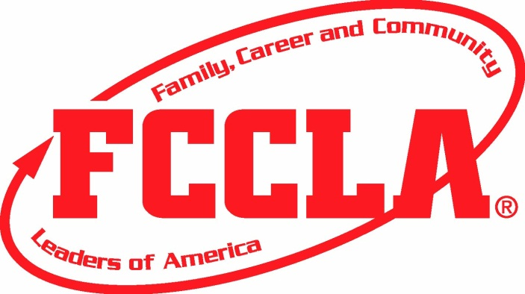

Mission
To promote personal growth and leadership development through Family and Consumer Sciences education. Focusing on the multiple roles of family member, wage earner and community leader, members develop skills for life through: character development, creative and critical thinking, interpersonal communication, practical knowledge, and career preparation.

For More Information
Please Contact
Kari Williams
kariwill@live.com
801-618-8848

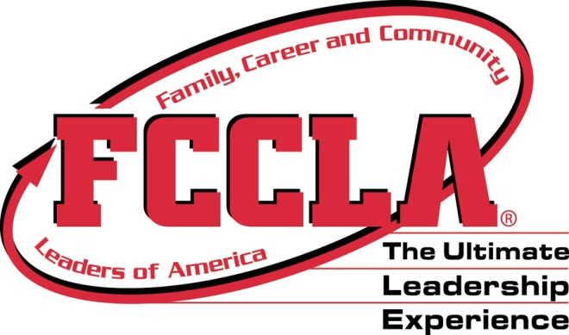

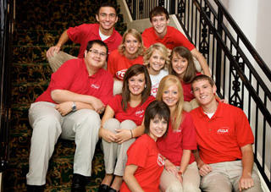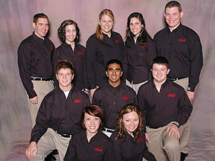
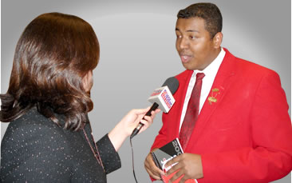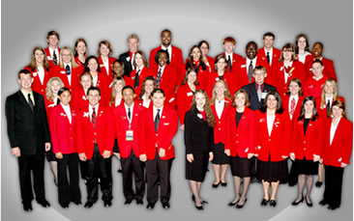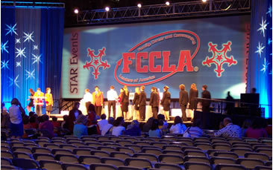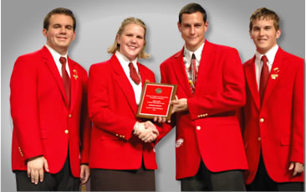

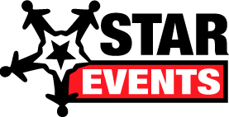

STAR (Students Taking Action with Recognition) Events are competitive events in which members are recognized for proficiency and achievement in chapter and individual projects, leadership skills, and career preparation. STAR Events offer individual skill development and application of learning through the following activities:

Cooperative:
Teams work to accomplish specific goals.
Individualized:
An individual member works alone to accomplish specific goals
Competitive:
Individual or team performance measured by an established set of criteria.

EVENTS INCLUDE:
Parliamentary Procedure; Advocacy; Career Investigation; Fashion Design; Chapter Service Project; Culinary Arts; Hospitality, Tourism, and Recreation
And more!
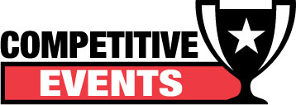

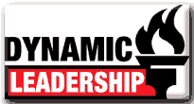 | Ignite the fire of Dynamic Leadership! Try new leadership experiences and investigate exciting topics through interactive participation in various programs. | 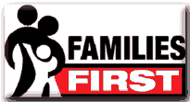 | Discover how you can strengthen family relationships through FCCLA's national peer education program, Families First.
 | Learn how to explore career pathways and skills for success in families, careers, and communities. |  | Take Action in your community and discover the difference you can make.
 | Put yourself in charge of your future! Enhance your job skills and gain valuable on-site work experience. |  | Give yourself the power to make a positive change in your families, careers, and communities, one goal at a time.
 | Manage your money! Use this program to help you make, save, and spend your money wisely to be financially fit. |  | Experience another culture and develop independence while living with a Japanese host family.
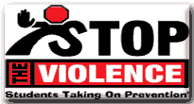 | Empower youth with attitudes, skills, and resources to recognize, report, and reduce youth violence. | 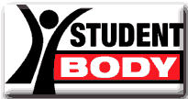 | Eat right, be fit, and make healthy choices.
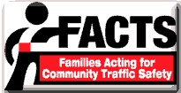 | Put the brakes on impaired driving and traffic crashes. Through peer education help your friends arrive alive and lower the number one cause of death for youth in America.

