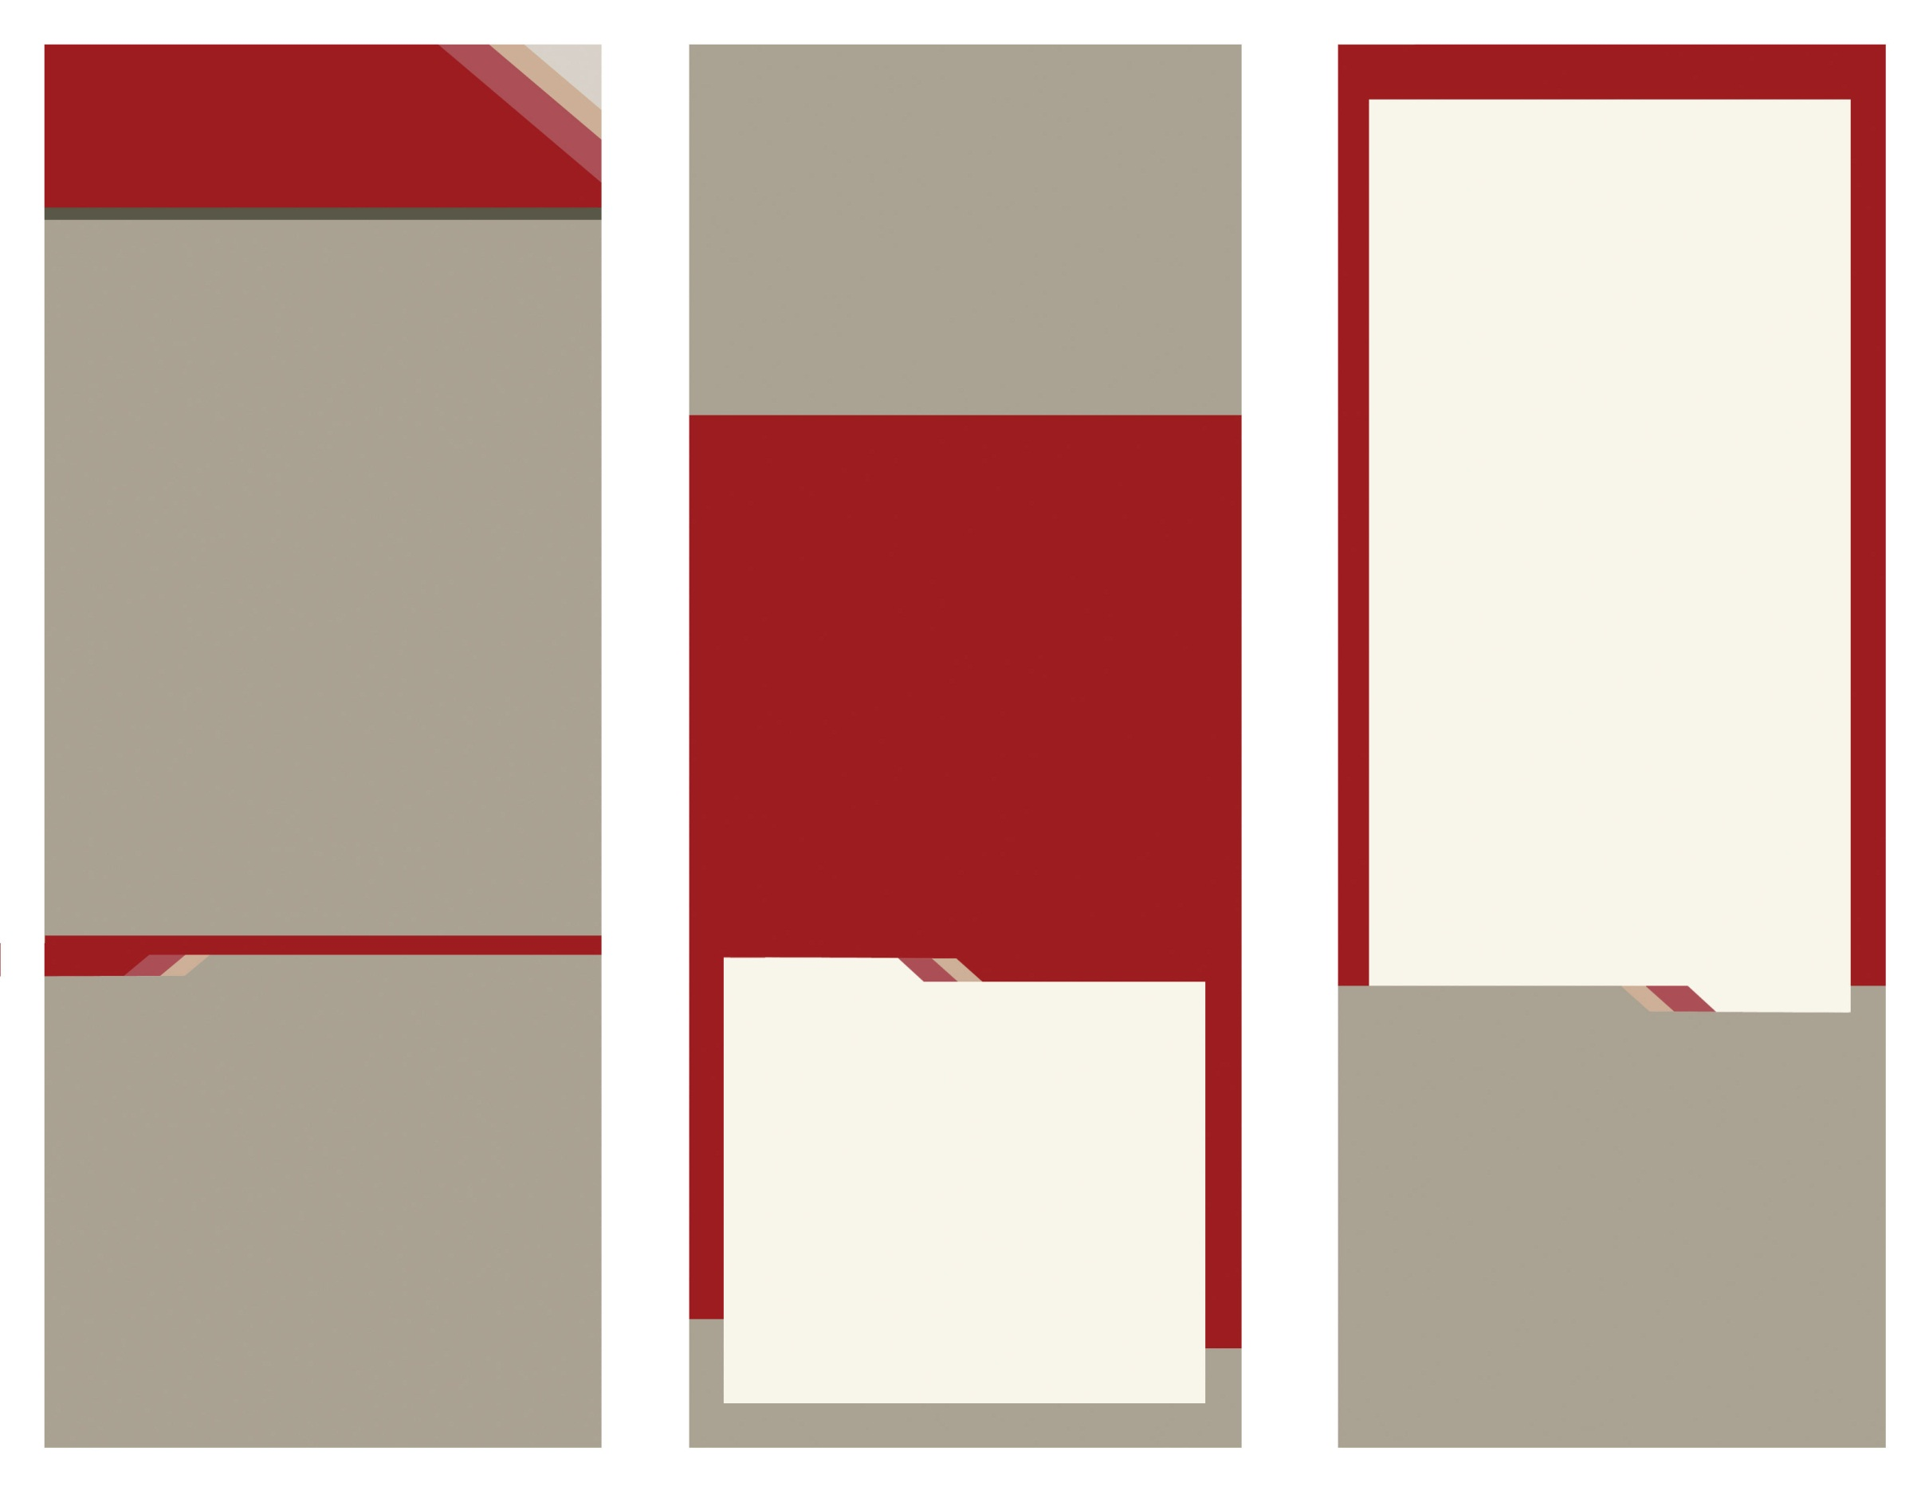

Opportunities

National Outreach Project

Competitive Events

Career Connection

Community Service

Dynamic Leadership

FACTS-Families Acting for Community Traffic Safety

Families First

Financial First

Financial Fitness

Power of One

STOP the Violence-Students Taking on Prevention

Student Body

FCCLA

Samantha Kirby

435.757.1665

samantha.kirby@aggiemail.usu.edu

Please contact me for more information!

Mission

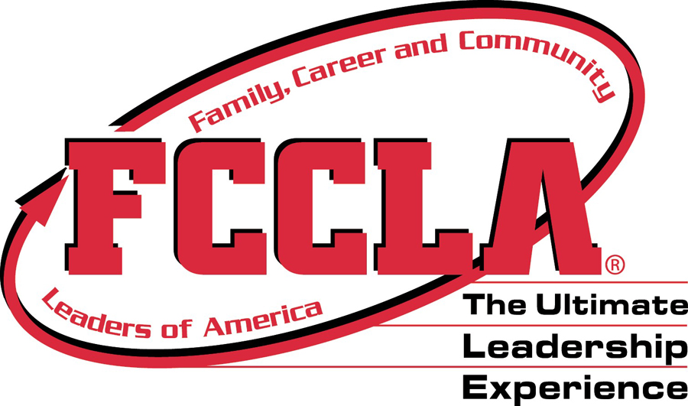

Enter Contact Information Here | 1127 Lombard Blvd. San Francisco, CA 59802 | phone 555.555.5555 | fax 555.555.5555

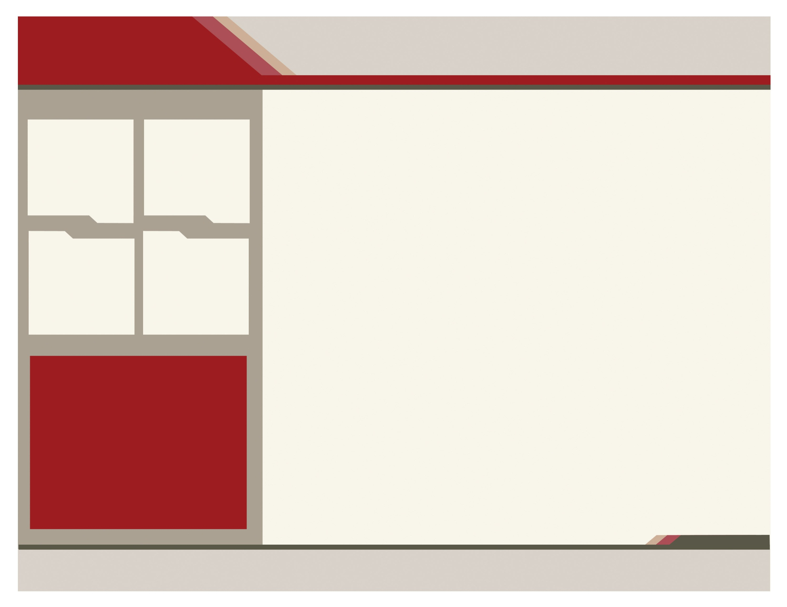

Take a look inside to see what you could be a part of!

The FCCLA Membership Kit! is your guide to kicking off your year with a bang! Packaging will include the Join FCCLA! poster. To request this kit please email membership@fcclainc.org or call 1-800-234-4425.

To promote personal growth and leadership development through Family and Consumer Sciences education.

Focusing on the multiple roles of family member, wage earner and community leader, members develop skills for life through character development; creative and critical thinking; interpersonal communications; practical knowledge; and career preparation.

Today over 205,000 members in nearly 6,500 chapters are active in a network of associations in 50 states, including the Virgin Islands and Puerto Rico. Chapter projects focus on a variety of youth concerns, including teen pregnancy, parenting, family relationships, substance abuse, peer pressure, environment, nutrition and fitness, teen violence, and career exploration. Involvement in FCCLA offers members the opportunity to expand their leadership potential and develop skills for life -- planning, goal setting, problem solving, decision making, and interpersonal communication -- necessary in the home and workplace.

www.fcclainc.org

Why you want to join us:

Leadership is a primary focus of FCCLA. As students take responsibility for planning, implementing, and evaluating chapter projects and activities, they develop the skills needed to take the lead in their families, careers, and communities.

Family, Career and Community Leaders of America is a nonprofit national career and technical student organization for young men and women in Family and Consumer Sciences education in public and private school through grade 12. Everyone is part of a family, and FCCLA is the only national Career and Technical Student Organization with the family as its central focus. Since 1945, FCCLA members have been making a difference in their families, careers, and communities by addressing important personal, work, and societal issues through Family and Consumer Sciences education.

Community

Career

Family

FCCLA

**about us**

Leaders of America