Opportunities offered through FCCLA:

From this…

To this…
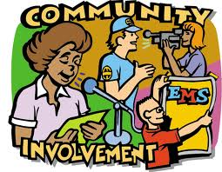

To find out how you can join FCCLA, or to know more information, contact your Local Chapter on www.fcclainc.org

Family Support in School, what?!
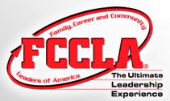

Define: The whole purpose of the FCCLA is to promote individual character and Leadership through family involvement in communities.

Strengthen:
- “Character Development
- Creative and Critical Thinking
- Interpersonal Communication
- Practical Knowledge
- Vocational Preparation”
(From FCCLA Mission Statement)

The main goal that the FCCLA has is to strengthen the family as a fundamental unit in society, because the family is the basic unit.
There are 8 goals that the FCCLA have for each student:
- To provide opportunities for personal development
- To strengthen the function of the family unit
- To encourage democracy through cooperative action
- To encourage individual and group involvement to achieve global harmony.
- To promote greater understanding between youth and adults
- To provide opportunities for making decisions and assuming responsibilities
- To prepare for diverse roles that we play in society
- To promote family, consumer science, and other occupations

Gain professional Experience

Help others

Provides great opportunities

Learn of new/different resources

Why do Students want to join The FCCLA?
Become a Great Leader

Expand professional support

Connect with other students

Help build support systems for students

It’s fun!

Gain community support

