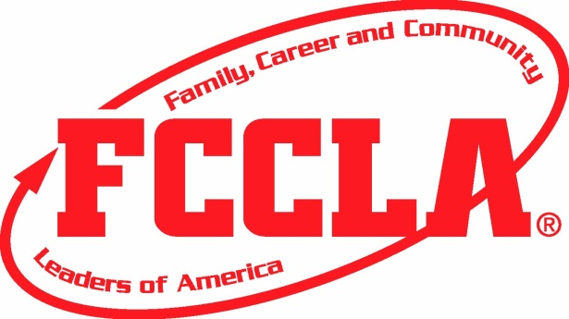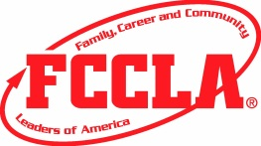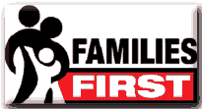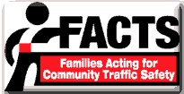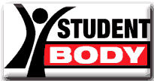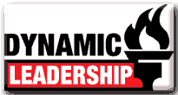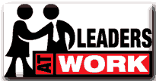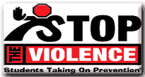

Join the Family Career and Community Leaders of America!

The ULTIMATE Leadership Experience

Interested in joining, or finding out more?

Talk to your FCCLA state advisor or national FCCLA

Contact FCCLA:

1910 Association Drive

Reston Va. 20191

www.fcclainc.org

(703)476-4900

1. FCCLA creates a foundation for a healthy, responsible, and productive life outside of high school—regardless of your chosen occupation!
2. FCCLA is the only student-led organization centered on families!
3. Make a difference in your families, school, and community!

FCCLA offers many national programs that will guide you and motivate you to achieve greatness and help make a difference in today’s society!!

3 reasons to join FCCLA today!

#### National Programs

#### What is FCCLA all about?

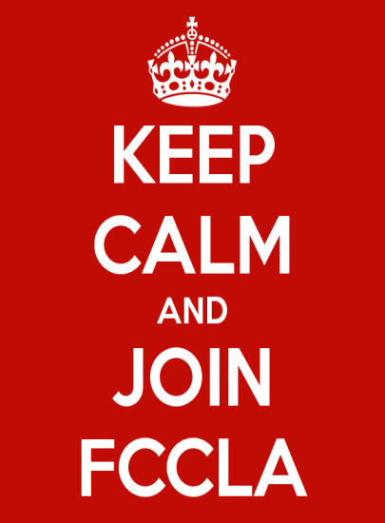

What FCCLA Can do For You!

# Goals of FCCLA

**1.** to provide opportunities for personal development and **preparation for adult life**

**2.** to **strengthen the function of the family** as a basic unit of society

**3.** to **encourage democracy** through cooperative action in the home and community

**4.** to encourage individual and group involvement in helping **achieve global cooperation and harmony**

**5.** to **promote greater understanding** between youth and adults

**6.** to **provide opportunities** for making decisions and for assuming responsibilities.

**7.** to **prepare for** the multiple **roles** of men and women **in today's society**

**8.** to **promote Family and Consumer Sciences** and related occupations

With over 220,000 members, FCCLA connects you to Alumni and Associates in the field of Family and Consumer Sciences.

Prepares you for careers in many different fields giving you leadership experience and confidence.

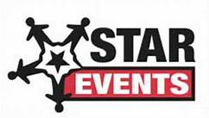

STAR events give you the opportunity to showcase your leadership and cooperative action skills through projects that you present in competition at the district, state, and national level.

# What is FCCLA?

Family, Career, and Community Leaders of America or FCCLA is a nonprofit national career and technology student organization for young men and women in family and consumer sciences education in public and private schools.

FCCLA helps young men and women become leaders and address important personal, family, work, and societal issues through family and consumer sciences education.