Fashion Merchandising NOTES
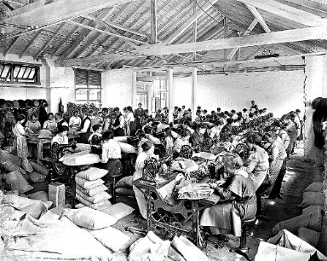
Standard 4: Components of the Fashion Industry

DEVELOPMENT OF THE APPAREL INDUSTRY
History
Industrial Revolution
Development of factory system of production-assembly line
Mechanized Textile Mills-made better fabrics in less time
Apparel switched from hand made to ready-to-wear
*
Politics
Civil War-introduction of standardized sizes due to ____________________ _____________________
Global Capitalism
More open interaction between governments allows free trade to occur worldwide
Entrepreneur-person who _______________ his or her own business and who assumes the _________ and management of the enterprise
Clothes were made faster, which dropped prices so all were competitive in sales.
Economics
Techniques in mass ____________________, _______________________ and retail selling developed and refined
Creation of retail _________________ (department stores)-19th century. Began in Europe. Permanently reshaped shopping habits
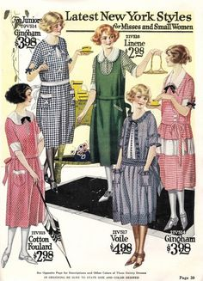
Textile and apparel _______________________ is the largest industry in many nations, especially the developing countries. One of the largest employers in the U.S.
Media
Advertising and_____________________ of all types of apparel, from haute couture to every day low-priced garments. Items shown in ads, ______________________ and on social media develop a need to purchase.
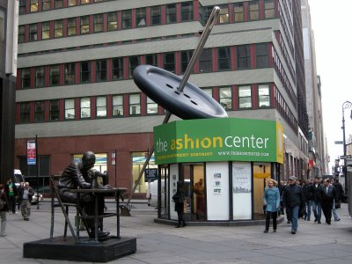
Introduction of movies, then _____________________, then______________________ constantly sped up introduction of new fashion to the public
FASHION CENTERS OF THE WORLD
United States
New York City:
Center of U.S. fashion
Fashion Weeks (February for FALL and September for SPRING)
Over 5,000 showrooms
Seventh Ave.- Fashion Walk of Fame
Separates, sportswear and natural fibers
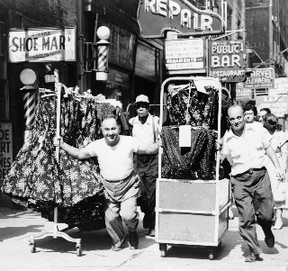
New York City
Fashion District is the largest in the ________________________. It ranges from 5th Avenue to 9th Avenue and from 34th to 42nd Street
It is estimated that there are ________________fashion companies headquartered in NYC.
_____________________ are employed in the industry, which generates over $2 billion in tax revenues a year
Los Angeles
Largest ______________________ of fashion related businesses in the western US- consisting of _________ city blocks
California Market Center- ____________ showrooms
Known for laid-back ________________ styles and life style and bloggers.
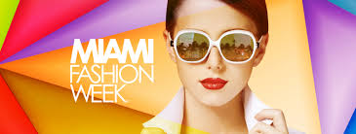
Miami
Known for _______________________ boutiques, designer stores galore, and its international center of commerce.
Miami holds________ fashion weeks: Fashion Week Swim, Miami Beach Internationals and _________________________Fashion Week. They showcase ____________________, international design, and resort wear.
Chicago
Known for the __________________________Mile (Michigan Ave) Great shopping!
Chicago does it’s own fashion show and has showcases for many major fashion events
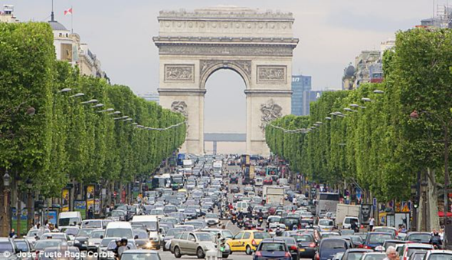
International Market Centers
Paris, France
First ______________________________ capital
Home to many premier designers: Chanel, Dior, Hermes, Vuitton, and St. Laurent
Paris Fashion Week is the grand finale of the Big _______ (New York, London, Milan are the others)
Biggest names in the industry are in Paris.
Best shopping streets in the world.
__________________ _______________________ was born in Paris
Only the French Chambre Syndicale de la Haute Couture can bestow upon a designer the title of ____________________.
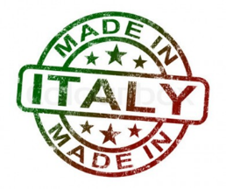
The French dress to impress!
Milan, Italy
Home to many famous designers: Armani, Versace, Prada, Valentino
Milan Fashion Week is held______________ a year.
Italian designers are known for _____________________ goods (shoes) and luxury ____________________

London, England
Home of famous designers: Vivienne Westwood, Alexander McQueen, Stella McCartney, Jimmy Choo, and Manolo Blahnik
Major fashion districts are: Knightsbridge District, South Kensington,_______________ ___________, and Chelsea
London Fashion Week and The Clothes Show London are the prominent fashion events.
London Fashion Week is known for its new, fresh and creative designers
London is known for 2 conflicting fashion styles: uptight and “___________________” and ____________
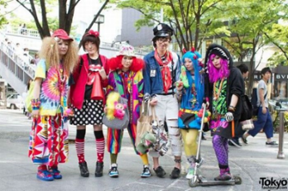
Tokyo, Japan
Famous designers are: Issey Miyake, Rei Kawakubo, Yohji Yamamoto, Hanae Mori
Known for street style: Lolita, Gyaru, Ganguro, Kogal, Dolly Kei, Fairy Kei, Mori Girl, etc
Known for significant consumption of _____________________goods
Known for clothing that doesn’t follow the body ________________
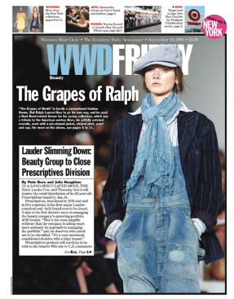
FASHION PUBLICATIONS
Trade Publications
Definition: magazines, newspapers, and books that deal with a specific ___________________________.
Women’s Wear Daily: Major US trade publication for ________________ ____________________. It reports all new apparel trends with photos, fashion illustrations, and stories.
Fashion Magazines
Consumer magazines sold commercially, featuring articles, illustrations and advertisements all dealing with fashion.
Editorial pages: The pages created by the ____________________, _____________________ of the magazine
Internet Sites/Social Media
Internet sites: Easily accessible information,_____________________ updates on the latest designs, access to designers
Social Media: Including Fashion Blogs
Connect with brands and designers on a different level
FASHION DESIGNERS
French Designers
Coco Chanel: Famous French couturier known for introducing the ______________ _____________ ____________, died in 1971, still remains a top French fashion house
Karl Lagerfeld: German born French designer, creates for ___________________, Fendi as well as himself
Known for quality tailoring and bold ready-to-wear pieces
Pierre Cardin: Italian born, French designer, worked for _________________, famous for licensing his name on products and the space look in the__________
Christian Dior: French designer who introduced the “_________ _____________” (fitted blouses and long full skirts) in 1947, died in 1957
Yves St. Laurent: paved the way for __________________ and female power dressing, died in 200
Louis Vuitton: (1821-1892) Famous for bags and_____________________. 2006-2012: World’s most luxurious goods.
American Designers
Ralph Lauren: Popular American designer famous for his ____________________men’s and women’s lines influenced by the American _____________, also sells home furnishings etc.
Levi Strauss: American business man who popularized the _______________ craze (including inventing _____________ that only continues to rush forward, died in 1902
Calvin Klein: Became famous with his designer______________ and _______________________, continues to design simple, sophisticated sportswear
Tom Ford: American designer who has worked behind the Gucci and YSL labels. Known for classic __________________
Marc Jacobs: American designer who's designs include__________________-hobo chic meets sophistication
Donna Karan: American designer who designs simple,____________________ women’s clothes that stretch and move well
Diane von Furstenberg: Belgian- born designer and former princess who’s jersey _______________ dress became her brand’s iconic look, works in NYC
Michael Kors: Famous for ______________________ and accessories. Became a household name after being a judge on Project Runway.
Italian Designers
Giorgio Armani: Italian designer known for ____________________, mostly finely tailored _____________ and upscale ready-to wear. Neutral colors
Dolce and Gabbana: Italian design team known for modern, _________________ styles and high-end casual for men and women
Gianni Versace: Italian designer who used ____________ color, __________________cuts, innovative materials and sex appeal. His sister Donatella took over in 1997 after his tragic death.
Japanese Designers
Issey Miyake: Known for _____________________, __________________, ____________________ clothing including a line called “Pleats Please”.
British Designers
Alexander McQueen: Creative designer known for being the _________ __________________ at Givenchy in Paris as well as his own brand in London. British Designer of the Year _______ times.
Vivienne Westwood : Known as the creator of “_______________”. Uses lots of traditional tartan.
CAREERS IN RELATED FASHION FIELDS
Fashion Designer
Fashion Blogger
Fashion Journalist

