Who was the Father of Haute Couture?

What did he do to become known as the “Originator of Fashion”

Who is Christian Dior?
Decade of Influence?
What was happening in the world during this time?
What was the name of his Design?

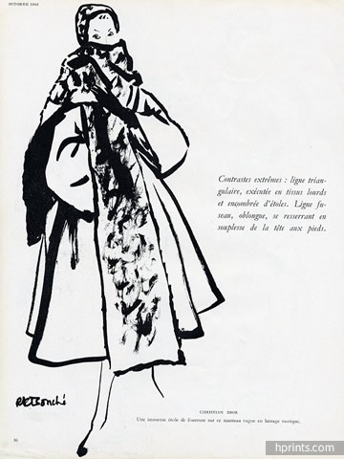

What influence did Coco Chanel have on Fashion?
When were her decades of Influence?
What was happening around the world during this time?
