Textile Fibers
What are Fibers?
- Fibers are the of all . Textiles are a from which clothing and other items are made. Fibers are put together to form a , making a are together to make fabrics.
Fiber Characteristics
- Knowledge of fiber characteristics will help you select the right fabric for your needs.
  - Strength:
  - Shrinkage:
  - Warmth:
  - Durability:
  - Absorbency:
  - Wicking:
  - Wrinkle Resistance:
  - Resiliency:
  - Elasticity:
  - Shape Retention:
  - Abrasion Resistance:
  - Luster:
  - Static Resistance:
Group of Fibers
- There are two main groups of fibers.
  - which are made from
  - which are made from
Natural Fibers
Natural Fibers
- The most common natural fibers are Natural fibers vary in depending on the kind of and the . The fibers must be before they can be made into . Supplies of natural fibers according to the . They each have that cannot be
- There are two categories of Natural Fibers:

Cellulosic Fibers
- Cellulosic Fibers come from . There are many kinds of cellulosic fibers, but few are used in fabric. are the main cellulosic fibers that are used in the fashion industry.
Protein Fibers
- Protein Fibers come from
- are the main protein fibers.
Cotton
- Cotton is a that is obtained from the It is the
- The cotton plant can grow in any part of the world where the growing season lasts leads in cotton production, followed by the
Advantage of Cotton | Disadvantages of Cotton
 | - A discoloration caused by a fungus that grows on the fabric when it is stored moist over a period of time.
Flax (Linen)
- is the fiber used to make fabric. It was the first used for making fabric.
- The Egyptians grew fields of along the Nile River over 4000 years ago and made it into . Pieces of have been found in are still seen in museums.
- Today, produce most of the linen fabric.
Advantages of Linen | Disadvantages of Linen
Wool
- Wool is made from the It is the people wear today, but its use goes back to early times.
- Crude wool fabrics have been found in the Even then, people knew that the of the sheep was than the skins of other animals.
- Sheep were the to be and raised for
Advantages of Wool | Disadvantages of Wool
Silk
- Silk is a protein fiber that comes from Manufactures to obtain the fiber. The silk fiber is the sometimes reaching a
- is the leading producer of raw silk today. also produce large amounts of silk. The does not produce raw silk because of the high cost of labor. However, it is the of silk products.
Advantages of Silk | Disadvantages of Silk
Manufactured Fibers
Manufactured Fibers
- Rayon was the produced fiber. It was followed by These fibers are made from They are called fibers.
- Combining molecules of makes most other manufactured fibers. The molecules are linked in various ways to form These manufactured fibers are called since they are made from
How Manufactured Fibers are Made?
- The raw materials and chemicals used to make manufactured fibers can vary. They all go through the same basic steps before they become fibers:

    - Silk is the only natural fiber that comes in a filament form.
    - Other natural fibers are short and are called staple fibers.
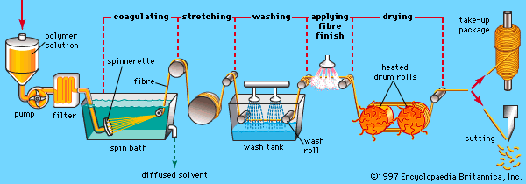

Rayon
- Rayon is a manufactured fiber. It is made from purified cellulose, primarily from , which is
- Has many of the same characteristics as . It was the . Often found in
Advantages of Rayon | Disadvantages of Rayon
Acetate
- Acetate is a chemical compound made of Also known as . A synthetic filament, yarn, or fabric composed of a derivative of the , differing from viscose rayon in having
Advantages of Acetate | Disadvantages of Acetate
Nylon
- A with a protein-like chemical structure, able to be produced as
- Nylon is and the out of all the fibers.

Advantages of Nylon | Disadvantages of Nylon
 | - Formation of small balls of fibers on the fabric surface due to wear.
Polyester
- A synthetic resin in which the used chiefly to make
- It is the out of all the fibers.
Advantages of Polyester | Disadvantages of Polyester
Acrylic
- Acrylic is made from polymers of
- Acrylic is often a in garments.
Advantages of Acrylic | Disadvantages of Acrylic
Spandex
- Spandex is a type of fabric. Used in a variety of different clothing styles, especially
Advantages of Spandex | Disadvantages of Spandex
Fabric Construction
Making Fabric
- The two most common methods of making fabric are Other methods include From only a come many different fabrics.
Weaving Fabrics
- Weaving is the process of to each other to create a woven fabric. It’s done on machines called . For generations, weaving was done by hand.
- Weaving requires the use of . The yarns are the yarns. The yarns are the yarns. The yarns are threaded onto the . They must be to withstand the strain of the weaving process.
- The yarns pass the yarns. When they reach the edge, they turn back and weave across the wrap yarns in the other direction. The turned filling yarns along each side of the woven fabric form the
Types of Weaves
- Through the weaving process, passing the filling yarns over and under different numbers of warp yarns can create various types of woven fabric. There are three basic types of weaves:

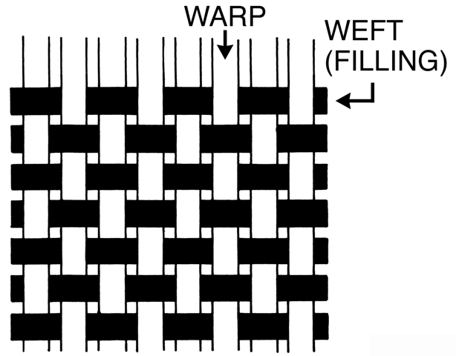
Plain Weave
- Passing a filling yarn yarn makes the plain weave. is an example of the plain weave.
- Plain weave fabrics are They than fabrics of other weaves.
Twill Weave
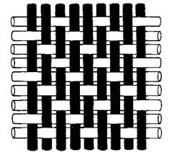
- The twill weave forms when Each float begins one yarn over from the last one. The floats can be either filling or wraps yarns. Twill weaves fabrics have a
- Twill weaves are They are less stiff than plain weave fabrics that have the same number of yarns.
Satin Weave
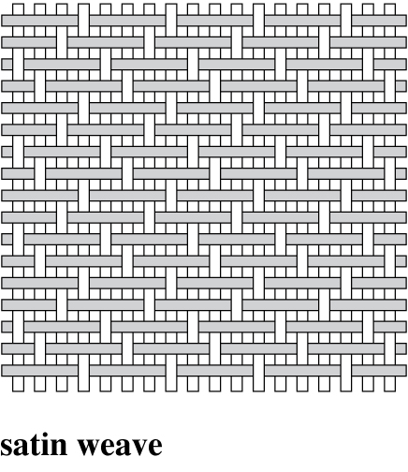
- The satin weave forms by Each float begins two yarns over from where the last float began.
- Satin weaves fabrics have great Satin weaves However, satin weaves The floats tend to catch other surfaces, causing them to
Knitted Fabrics
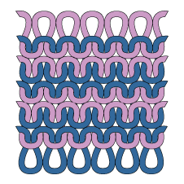
- Knitting is a process that The loops or stitches can be varied to create different patterns and textures. Different yarns produce different effects. Textured filament yarns are often used in knits.

Felt Fibers
- Felt is made from . Wool fibers have Under a microscope you can see they look like As are applied to the fibers, the scales interlock to form a solid mass.
Fabric Finishes
Fabric Finishes
- After the cloth is woven or knitted into fabric, it is still in an unfinished state. . The fabric still has a way to go before it is ready to be sewn into finished garments.
Solution Dyeing
- Manufactured fibers are solution dyed. In solution dyeing,
Yarn Dyeing
- Before some yarn is knitted or woven into fabrics, it goes through a process called Most fabrics that are plaid or striped are yarn dyed. Generally,
Piece Dyeing
- During the piece dyeing process, Piece dyeing allows manufacturers to follow fashion trends closely.
Printed Fabric
- Printing also adds color to fabrics. You can easily tell whether fabrics have been colored in a dye bath or by printing. Both sides of dyed fabrics are the same color.

