What does one TRILLION dollars look like?
All this talk about "stimulus packages" and "bailouts"...
A billion dollars...
A hundred billion dollars...
Eight hundred billion dollars...
One TRILLION dollars...
We'll start with a $100 dollar bill. Currently the largest U.S. denomination in general circulation. Most everyone has seen them, slightly fewer have owned them. Guaranteed to make friends wherever they go.
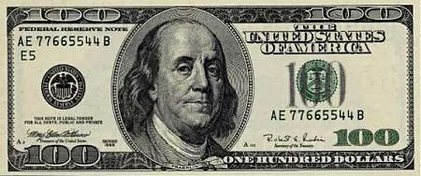
A packet of one hundred $100 bills is less than 1/2" thick and contains $10,000. Fits in your pocket easily and is more than enough for week or two of shamefully decadent fun.
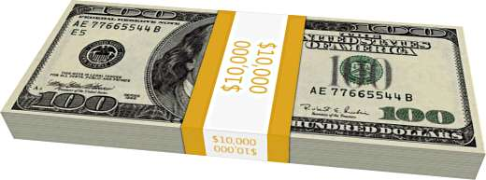
Believe it or not, this next little pile is $1 million dollars (100 packets of $10,000). You could stuff that into a grocery bag and walk around with it.

While a measly $1 million looked a little unimpressive, $100 million is a little more respectable. It fits neatly on a standard pallet...
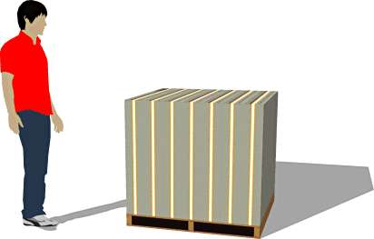
And $1 BILLION dollars... now we're really getting somewhere...
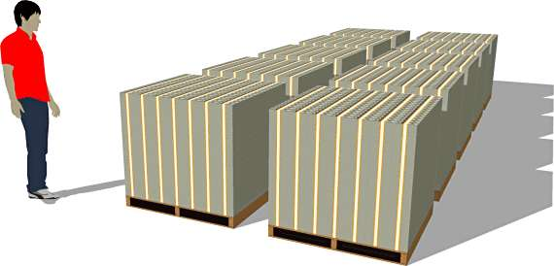
Next we'll look at ONE TRILLION dollars. This is that number we've been hearing so much about. What is a trillion dollars? Well, it's a million times a million. It's a thousand billion. It's a one followed by 12 zeros.
You ready for this?
It's pretty surprising.
Go ahead...
Scroll down...
Ladies and gentlemen... I give you $1 trillion dollars...
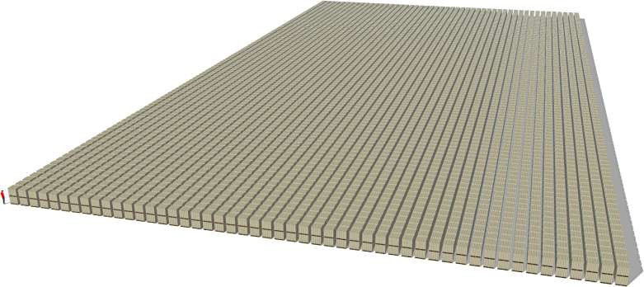
(And notice those pallets are double stacked.)
So the next time you hear someone toss around the phrase "trillion dollars"... that's what they're talking about.

