Name: ____________________________________ Period:_________

Foods and Nutrition Science 1 Final Review

Standard 1: Kitchen Safety Procedures and Sanitation Techniques
- When using electrical appliance:
  - Use ____________ hands
  - Stand on ________ floor
  - Keep away from ________
  - Plug cord into appliance before plugging into _______________
- When extinguishing a grease fire use:
  - __________________________
  - __________________________
  - __________________________
  - __________________________
  - NEVER use ________________
- Cleaning chemicals should be stored ____________ from food and in the _____________ containers.
- To prevent burns, cuts, fires, falls and proper lifting remember:
  - _____________ knives are dangerous
  - Keep ______________ and ____________ away from direct heat and the stovetop
  - Turn pot and pan handles _______________ from the front of the range
  - ______________ ______ spills immediately to avoid falls
  - Lift __________ on hot foods away from you
  - Always use ________ _______ when handling hot baking pans
  - Store ____________ items on the bottom shelves
  - Use a step stool for reaching ____________ objects
- To prevent poisoning and chemical contamination:
  - Keep cleaning supplies ________________ from food
  - Mixing _______________ with ______________ will created toxic deadly fumes.
- Fill in the box on how to treat different injuries:
Severely bleeding cut | Treatment:
First degree burn | Treatment:
Electrical shock | Prevention:
- Proper hand washing:
  - How long should you wash your hands for?
  - When should you wash your hands?
  - Clothes and aprons should be _________________ and hair should be ______________ or _____________.
- What is the proper order for washing dishes by hand?
- What is the best way to dry dishes?

- Cleaning and sanitizing work surfaces:
  - Keep all work _____________ clean
  - _______________ work surfaces to prevent ______________-_________________
  - When tasting food, use a ____________ spoon only once.
  - To reduce pests/insects what are three things to do?
- What is the proper order for using sanitizer on a surface?
- When should you wear gloves?
- What is the proper way to store:
  - Utensils and equipment?
  - Glasses and cups?
- Remove garbage ________________ to prevent contamination. Do not __________ garbage cans near food prep or storage areas.
- What is a food-borne illness?
- What are some symptoms of food-borne illnesses?
- Will food always look and smell normal if it has a food-borne illness in it?
- When in doubt, ____________ __________ _________!
- What is a microbe?
- What foods are most susceptible to bacteria?
- What does FATTOM stand for?
- Fill in the chart about food-borne illnesses:
Illness | Sources
Botulism
E-coli
Hepatitis A
Salmonella
Staphylococci
Norovirus
Clostridium Perfingens
Campylobacter
- What does YOPI stand for?
- How are YOPI population groups affected by food-borne illnesses?
- What is cross-contamination?
  - A large majority of food-borne illnesses can be prevent by proper __________ ______________
  - Throw away food with a ______________ odor or flavor
  - Do not buy or use ________________ cans
  - Frequently _______________ and ______________ work surfaces
- How do you prevent cross-contamination?
- Can wearing gloves prevent contamination from cuts and burns?
- What is the temperature danger zone?

- How long can foods be in the temperature danger zone before being thrown out?
  - At home:
  - In a restaurant:
- When taking food temperatures, where should your thermometer be in the food?
- Cooking temperatures:
  - Fridge: _______________
  - Freezer: ______________
  - Whole beef cuts, lamb, seafood, pork and veal: _____________
  - Ground meats: _____________
  - All poultry: _____________
  - Reheating foods: ____________
- What are the three ways to properly cool foods fast?

- What are the three ways to properly thaw foods?

- Define TCS foods?
  - Examples:
- What can happen with foods that are left out at room temperature for too long?

Standard 2: Kitchen Equipment and Management
- What do you use a pastry blender for?
- What do you use a straight edge spatula for?
- What do you use a wooden spoon for?
- What do you use a wire whisk for?
- What three things are microwaves attracted to?
- Microwaves create friction to cause _________________ that cooks the food.
- What are the three microwave-safe containers?
  - Never use _________________
- What shape of container cooks best in the microwave?
- What is standing time?
- What increases as you increase the amount of food?
- What are the four types of covering you can use in the microwave?
a. c.
b. d.
- What does covering food prevent?
- What two things does microwave cooking not give food?

- Equivalents
1 cup = _____ oz 8 fl. oz. = _____ cup 16 oz. = _____ lb
1 pint = _____ cup 1 quart = _____ cup 1 cup = _____ Tbsp
1 gallon = _____ cup 1 Tbsp = _____ tsp ½ cup = _____ stick of butter
1 gallon = _____ qt ¼ cup = _____ Tbsp
- Abbreviations
tbsp, T or tbp: |  | hr: |  | oz:
gal: |  | t. or tsp.: |  | tbp:
qt: |  | T: |  | min:
lb. or #: |  | c: |  | pt:
- How do you properly measure flour?
- How do you properly use a liquid measuring cup?
- How do you properly measure brown sugar?
- What are the two ways to measuring shortening?
- When halving or doubling a recipe what always remains the same?
- What is ¾ cup doubled?
- What is 2/3 cup halved?
- What is half of ¼ cup?
- What is half of 1 1/3 cup?
- Define the following cooking terms:
Term | Definition | Term | Definition
Chop |  | Grate
Cream |  | Knead
Cut-in |  | Mince
Dice |  | Peel
Dredge |  | Saute
Flour |  | Simmer
Fold-in |  | Steam
Whip

Standard 3: Carbohydrates and Fiber
- What are simple carbohydrates?
  - Examples?
- What are the 5 types of simple carbohydrates?
- What are complex carbohydrates?
  - Examples
- Is fiber a simple or complex carbohydrate?
- Complex carbohydrates are converted into what type of sugar in the body?
- How many calories per gram are there in carbohydrates?
- What is the primary function of carbohydrates?
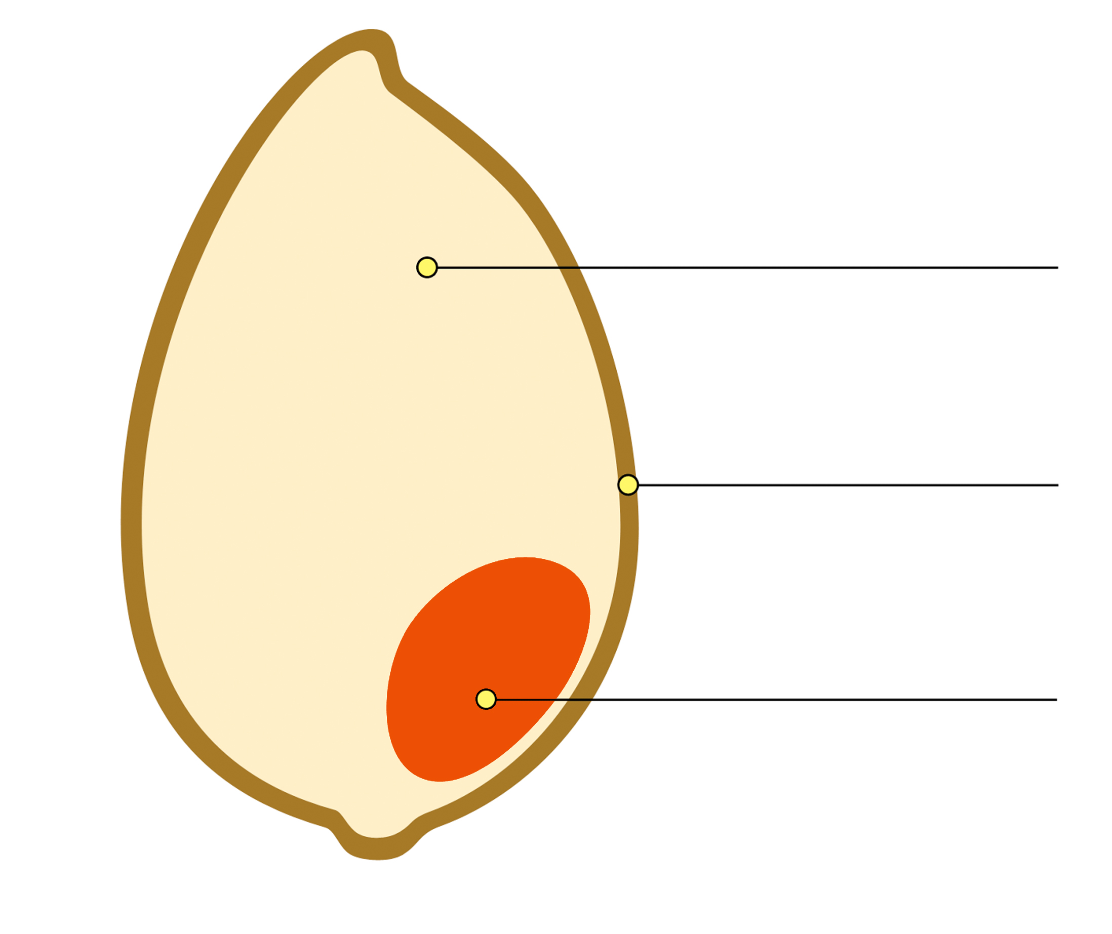
- Label the three parts of the wheat kernel -------------------->
- What nutrients does each part of the wheat kernel provide?
  - Endosperm:
  - Germ:
  - Bran:
- What is fiber also known as?
- What does fiber do for our bodies?
- Why do we need to drink water when we eat fiber?
- How much fiber is recommended that we eat?
- What disease can fiber reduce the risk of?
- What foods are high in fiber?
- What are quick breads?
  - Examples?
- What happens if you over-mix your dough?
- What happens if you under-mix dough?
- Fill in for each ingredient its function in quick bread:

  - Flour:
  - Liquid:
  - Leavening agents:
  - Fat:
  - Salt:
  - Sugar:

- What is the method for cooking rice?
- Fill information about the 4 different types of rice:
a. Brown: c. Short Grain:
b. Instant: d. Long Grain:
- What are the four steps to cooking rice?
a. c.
b. d.
- What is the ratio of rice to water to cooked rice?
- How should you store pasta?
- Why is pasta such a popular dish?
- What does al Dente mean?
- What are the four steps to cooking pasta?
a. c.
b. d.
- What is the ratio of uncooked to cooked pasta?

Standard 4: Proteins and Lipids
1. What is the primary function of protein?
2. Protein provides how many calories per gram?
3. What is the tip for protein?
4. How much seafood is recommended each week?
5. What are amino acids?
6. How many amino acids are there? How many are considered essential?
7. What is a complete protein?
a. Examples?
b. Plant or animal sources?
c. Two Exceptions?
8. What are incomplete proteins?
a. Examples?
b. Plant or animal sources?
9. What foods combine to create a complementary protein?
a. Examples?
10. Give examples of each of the following function of eggs:
a. Binder: d. Leavening agent:
b. Thickener: e. Emulsifier:
c. Coating:
11.What are the 5 methods of cooking eggs we discussed in class?
12. What happens to protein when exposed to heat for too long?
13. What is the best way to store eggs?
14. How many cups of milk or dairy is recommended each day?
15. What is the tip for dairy foods?
16. Define
a. Pasteurization:
b. Homogenization:
c. Fortified:
17. When you burn milk it is called ________________.
18. What are the two methods to prevent milk from burning?
19. What are milk replacements? Who needs them?
20. Raw milk is considered dangerous because it may contain what pathogens?
21. Identify the 7 functions of fat:
a. e.
b. f.
c. g.
d.
22. How many calories per gram does fat provide?
23. What are the two tips for fat?
24. What is cholesterol?
25. What does HDL do for our bodies?
26. What does LDL do for our bodies?
27. What does saturated fat do to our cholesterol levels?
a. Examples?
28. What does polyunsaturated fat do to our cholesterol levels?
a. Examples?
29. What does monounsaturated fat to do our cholesterol levels?
a. Examples?
30. What does trans fatty acids do to our cholesterol levels?
a. Examples?
31. Why is fat considered the most concentrated form of energy?
32. Solid fat is typically considered what type of fat?
Standard 5: Vitamins, Minerals and Water
1. Fill in the chart about the different vitamins and minerals:
Vitamin/Mineral | Classification | Function | Source | Deficiency
Vitamin A
Vitamin B Folate
Vitamin C
Vitamin D
Vitamin E
Vitamin K
Sodium
Potassium
Calcium
Iron
2. In what cases can electrolytes become imbalanced?
3. What are the 4 functions of water?
a. c.
b. d.
4. Why is water the most important of all nutrients? (3 examples)
5. What in an indicator of thirst?
6. What color should your urine be?
7. How much water is recommended daily?
8. How much water should you drink and hour before exercise?
9. How much water should you drink as you exercise per hour?
10. What nutrients do vegetables provide?
11. Vegetables do not contain ________________ and are low in calories, fat and sodium.
12.What is the tip for vegetables?
13. What three things destroy nutrients in vegetables?
14. Why should you wash your fruits and vegetables before eating or preparing them?
15. What are the 7 ways or prepare fruits and vegetables that preserve the most nutrients?
a. e.
b. f.
c. g.
d.
16. What are the 3 tips for cooking fruits and vegetables to preserve nutrients?
a.
b.
c.
17. What do you look for when selecting fresh fruits and vegetables?
18. Why should you buy seasonal produce?
19. How long will fresh produce last in the fridge?
20. Why should you only buy what produce you will use or eat?
21. What happens to produce when it is left out at room temperature?
22. What is the tip for fruits?
23. What are the five farm-to-table steps?
a. d.
b. e.
c.
24. What are the four C’s of food safety?
25. What is oxidation?
26. What are the two ways to prevent oxidation?

Standard 6: Dietary Guidelines and ChooseMyPlate.gov
1. What are the six dietary guidelines and key recommendation for each?
a.
b.
c.
d.
e.
f.
2. What does the average American diet have more of?
3. What is the average American diet low in?
4. High consumptions of salt and sodium lead to what?
6. Fill in the chart for the parts of MyPlate
Group: | Tips:
Grain | 1.  2. 3.
Protein | 1.  2. 3.
Vegetable | 1. 2.
Fruit | 1.  2. 3.
Dairy | 1. 2.

7. Does any food group provide all the nutrients you need?
8. How can you ensure you get all the nutrients you need every day?
9. What are the three characteristics of healthy eating patterns?
10. What are you caloric needs based on?
11. Does everyone have the same caloric needs? Why or why not?

