Review Puzzle #1
Name: ____________________________
Period: ____________

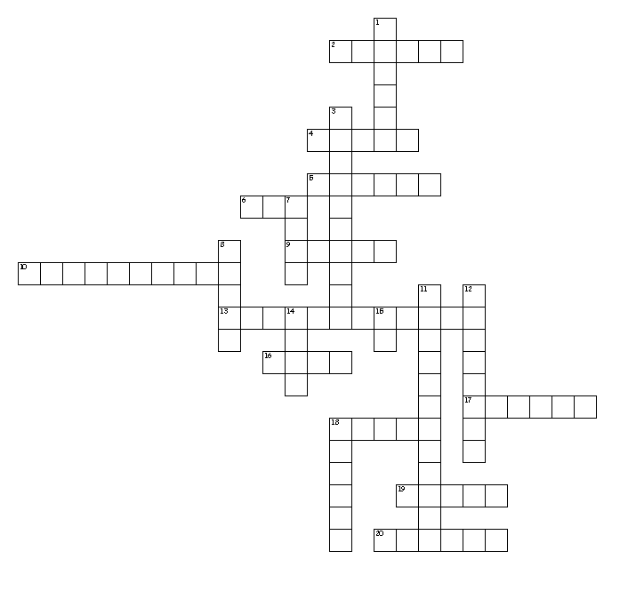
Down
1. What kind of carbohydrate is in milk and fruits?
3. Which ingredient is measured by packing into a cup?
7. What is the abbreviation for tablespoon?
8. These type of vitamins need to be consumed daily because they can't be stored in the body.
11. What red fruit is high in Vitamin C?
12. Another name for Vitamin C is ____ acid.
14. What is the cooking term to cut food into small pieces?
15. What is the abbreviation for pound?
18. Use this kitchen utensil to flip pancakes and lift cookies off a cookie sheet.

Across
2. Complete proteins are found in what kind of sources?
4. What color besides red and orange indicates a vegetable is high in Vitamin A?
5. How many seconds should you wash your hands?
6. Microwaves are attracted to ___, sugar and water molecules.
9. What is the cooking term to cook food in a small amount of fat?
10. What foodborne illness is associated to raw and undercooked poultry and eggs?
13. Which minerals help balance fluid in the body?
16. How many calories are in 1 gram of protein OR 1 gram of carbohydrate?
17. This cleaning product should never be mixed with ammonia.
18. How many teaspoons in a tablespoon?
19. How many fluid ounces in 1 cup?
20. Use this type of blender to cut fat into flour.

Review Puzzle #2
Name: ____________________________
Period: ____________

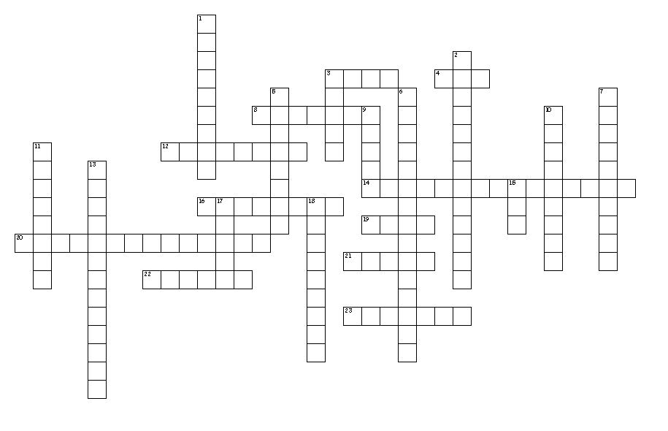
Across
3. What are the four fat soluble vitamins in alphabetical order?
4. Which nutrient satisfies hunger the longest, insulates and protects internal organs.
8. Measure by placing on a flat surface and checking it at eye level.
12. Eggs should be stored in the refrigerator in their ___ carton.
14. Which type of fat makes the HDL go up and LDL go down?
16. Use this to drain water out of pasta (not a strainer).
19. Water, air and ____ kill vitamins in fruits and vegetables.
20. This process helps kill bacteria in milk.
21. Measure this ingredient by spooning into a cup and leveling off.
22. Eggs act as a ____ in meatloaf.
23. How many tablespoons in 1 cup?

Down
1. Which B vitamin helps prevent neural tube defects in unborn babies. (hint: 2 words)
2. Minerals needed in relatively large amounts.
3. acids What are the building blocks of protein? (hint: 2 words)
5. Which nutrients helps our muscles, skin and nerves.
6. Which type of fat makes LDL and HDL go down?
7. What is the process to break fat up and mix permanently into milk.
9. To cook over boiling water.
10. Which type of fat makes LDL and HDL go up?
11. These are the only plant food that make a complete protein.
13. Use this kitchen utensil to scrape the sides of bowls.
15. How many tablespoons equal 1/8 cup.
17. This type of oil is high in monounsaturated fats.
18. What are the amino acids called that we can't make.

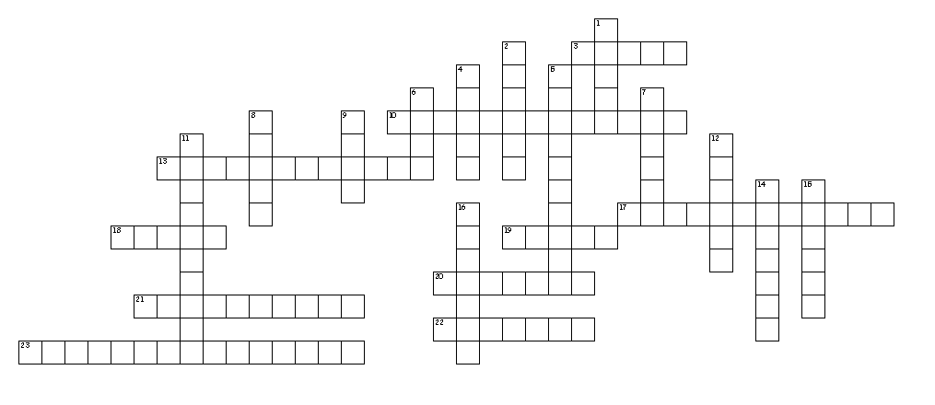
Review Puzzle #3

Across
3. The dietary guidelines recommend we exercise ___ minutes a day.
10. These minerals are needed in relatively small amounts, also called trace minerals.
13. Which nutrient is our main energy source.
17. This is caused by not enough calcium in the diet.
18. These type of foods have fiber and carbohydrates.
19. Foodborne illness caused by undercooked or raw hamburger
20. What should be washed first?
21. Cook this to 155 degrees.
22. This mineral helps us grown and repair.
23. What is the best type of fat?
Down
1. What is another name for roughage or cellulose?
2. This is caused by not enough iron in the diet.
4. One cup of uncooked rice equals ___ cups cooked rice.
5. The temperature between 41-135 is called the ___ (hint: 2 words)
6. How many calories in 1 gram of fat?
7. What should you wear if you have a cut on your hand?
8. Which ingredient provides structure for baked goods.
9. Whole cuts of seafood, beef, lamb and ___ should be cooked to 145 degrees.
11. To extinguish a grease fire use salt, fire extinguisher or ____. (hint: 2 words)
12. Staphylococci is caused by spread of germs through human ___.
14. Nuts, refried beans and grain foods are a good source of ___ carbohydrates.
15. What does pasta do in size when it cooks?
16. Cook ___ to 165 degrees

Review Puzzle #4
Name: __________________________
Period: ______
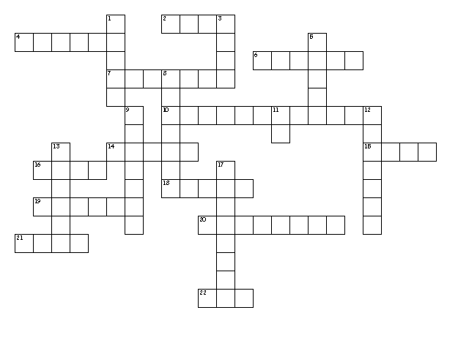
Down
1. Foods high in nutrients and low in calories are called nutrient ___.
3. Store cleaning supplies separate from ___.
5. Americans don't eat enough ___ and whole grains.
8. Choose lowfat or ___ dairy foods. (2 words)
9. Sugar that the body uses for energy.
11. This is the abbreviation for ounce.
12. Use this utensil to level ingredients and frost cakes.
13. For someone being electrocuted disconnect the main power ___.
17. Another name for complex carbohydrates.

Across
2. How much of your grains should whole grains?
4. Stir and ___ foods in the microwave for even cooking.
6. Americans eat more fat, ___, sugar and calories than recommended.
7. You should eat 8 oz. of ___ once a week.
10. 1/2 cup plus 1/4 cup equals ___ cup.
14. 4 cups equal 1 ___.
15. Lift a lid from a pot so the steam is directed ___ from you.
16. Defrost foods safely in refrigerator, microwave or sink with ___ water.
18. ___ calorie foods are high in calories and low in nutrients like chips and soda.
19. Make half your plate ___ and vegetables.
20. For a severe cut apply direct ___.
21. This knife is good for cutting, chopping and slicing.
22. Abbreviation for teaspoon.

Review Puzzle #5
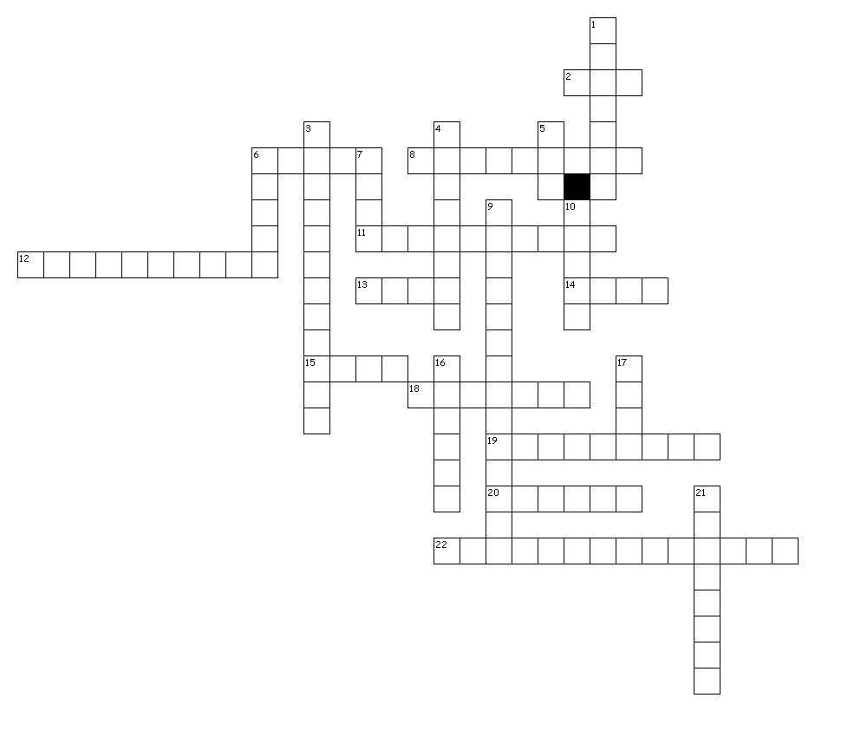
Name: ___________________________
Period: ___________
Across
2. Pasta dishes are usually ___ cost dishes.
6. What is the whole grain form of rice?
8. This vitamin helps prevent neural tube defects in unborn babies.
11. Eggs function as an ___ in salad dressing and mayonnaise.
12. Blood cholesterol should be below ___. (hint: two words and a number)
13. Sugar and ___ provide flavor for quick breads.
14. Don't stir, put the lid on and simmer to cook this food.
15. Soybeans make a curd called ___.
18. Eggs cooked out of the shell in boiling water.
19. Baking powder and baking soda are examples of ___ agents which help quick breads rise.
20. Milk, fruit, candy are all examples of ___ carbohydrates.
22. This process kills the bacteria in milk.

Down
1. Fruits and vegetables are NOT a good source of fats and ___.
3. Fat is a ___ source of energy.
4. Animal foods provide ___ proteins.
5. This ingredient helps quick breads to be tender.
6. Fiber helps keep you 'regular' and can reduce ___ cholesterol.
7. How many calories in 1 gram of fat?
9. 20-35 grams a fiber a day can help reduce the risk of ___, colon and rectal cancer.
10. High LDL levels are associated with ___ disease and stroke.
16. Substitute ___ for mayonnaise to reduce the fat in recipes.
17. The part of the grain kernel with the most fiber.
21. This vitamin helps blood clot.

Review Puzzle #6
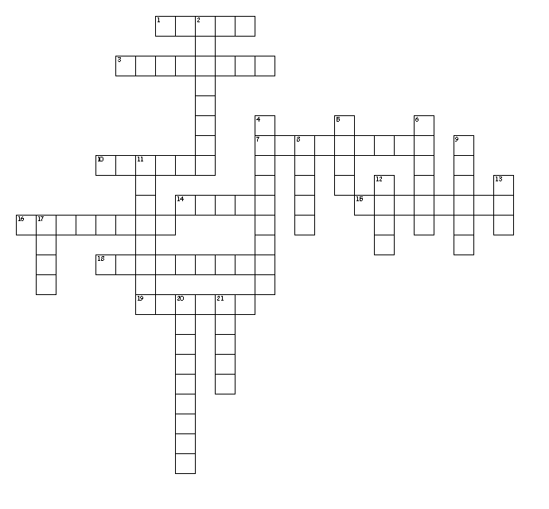
Name: ____________________________
Period: _______
Down
2. Energy is the same as ___. They measure the energy in food.
4. Water is the most ___ nutrient.
5. To mix ingredients gently by turning one part over another.
6. Folic acid helps prevent ___ tube defects in unborn babies.
8. To mix fats and sugars until smooth and fluffy.
9. Use this knife to peel or cut small foods.
11. The time when the microwave turns off but food continues to cook.
12. Vitamins A&D are added to ____.
13. Fruits and vegetables are mostly ___-free.
17. Diets low in ___ can cause anemia.
20. Water helps carry ___ throughout the body.
21. You should drink ___ cups of water a day or 64 ounces.

Across
1. Calcium, phosphorus and magnesium are all ___ minerals.
3. Anemia is __ __ cell formation.
7. A healthy way to cook vegetables is to steam, stir-fry or ___.
10. Water helps carry ___ out of the body.
14. This most important nutrient helps regulate body temperature.
15. This vitamin helps prevent night blindness
16. This vitamin helps wounds heal and strengthens our immune system.
18. What is it called when fruits turn brown after cutting them?
19. Calorie needs are based on age, ___ and activity level.

Review Puzzle #7
Name: ___________________________
Period: __________
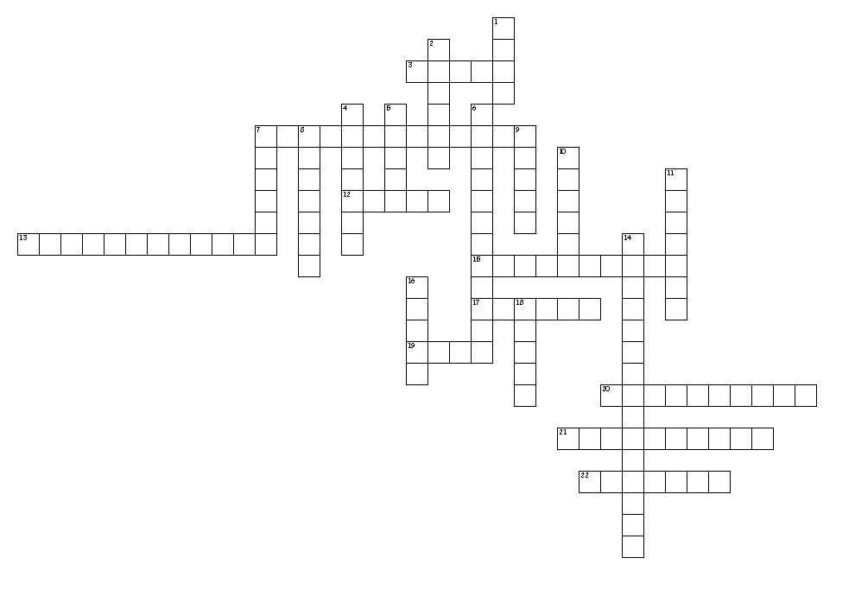
Across
3. Which ingredient provides structure for baked goods.
7. These minerals are needed in relatively small amounts, also called trace minerals.
12. One cup of uncooked rice equals ___ cups cooked rice.
13. This is caused by not enough calcium in the diet.
15. The temperature between 41-135 is called the ___ (hint: 2 words)
17. This is caused by not enough iron in the diet.
19. How many calories in 1 gram of fat?
20. To extinguish a grease fire use salt, fire extinguisher or ____. (hint: 2 words)
21. Cook this to 155 degrees.
22. What should be washed first?
Down
1. Whole cuts of seafood, beef, lamb and ___ should be cooked to 145 degrees.
2. What should you wear if you have a cut on your hand?
4. Cook ___ to 165 degrees
5. What is another name for roughage or cellulose?
6. Which nutrient is our main energy source.
7. Staphylococci is caused by spread of germs through human ___.
8. Nuts, refried beans and grain foods are a good source of ___ carbohydrates.
9. The dietary guidelines recommend we exercise ___ minutes a day.
10. What does pasta do in size when it cooks?
11. This mineral helps us grown and repair.
14. What is the best type of fat?
16. These type of foods have fiber and carbohydrates.
18. Foodborne illness caused by undercooked or raw hamburger

Review Puzzle #8
Name: __________________________
Period: ____________
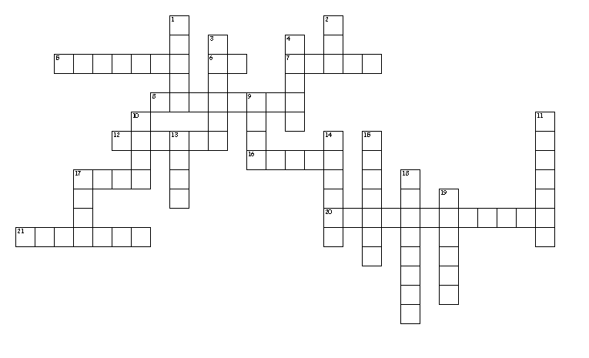
Across
5. Use this utensil to level ingredients and frost cakes.
6. This is the abbreviation for ounce.
7. ___ calorie foods are high in calories and low in nutrients like chips and soda.
8. Another name for complex carbohydrates.
12. Stir and ___ foods in the microwave for even cooking.
16. Americans don't eat enough ___ and whole grains.
17. Defrost foods safely in refrigerator, microwave or sink with ___ water.
20. 1/2 cup plus 1/4 cup equals ___ cup.
21. You should eat 8 oz. of ___ once a week.

Down
1. 4 cups equal 1 ___.
2. Abbreviation for teaspoon.
3. For someone being electrocuted disconnect the main power ___.
4. Foods high in nutrients and low in calories are called nutrient ___.
9. How much of your grains should whole grains?
10. Store cleaning supplies separate from ___.
11. Sugar that the body uses for energy.
13. Lift a lid from a pot so the steam is directed ___ from you.
14. Make half your plate ___ and vegetables.
15. Choose lowfat or ___ dairy foods. (2 words)
17. This knife is good for cutting, chopping and slicing.
18. For a severe cut apply direct ___.
19. Americans eat more fat, ___, sugar and calories than recommended.

