DAILY INDIVIDUAL LAB/ CLEANING RESPONSIBILITIES

CHEF | COOK
- RECIPE: Read the recipe  - LAB SHEET: Fills out on day of lab plan  - Main cook for the day  - STOVE: Clean thoroughly after cooking.  - Supervise and assist other cleaning jobs at end of lab  - FLOOR: Sweeps floor using broom AND DUSTPAN!!!  - APRONS: Checks Aprons --if dirty places in laundry basket --if clean hangs on back of chairs | - Assembles Equipment needed for the lab  - Assists the CHEF  - TABLE: Wipes Clean (do not throw crumbs on floor)  - COUNTER: Wipes counters/Walls  - TOWELS: Puts dirty towels in basket at end of lab  - TOWELS: Starts load of towels washing at end of lab. See teacher for detailed directions.  - Checks Clean Up--Last class and yours before leaving
Assistant Cook | Manager
- Preheats oven if needed  - gets out supplies for recipe (ingredients)  - Sets table (plate, eating utensil, cup, napkin)  - Makes Drink / Pours Drinks  - WASHES Dishes  - Cleans & Rinses Sink at end of lab.  - Wipes off Table and Chairs | - TOWELS: Places clean towels in dryer at beginning of lab. Removes dry towels from dryer and begins folding.  - DISHES: DRYS Dishes  - DISHES: Puts away dishes  - Extra duty assigned by teacher  - Assist Chef with whatever you are asked to do.

6th Grade ROTATIONS
A | C | B | D
B | D | A | C
C | A | D | B
D | B | C | A

A | C | B | D
B | D | A | C
C | A | D | B
D | B | C | A

A | C | B | D
B | D | A | C
C | A | D | B
D | B | C | A

A | C | B | D
B | D | A | C
C | A | D | B
D | B | C | A

A | C | B | D
B | D | A | C
C | A | D | B
D | B | C | A

A | C | B | D
B | D | A | C
C | A | D | B
D | B | C | A
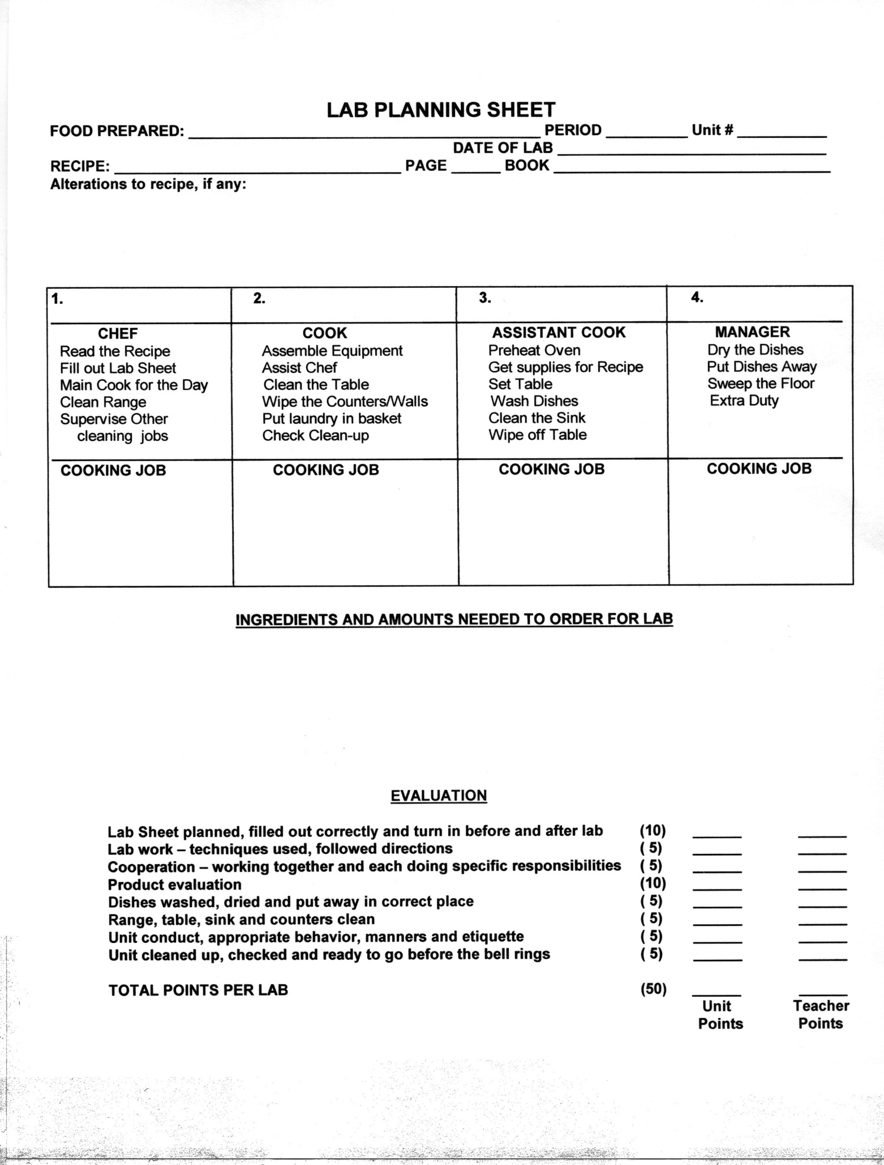
- ________
- _______

- ________
- ________
- ________
- ________
- ________
10
10
10
10
10
10
10
10

