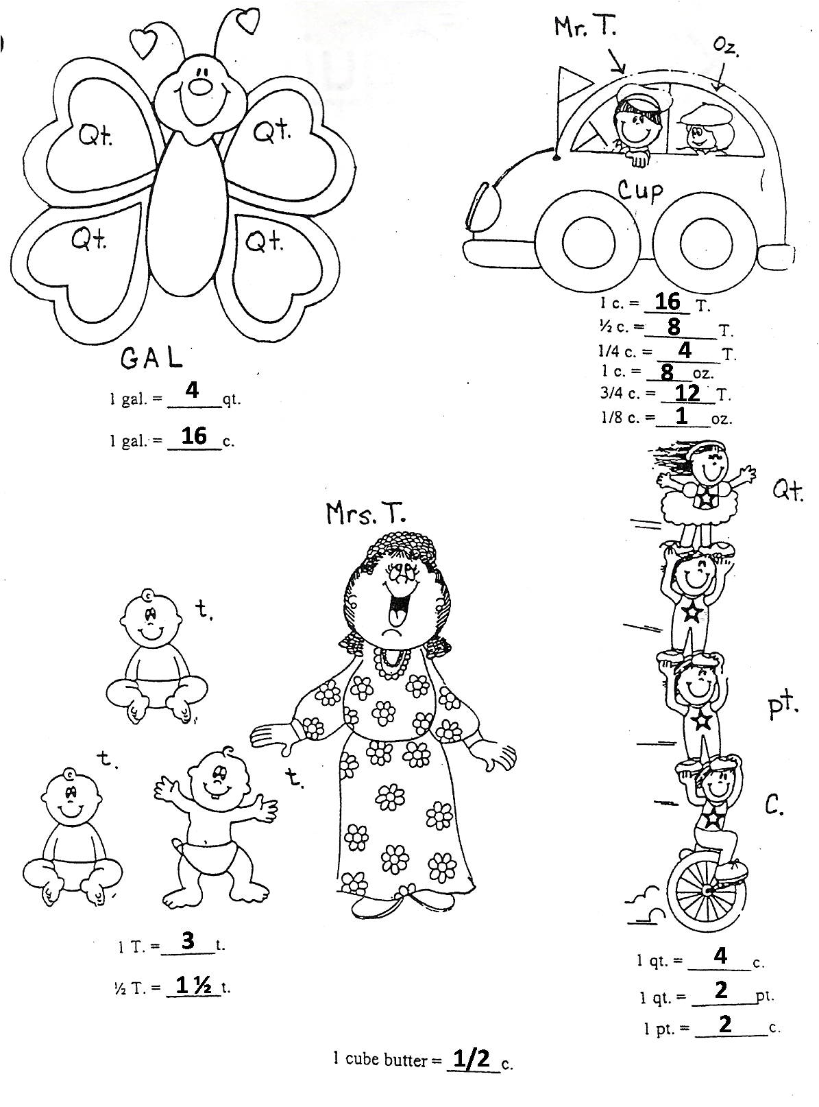Equivalent Cartoons

**Young T. and Cousin Oz.**

**Helpful Hints:**

* Young T. just got his drivers license-He is 16 (16 Tablespoons)
* He now gets to drive the “Cup Car” (1 Cup)
* Cousin Oz. is half as old as Young T.-He is only 8 (8 Ounces)
* It takes 8 ounces to fill up the “Cup Car” (8 oz. = 1 c.)

**Equivalents To Remember:**

* **8 Ounces = 1 Cup • 1/2 Cup = 8 Tablespoons**
* **1 Cup = 16 Tablespoons • 1/4 Cup = 4 Tablespoons**
* **3/4 Cup = 12 Tablespoons • 1/8 Cup = 2 Tablespoons**



**The Cup Kids**

**Helpful Hints:**

* Each Kid represents 1 cup
* Two Kids Equal a Pint
* Four Kids Equal 2 Pints
* Two Pints Equal 1 Quart

**Equivalents To Remember:**

* **2 Cups = 1 Pint**
* **2 Pints = 1 Quart**
* **4 Cups = 1 Quart**

**GAL the Butterfly**

**Helpful Hints:**

* GAL stands for Gallon
* GAL’s wings are so QT! (Quart)
* 4 Wings = 4 Quarts
* Small Circles Represent 1 C.

**Equivalents To Remember:**

* **4 Cups = 1 Quart**
* **4 Quarts = 1 Gallon**
* **16 Cups = 1 Gallon**



**Mrs. T and Her Babies**

**Helpful Hints:**

* T. = Tablespoon
* t. = teaspoon
* Mrs. T. has 3 baby t.’s
* There are 3 little t.’s with 1 big T.

**Equivalents To Remember:**

* **1 Tablespoon = 3 teaspoons**
* **1/2 Tablespoon = 1 ½ teaspoons**
* **9 teaspoons = 3 Tablespoons**



**Young T.**

**Cousin Oz.**

**Cup Car**