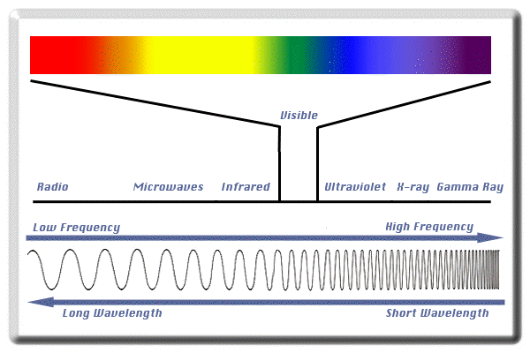

Source: http://www.lcse.umn.edu/specs/labs/images/spectrum.gif

The wavelengths are counted by their frequency—the time from one wave peak to the next wave peak per unit of time. The measurement unit for radio waves is a hertz (Hz) or megahertz (MHz)—a Hertz (Hz) is 1 cycle (peak-to-peak) per second, megahertz (MHz) is one million hertz per second.

For a complete, easy-to-understand explanation of how microwave ovens work, please go to: http://www.explainthatstuff.com/microwaveovens.html

