Nutrient and Cost Analysis of Macaroni and Cheese—4 servings
Performance Objective #5—Complex Carbohydrates, Scratch vs. Convenience

Food | Cost per Package | Cost per 4 serving recipe | Time: Prep + Cooking | Totals
1/2 pound (2 cups) macaroni noodles | $2.24—16 oz. pkg. | $1.12 | 20 + 10-15 = 30 to 35 minutes | 30 to 35 minutes
1 cup whole milk | $2.79 gallon | $0.18
4 oz. (1/2 pkg) cream cheese | $2.26—8 oz.  pkg. | $1.13
2 TB butter | $2.89 per pound | $0.18
1/2 tsp pepper | $3.25—4 oz. (113 g) | $0.29
1/4 tsp salt | $1.12—26 oz. | $0.01
2 cups sharp cheddar, grated | $4.72—16 oz.  (abt. 4 cups) | $2.36 |  | $5.27
Kraft Deluxe Macaroni and Cheese Dinner | $2.24—14 oz.  (abt 4 servings) |  | About 9 minutes | $2.24
Stouffers Macaroni and Cheese--Microwaveable | $2.23—20 oz. (abt 2.5 servings) | $4.46 (need two boxes for 4 people—leftover 1 svg) | 8 min, stir, 3 more minutes = 11 minutes twice= 22 min | $4.46

NOTE: Comparisons of the Homemade Deluxe Mac and Cheese are made using skim milk and skim milk along with lowfat cheese. The costs are virtually the same for the milk, but the lowfat cheese is $6.10 a pound, so $3.05 for 2 cups, making the total $5.96

KRAFT DELUXE MACARONI AND CHEESE 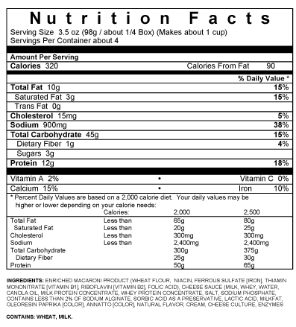
Homemade Deluxe Macaroni and Cheese: 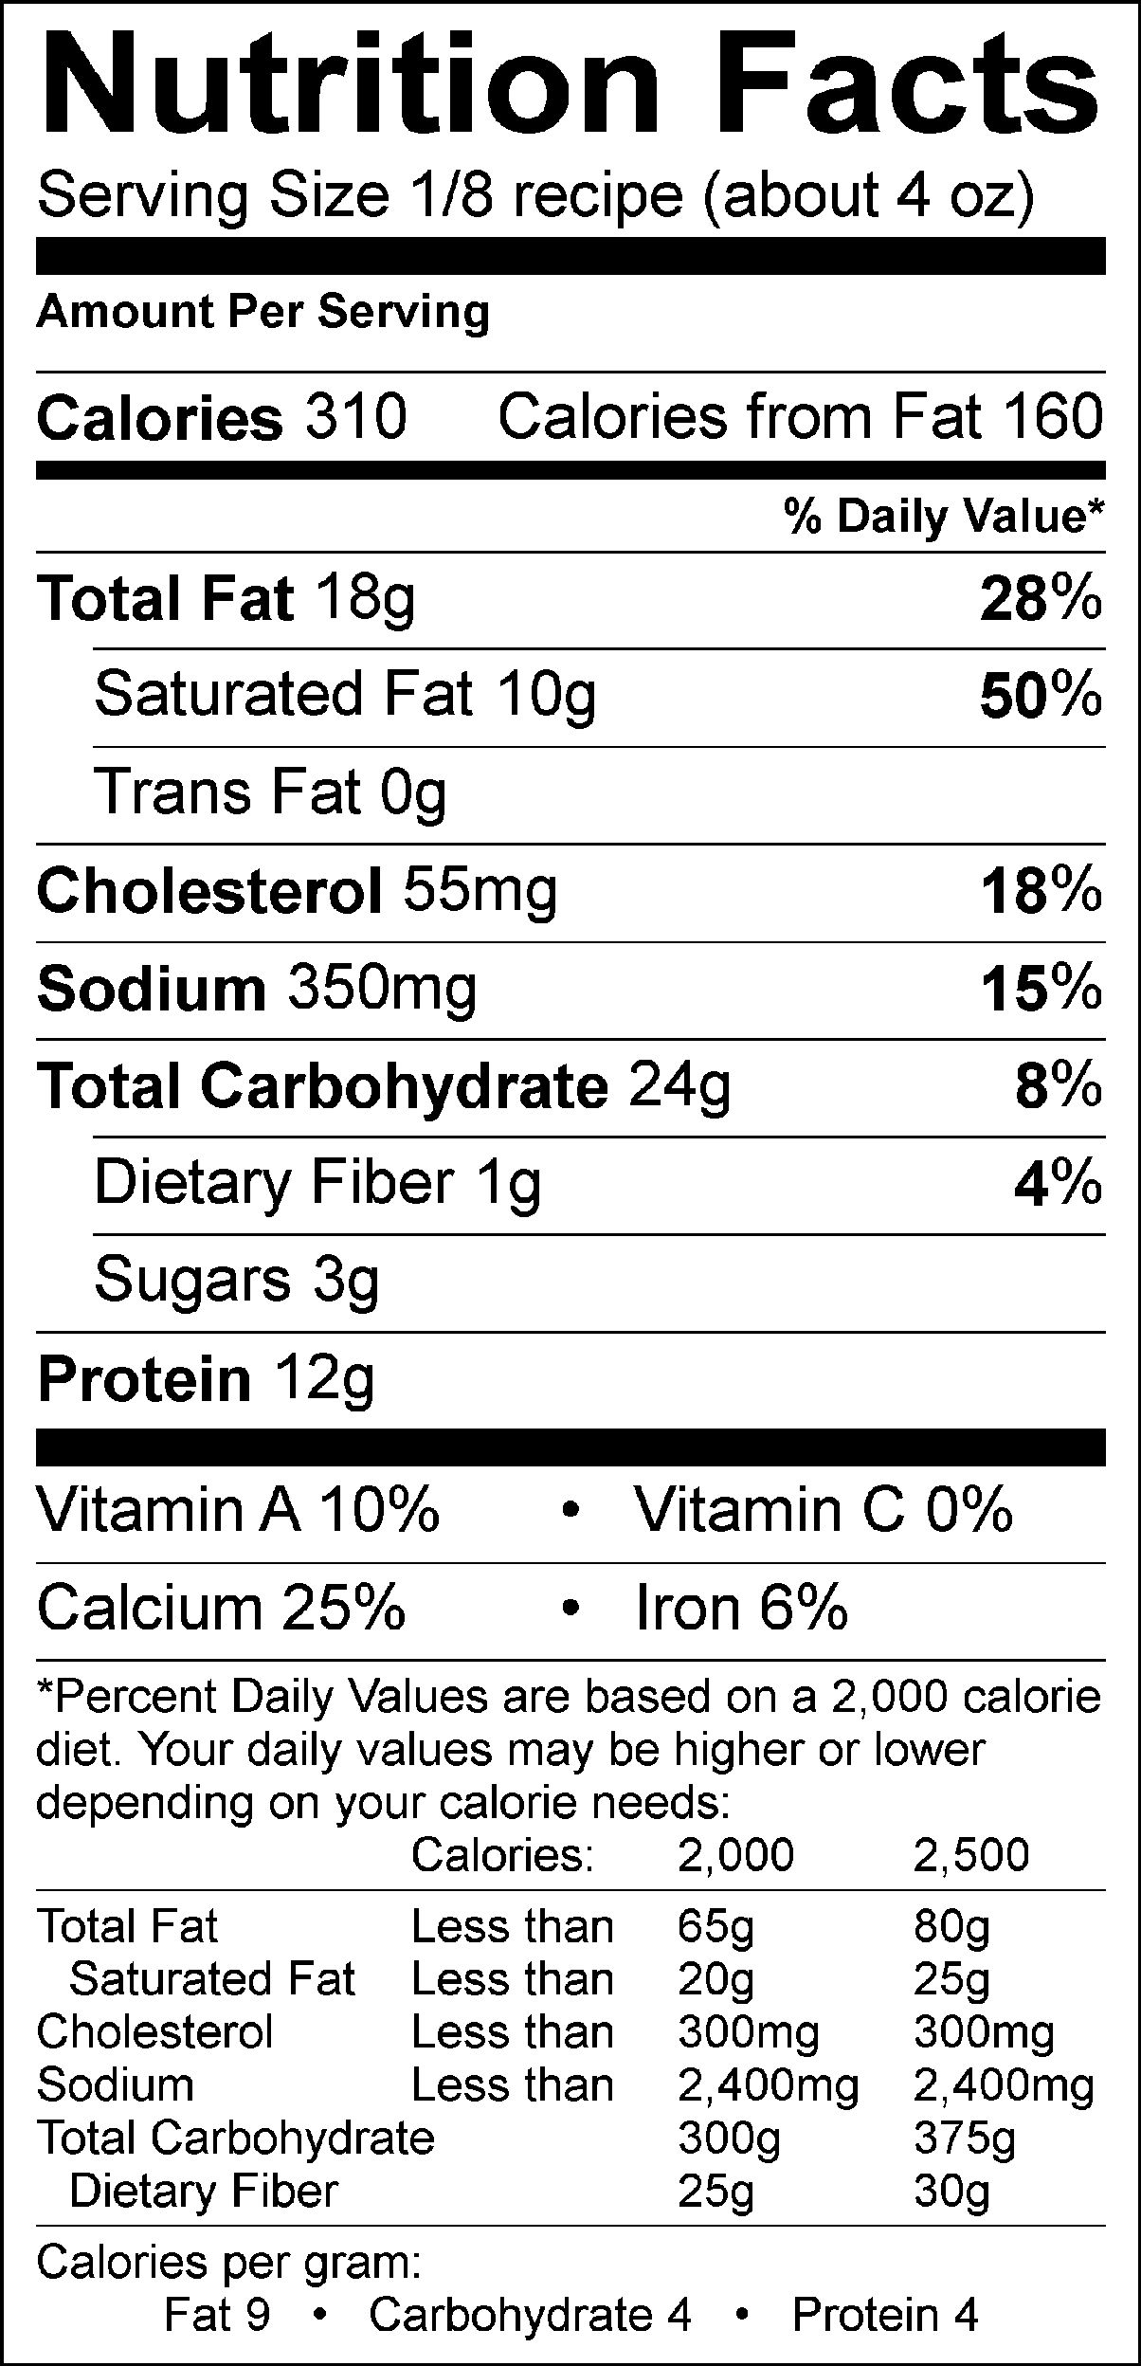Stouffers Microwave: 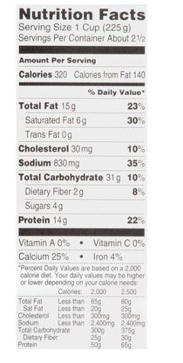

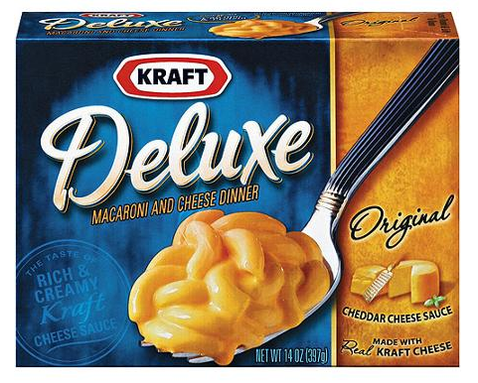 Stouffer’s Macaroni & Cheese
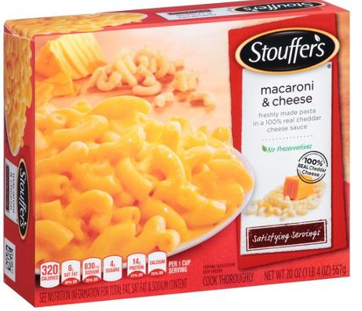

Comparison Homemade Deluxe Mac and Cheese using:

Whole Milk Skim Milk Skim Milk and lowfat cheese
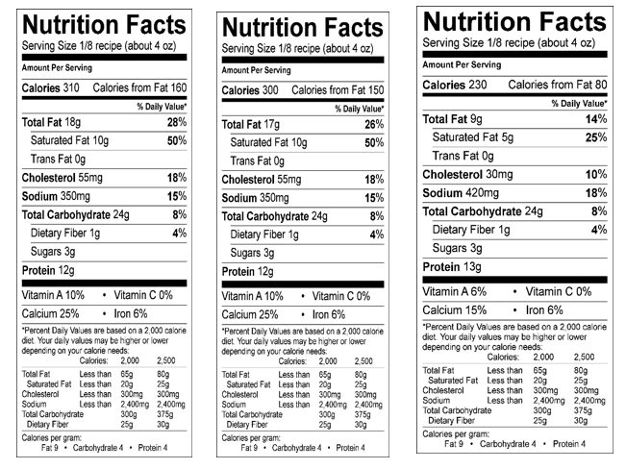

HOMEMADE DELUXE MAC AND CHEESE

1/2 pound (or 2 cups) dry macaroni noodles 1/2 tsp. pepper
1 cup whole milk 1/4 tsp. salt
1/2 pkg (4 oz.) cream cheese 2 cups sharp cheddar cheese, grated
2 TB butter

1. Preheat oven to 350º F.
2. In a large pot, cook pasta until al dente. When pasta is cooked, drain the liquid from the noodles in a colander, and then return the noodles to the large pot.
3. In a large saucepan, combine milk, cream cheese, butter, pepper, and salt. Cook over medium heat, stirring constantly, until smooth and creamy.
4. Toss the pasta with the grated cheddar cheese.
5. Pour the warm milk mixture over the pasta and then stir until the cheese is melted and the pasta is coated.
6. Pour the noodle mixture into the square glass pan. Bake the macaroni and cheese on the middle rack of the oven for about 10-15 minutes.
7. Remove from the oven. Eat and enjoy!

