Nutrition and Cost Analysis of Southwest Beans and Rice—4 servings
Performance Objective 6: Complete/Incomplete Protein Scratch vs. Convenience

Food | Cost per Package | Cost per 4 serving recipe | Time: Prep + cook
1 cup Water | n/a |  | 10 + 15 = 25 min.
1 cup instant brown rice | $2.00 per 14 oz. box | $0.45
2 cups (1 can) black beans | $1.16 per can | $1.16
1 cup canned corn (1/2 can) | $0.69 per can | $0.34
1/2 cup salsa | $2.00—3 cup bottle | $0.67
1 teaspoon cumin | $2.48—2 oz | $0.01
1/2 cup shredded cheese | $7.94—32 oz.—8 cups | $0.50 | Total cost per recipe: $3.13

Closest convenience food matches: Lean Cuisine Santa Fe-Style Rice & Beans—includes a powdered sour cream base the scratch recipe does not have—and Vigo Santa Fe Pinto Beans and Rice.

Food | Cost per Package | Cost per 4 serving recipe | Time: Prep + cook
Lean Cuisine Santa Fe-Style Beans and Rice | $2.14—per one serving size package | 4 packages = $8.56 | Microwave: 6 min per package  Oven: 45 min
Vigo Santa Fe Beans and Rice | $1.94—per 8 oz. package—serves 4 | $1.94 | 5 min to boil + 25 minutes to simmer = 30 minutes

Lean Cuisine Nutrition Label:
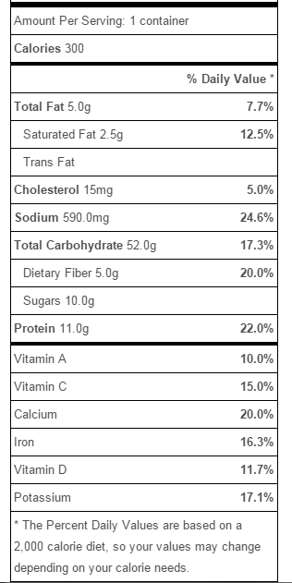
Southwest Beans and Rice Nutrition Label: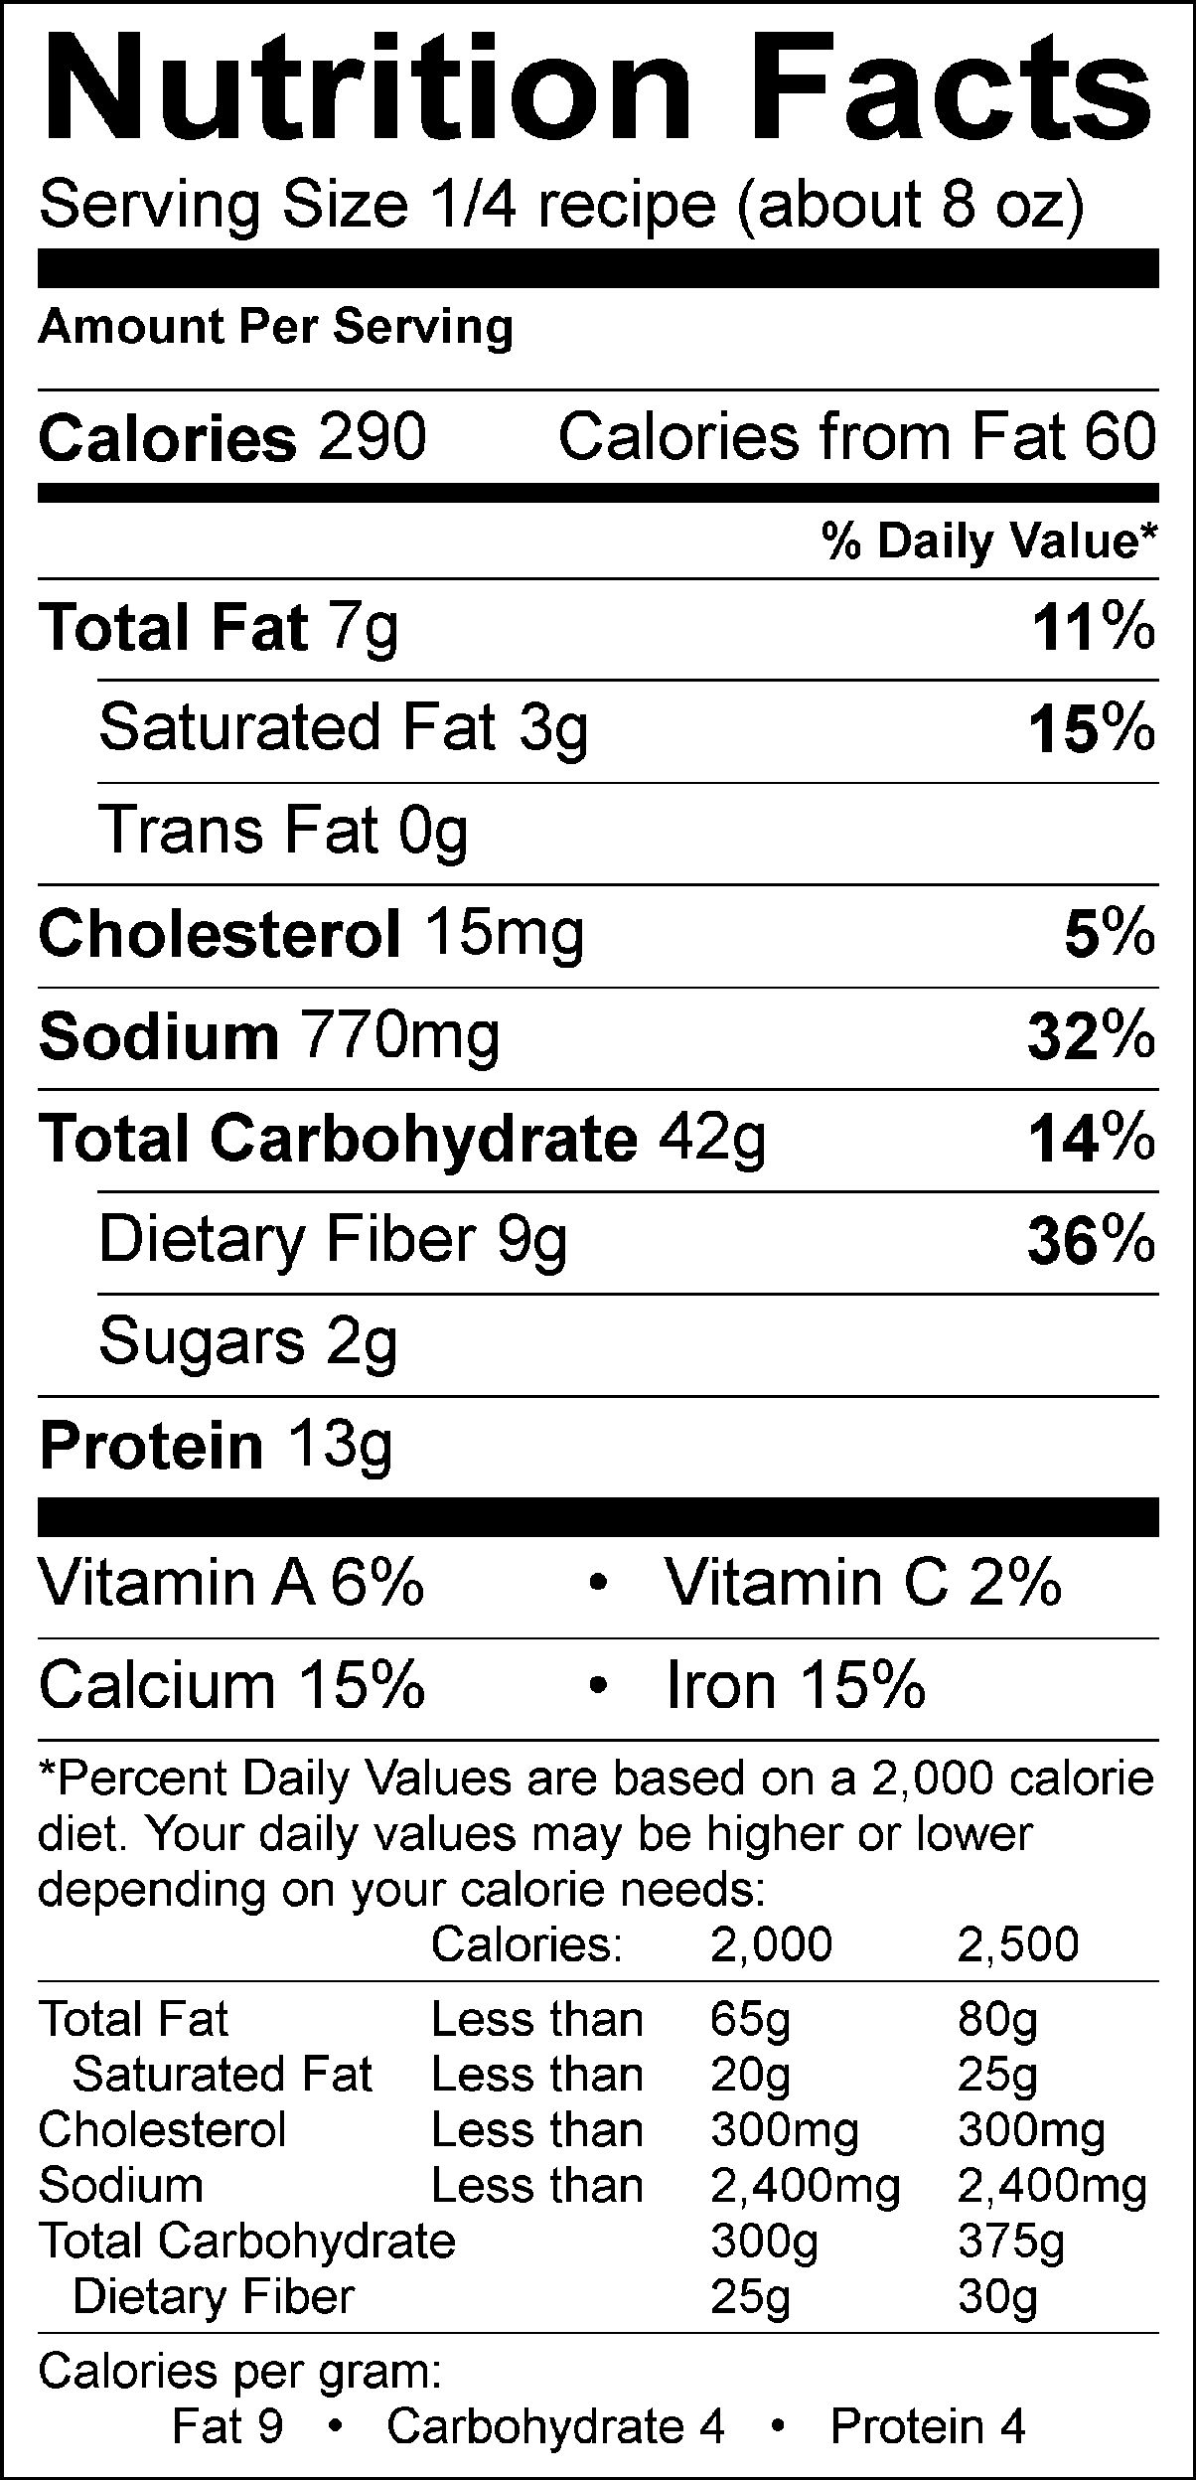
Vigo Santa Fe Beans and Rice:
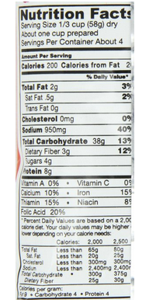

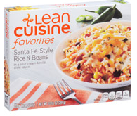

Vigo Santa Fe Beans and Rice:

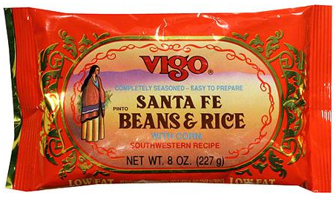

Southwest Rice and Beans
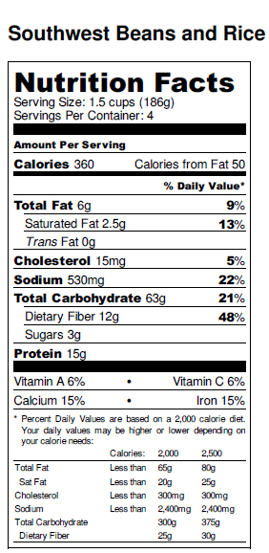
Southwest Beans and Rice with lowfat cheese: 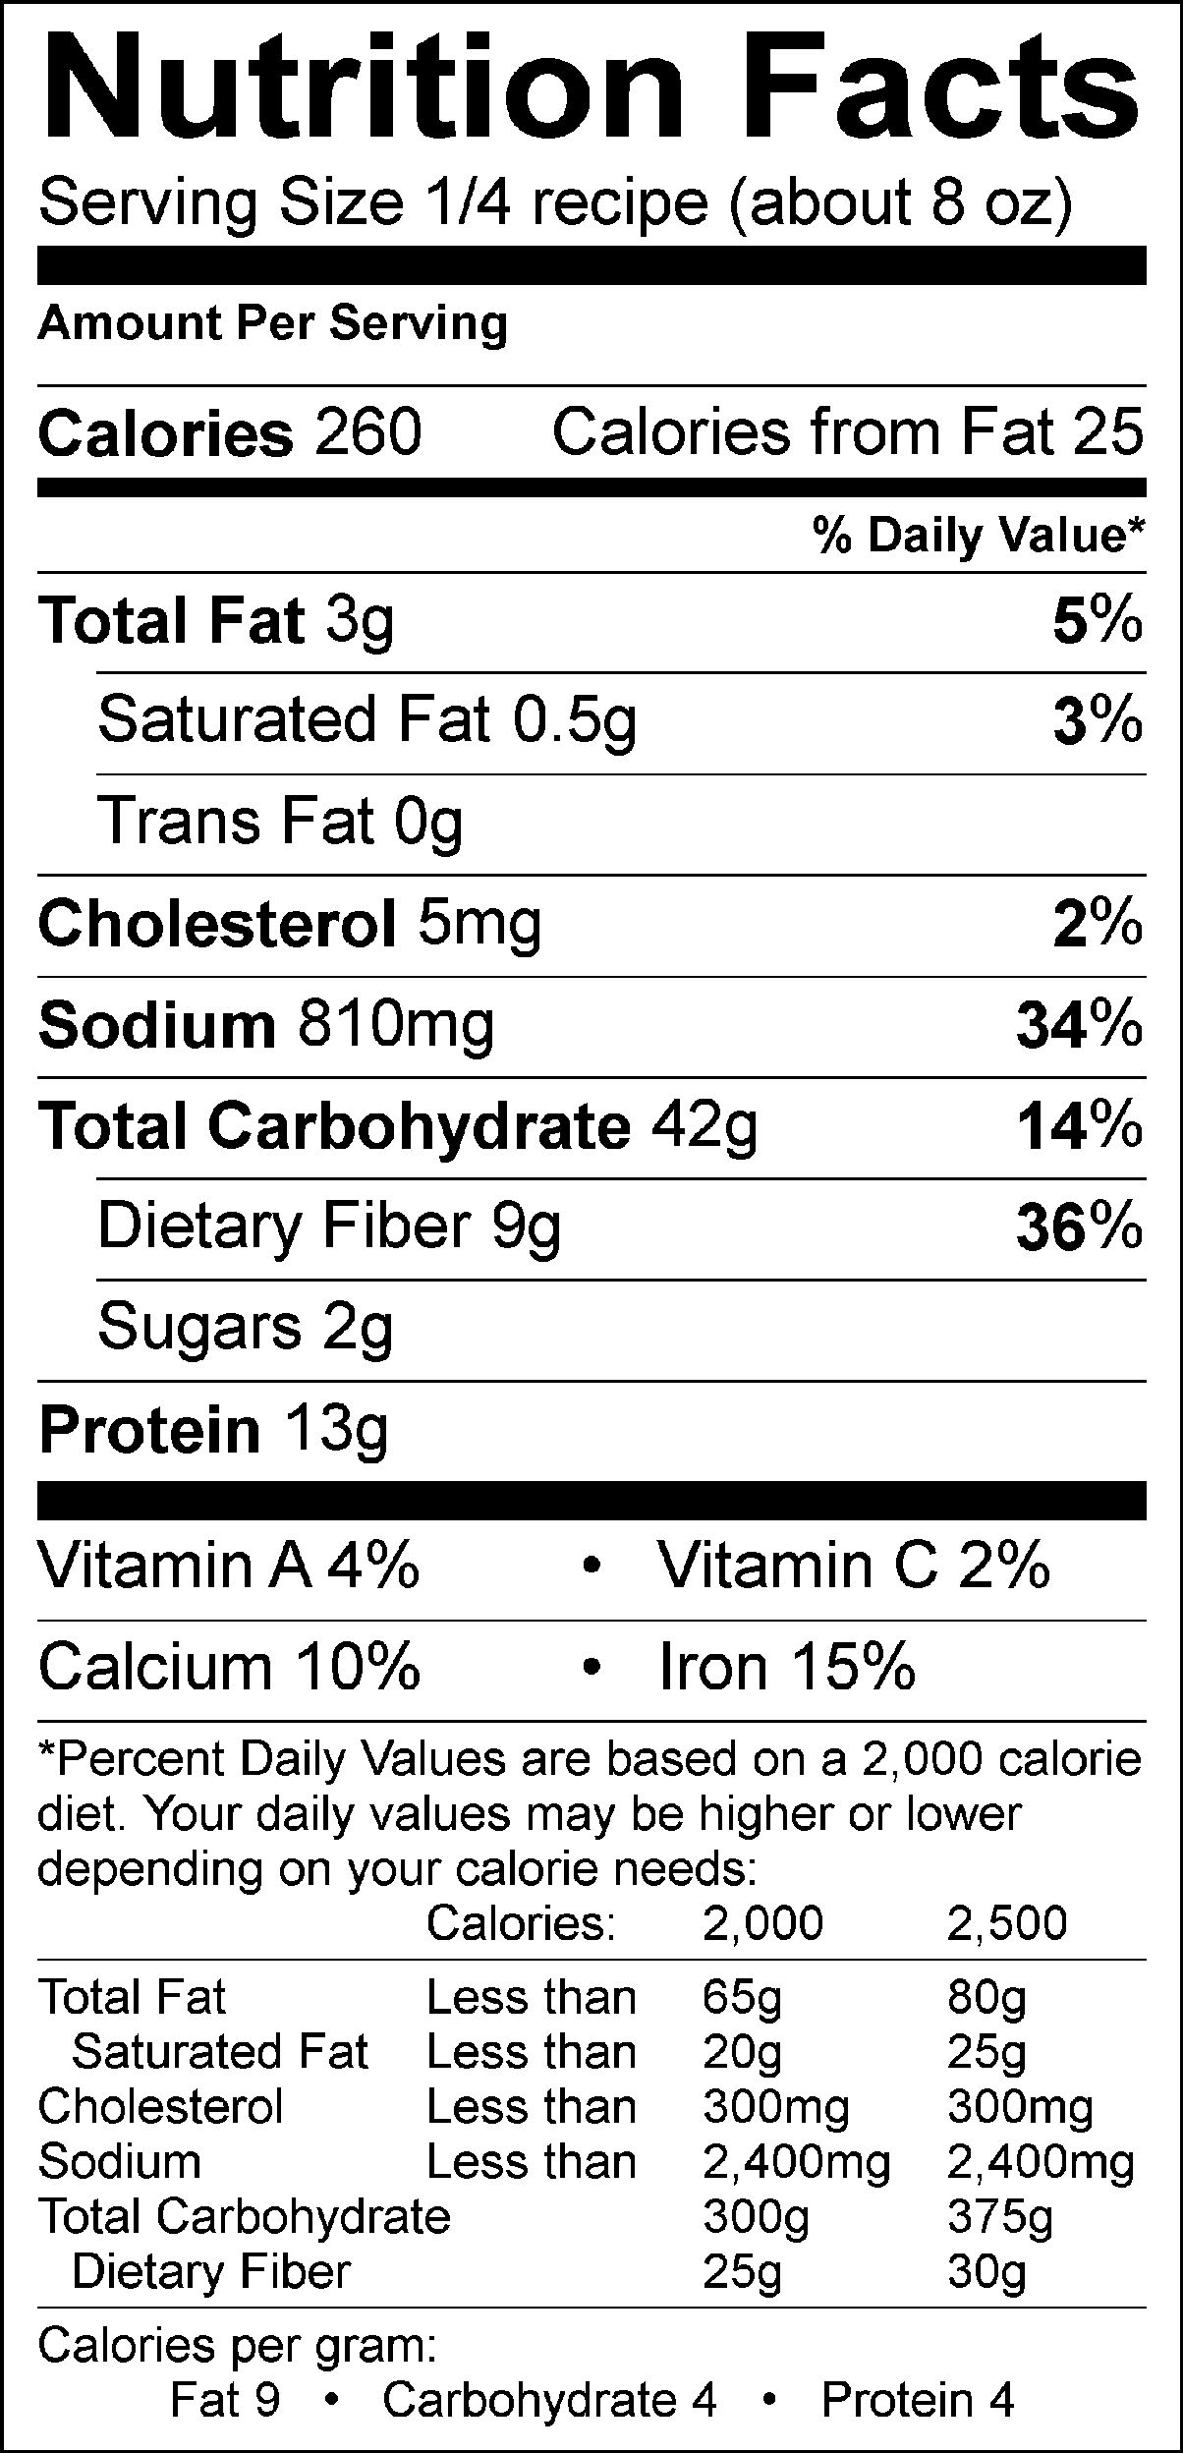

Ingredients:
- 1 cup water
- 1 cup instant brown rice
- 2 cups canned black beans, drained (1 15oz can)
- 1 cup canned corn, drained (1/2 15oz can)
- 1/2 cup salsa
- 1 teaspoon cumin
- 1/2 cup shredded cheese

Directions:
Preheat oven to 350 degrees.

Bring water to a boil.

Stir in rice; Return to boil. Reduce heat to low; cover and simmer 5 MINUTES.

Remove from heat and stir; cover. LET stand 5 MINUTES or until water is absorbed. Fluff with fork.

In a bowl, mix rice, beans, corn, salsa, and cumin.

Spoon into a greased baking dish and sprinkle with cheese.

Bake at 350 for 15 minutes or until cheese is melted and casserole is warmed through.
*******************

