-Actively participate in the preparation of a complete and/or complimentary protein food from scratch. (Standard 4)
-Compare the nutritional content and cost of a comparable convenience food vs. the complete and/or complimentary food from scratch. (Standard 4)
Protein Recipes
1- Chow Mein vs. La Choy Heat & Serve Chow Mein
2- Lasagna Roll-ups vs. Frozen Lasagna
3- Chicken Enchiladas vs. Frozen Chicken Enchiladas in white sauce
4- Super Burritos vs. Burrito Supreme from Fast Food Restaurant

1 – Chow Mein/Protein (Protein)
1 Thick Cut Boneless Pork Chop
1 Tbsp. Oil
Cut pork chops up into bite size pieces on cutting board. Cook in small amount of oil until no longer pink.
------------------------------------------------
1/4 Medium Onion, chopped
1 stalks Celery, sliced
1 c. Water
1 c. Bean Sprouts
Add the above ingredients to pork, cover and cook on medium for 8 minutes.
----------------------------------------------
2 Tbsp. Soy Sauce
1 Tbsp. Corn Starch
1 Tbsp. Brown Sugar
Mix and add to skillet mixture and cook until thickened, about 8 more minutes.
------------------------------------------------
1 c. Crunchy Chow Mein Noodles
Serve chow mein over rice and top with crunchy noodles.
Ingredient | Cost | Total Fat | Saturated Fat |  | Sodium
1 Thick Cut Boneless Pork Chop | $1.41 | 9 g | 3 g |  | 520 mg.
1 Tbsp. Oil | .06 cents | 14 g | 1 g |  | 0 mg.
1/4 Medium Onion, chopped | .11 cents | 0 g | 0 g |  | 0 mg.
1 stalks Celery, sliced | .17 cents | 0 g | 0 g |  | 0 mg.
1 c. Bean Sprouts | .56 cents | 0 g | 0 g |  | 60 mg.
2 Tbsp. Soy Sauce | .12 cents | 0 g | 0 g |  | 1800/2T.
1 Tbsp. Corn Starch | .02 | 0 g | 0 g |  | 0 mg.
1 Tbsp. Brown Sugar | .02 | 0 g | 0 g |  | 0 mg.
1 c. Chow Mein Noodles | .26 cents | 12 g | 4 g |  | 520 mg.
Totals
Cost per Serving | Total Cost / Number of Servings = Cost per Serving

2 – Lasagna Roll-ups
Ingredient | Cost | Total Fat | Saturated Fat |  | Sodium
1/2 pound ground beef, cooked & drained | $1.05 | 13 g | 6 g |  | 2500 mg.
1 1/2 cups spaghetti sauce | .59 cents | 3 g | 0 g |  | 1680 mg.
1/2 cup cottage cheese | .55 cents | 5 g | 3.5 g |  | 420 mg.
1/2 cup mozzarella, grated | .50 cents | 12 g | 7 g |  | 400 mg.
1/4 cup parmesan cheese | .50 | 9 g | 6 g |  | 450 mg.
5 lasagna noodles, cooked | .50 cents | 2.5 g | 0 g |  | 0 mg.
Totals
Cost per Serving | Total Cost / Number of Servings = Cost per Serving

Instructions:
Combine cooked ground beef and the spaghetti sauce. Set aside.
Combine cottage cheese, ¼ c. mozzarella cheese and the parmesan cheese in a bowl.
Spread each noodle with ¼ c. spaghetti sauce. Top with cheese mixture.
Starting at narrow end, roll up, being careful to keep filling inside. Place in glass casserole.
Top noodles with remaining sauce and ¼ c. mozzarella cheese.
Microwave, covered with lid or plastic wrap, on 50% power or medium for 7-9 minutes.
May be baked at 350 degrees for 20 minutes.

3 – Chicken Enchiladas
Step 1:
1 boiled Chicken Breast

Preheat oven to 400. Shred chicken with a fork.

Step 2:
3/4 c. Chicken Broth
3/4 c. Cream of Chicken Soup
1/4 c. Sour Cream
2 Tbsp. Green Chilies
1 c. Cheddar or Mexican Cheese (SAVE 1/4 cup of cheese to sprinkle on the top.)

Mix shredded chicken, broth, chicken soup, sour cream, green chilies and 3/4 CUP OF CHEESE – LEAVE 1/4 CUP OF CHEESE FOR THE TOP.

Step 3:
5 Tortillas

Grease the RECTANGLE glass dish. Place 1/5 of the mixture into the middle of a tortilla and roll up. Place in RECTANGLE glass dish. Bake for 30 minutes. Sprinkle LEFTOVER 1/4 CUP OF cheese over the top the last 5 minutes.
Ingredient | Cost | Total Fat | Saturated Fat |  | Sodium
1 boiled Chicken Breast | $1.51 | 5 g | 0 g |  | 300 mg.
3/4 c. Chicken Broth made from bouillon cubes | .10 cents | 0 g | 0 g |  | 435 mg.
3/4 c. Cream of Chicken Soup | .75 cents | 12 g | 4 g |  | 1305 mg.
1/4 c. Sour Cream | .21 cents | 10 g | 7 g |  | 30 mg.
2 Tbsp. Green Chilies | .27 cents | 0 g | 0 g |  | 120 mg.
1 c. Cheddar or Mexican Cheese | .98 cents | 36 g | 20 g |  | 720 mg.
6 Tortillas (Soft Taco Size) | 1.23 | 18 g | 6 g |  | 1380 mg.
Cost per Serving | Total Cost / Number of Servings = Cost per Serving

4 – Super Burritos
½ lb. Hamburger
1 clove Garlic, minced
¼ c. Water
1 ½ tsp. Chili Powder
1/8 tsp. Cumin
1/8 tsp. Salt
4-5 Burrito Size Flour Tortillas
Cook hamburger with garlic, water, chili powder, cumin, & salt until hamburger is thoroughly cooked.

1 c. Refried Beans, heated
½ c. Shredded Cheddar Cheese
Divide beans, cheese and hamburger between tortillas. Put toppings on top, roll up like a burrito and eat, cut in half. Enjoy.
Toppings: Sour Cream, Salsa, Shredded Lettuce

Ingredient | Cost | Total Fat | Saturated Fat |  | Sodium
1/2 lb. Hamburger | $1.05 | 13 g | 6 g |  | 2500 mg.
1 clove Garlic, minced | .05 | 0 g | 0 g |  | 0 g
1 ½ tsp. Chili Powder | .01 | 0 g | 0 g |  | 60 mg.
1/8 tsp. Cumin | .01 | 0 g | 0 g |  | 0 mg.
1/8 tsp. Salt | .01 cents | 0 g | 0 g |  | 295 mg.
4 Burrito Size Flour Tortillas | .94 cents | 20 g | 6 g |  | 1440 mg.
1 c. Refried Beans, heated | $1.10 | 5 g | 2 g |  | 1080 mg.
1/2 c. Shredded Cheddar Cheese | .49 cents | 18 g | 10 g |  | 360 mg.
1/2 c. Sour Cream | .42 cents | 20 g | 14 g |  | 60 mg.
1/2 c. Salsa | .28 cents | 0 g | 0 g |  | 920 mg.
1/2 c. Shredded Lettuce | .20 cents | 0 mg. | 0 mg. |  | 3 mg.
Cost per Serving | Total Cost / Number of Servings = Cost per Serving

Nutrition and Cost Analysis of Pepperoni Calzones
Performance Objective 6: Convenience vs. Scratch, Complete and/or Incomplete Protein

Scratch Calzone | Cost per Package | Cost per 4 Serving Recipe | Estimated Time: Prep + Cooking | Totals
Dough:
1 TB yeast  (12 g) | $4.62 for 4 oz. (113.4 g)  1 TB = 12 g | $0.49
1 tsp sugar  1 tsp = 4.2 g | $1.88 for 2 lb. (907 g) | $0.01
1 c warm water | n/a
1/4 tsp salt  (1.5 g) | $1.12 for 26 oz. (737 g)  1 tsp = 6 g | $0.01
2 TB oil | $2.32 for 48 fl. oz. (1 TB = serving; 96 TB in 48 fl oz.) | $0.05 for 2 TB
2-3 cups flour | $2.36 for 5-pound bag--$0.16 per cup | $0.48 | About 15 minutes to prep  $1.04 cost | Time for dough: about 15 minutes
Frozen Dinner Rolls  (about 3 rolls for 1 calzone)  (114 g) | $2.98 for 36 count rolls  1 roll = 38 g | $1.00 | Thaw/let rise for 2 hours, then roll out thin and use as Calzone
Cost
Continuation:

Filling:
1/2 c pizza sauce  (126 g) | $0.98 per 14 oz. (397 g)  1/4 c = 63 g | $0.32
30 pepperoni slices  (60 g) | $2.00 for 6 oz. (170 g)  (1 oz. = 28 g)  1 slice = 2 g | $0.71
1/4 c sliced olives  (33.6 g) | $2.32 for 6.5 oz. (784 g)  1 TB = 8.4 g | $0.10
1/4 c sliced mushrooms  (39 g) | $0.98 for 7 oz.  (199 g)  1/2 cup pieces canned = 78 g | $0.20
1/2 c pineapple  (90.5 g) | $1.47 for 20 oz. (567 g)  1 cup chunks = 181 g | $0.24
1-1/2 c mozzarella cheese, grated  (129 g) | $4.93 for 1 lb (454 g)  1 c shredded = 86 g 1 oz. = 28.35 g | $1.41 | Prep about 10 minutes + 20 minutes cooking time = 30 minutes  $2.98 filling cost | Total time: about 40-45 minutes  Total Cost: $2.98 + $1.04  = $4.02
Hot Pockets Pepperoni Pizza in a garlic buttery seasoned crust | $1.98 for 9 oz., 2 count sandwiches  (255 g) | $3.96 (need two boxes for 4 servings) | About 2 minutes per calzone—for 4 calzones = 8 to 10 minutes | Time: about 10 minutes  Cost: $3.96

Pepperoni Calzone from Scratch | Hot Pocket Pepperoni Pizza [Sandwich] | Pepperoni Calzone from Scratch, Half Calzone Serving
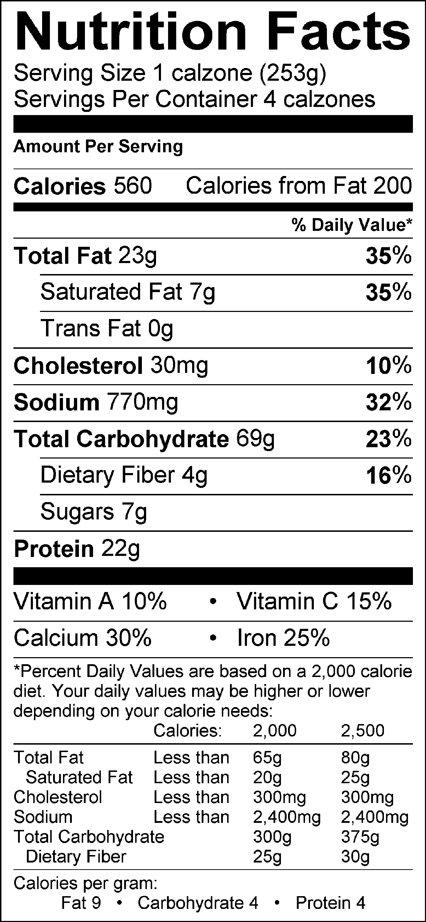 | Nutrition Facts  Serving Size 127 g  Servings Per Container 2  Amount Per Serving  Calories 320 Calories from Fat 140  %Daily Value*  Total Fats 15 g 23%  Saturated Fat 6 g 30%  Trans Fat 0 g  Cholesterol 25 mg 8%  Sodium 700 mg 29%  Total Carbohydrate 35g 12%  Dietary Fiber 1 g  Sugars 3 g  Protein 11g  Vitamin A 2%  Vitamin C 4%  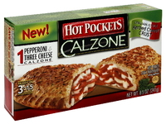  Calcium 20%  Iron 10%  *Percent Daily Values are based on a 2,000 calorie diet. Your daily values may be higher or lower depending on your calories needs. | 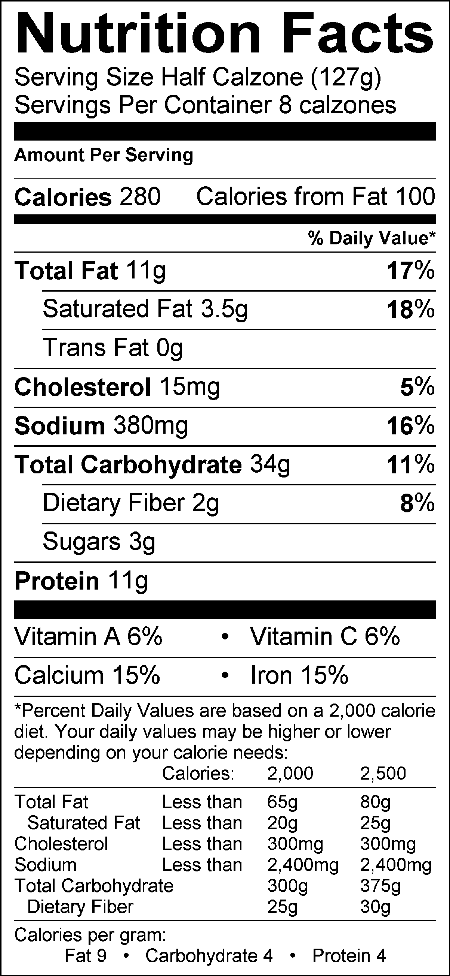

Calzones
Dough Ingredients: Filling Ingredients:
1 Tbsp. yeast 1/2 c. pizza sauce
1 tsp. sugar 30 pepperoni slices
1 c. warm water (115°-125°) 1/4 c. sliced olives
1/4 tsp. salt 1/4 c. sliced mushrooms
2 Tbsp. oil 1/2 c. pineapple
2-3 c. flour 1-1/2 c. grated mozzarella cheese

- Preheat the oven to 375°.
- In the bowl attachment of the KitchenAid mixer, combine the yeast, sugar and warm water. Stir to allow yeast to dissolve then cover with a large towel and allow it to activate.
- After the yeast is activated, (it should be frothy and foamy), add the salt and oil.
- Using the dough hook attachment, slowly add the flour, 1/2 c. at a time, mixing until it is ready to be kneaded on the countertop. You might not use all of the flour. Allow the dough hook to knead the dough for about 2 minutes. Be sure to turn the motor up to the appropriate speed.
- Sanitize and lightly flour your countertop and knead the dough by hand for about 5 minutes. Don’t add too much flour. Only add flour if it sticks to you or the countertop.
- Divide the dough into equal pieces for each member of the group. Roll each section into a rectangle.
- Spread the pizza sauce onto 1/2 of the rectangle, leaving about ½-inch around the edge so you can seal it.
- Layer the remaining filling ingredients onto the dough circle, (on top of the pizza sauce side). Evenly distribute all of the filling ingredients between all of the calzones before you close them up.
- Fold the other half of the dough rectangle over the filling and seal the edge by pressing it together with a fork. Be sure to seal the edge securely so that none of the filling will leak out.
- Poke holes or cut small slits in the top to allow the steam to escape.
- Carefully transfer the calzones onto a cookie sheet with foil, and sprayed with cooking spray.
- Bake on the top rack of your oven at 375° for 20-25 minutes, or until golden brown.

Name:_______________________ Period:______ Table #_____

Analysis of Performance #6-Calzones from Scratch vs Brand Name

Instructions: Complete the Venn Diagram below by displaying the differences in the calzones by reading the labels and the information concerning total cost, preparation time and nutritional information. Then write a well-written paragraph describing your conclusions of which calzone you think you would use more often and justify why.

Paragraph:

