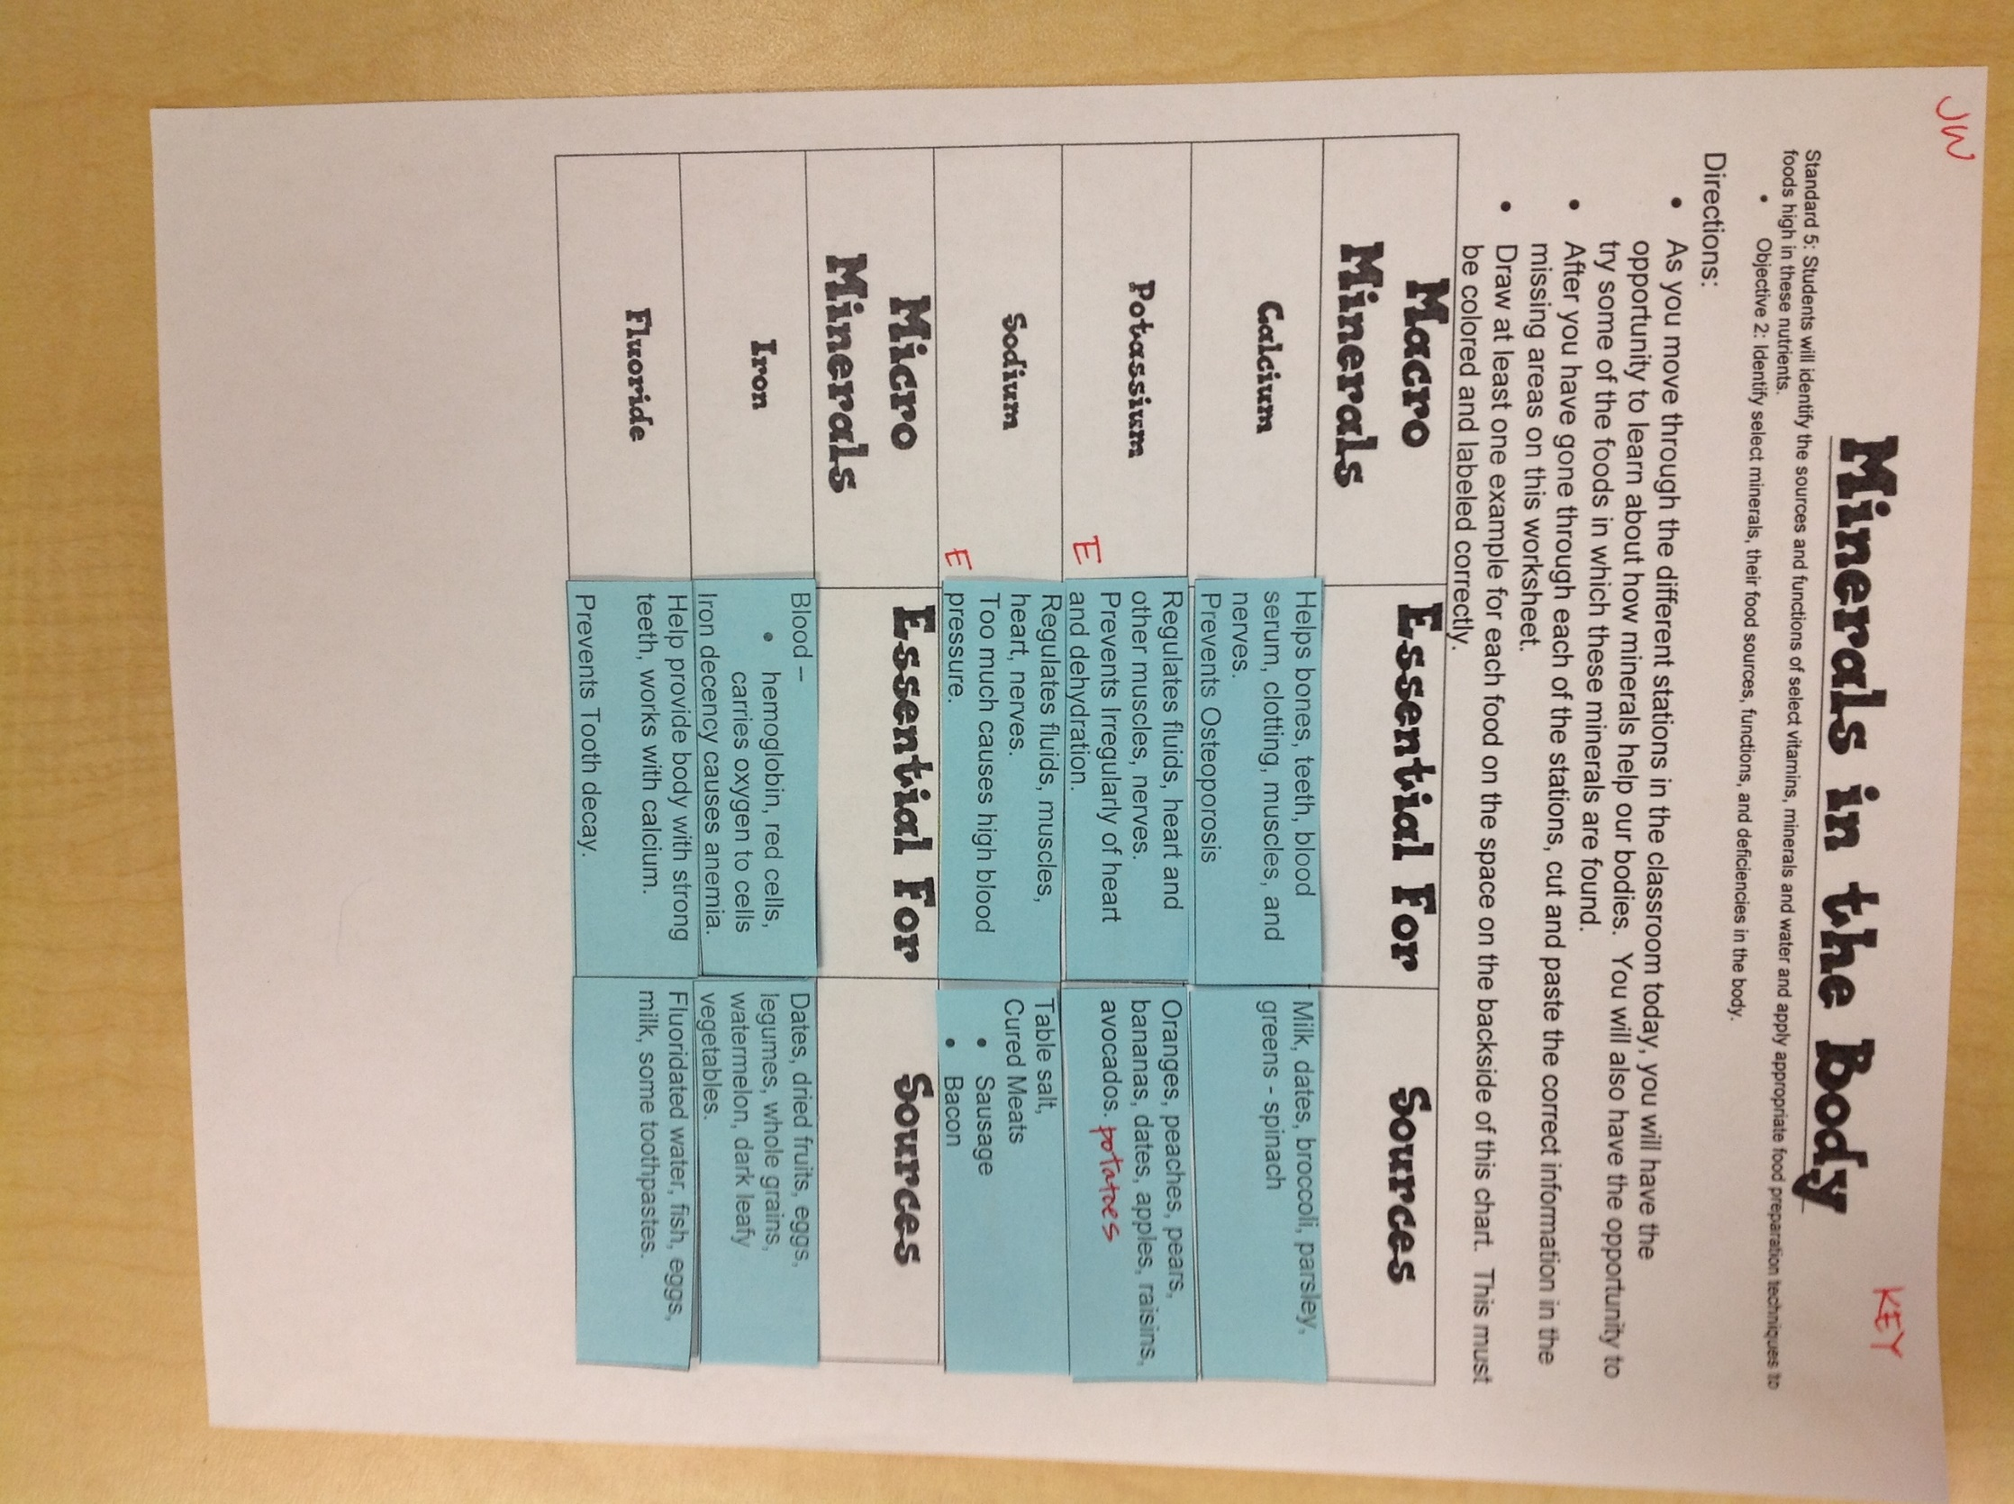
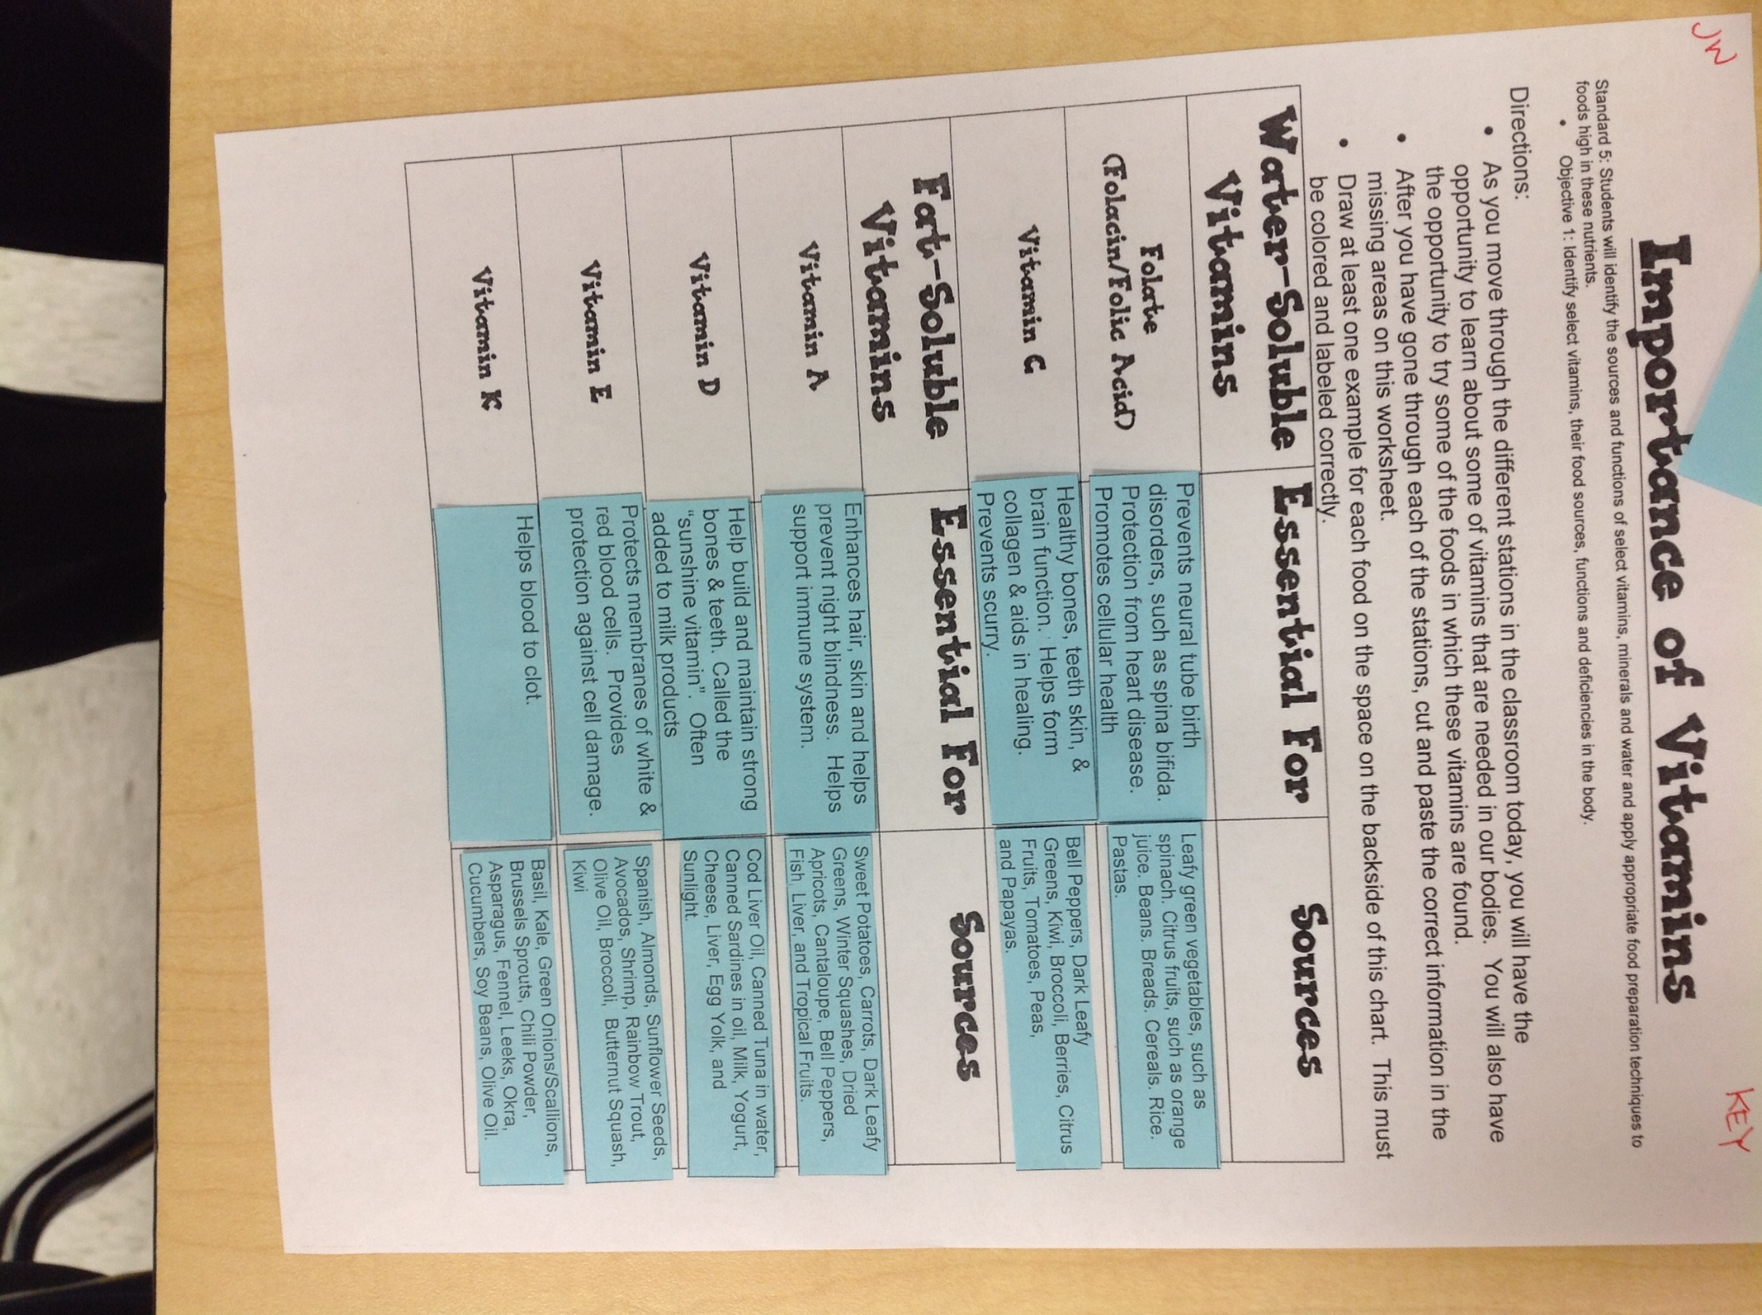
Foods for Vitamins & Mineral Stations Foods for Vitamins & Mineral Stations
Potassium—Bananas Potassium--Bananas
Sodium—Pepperoni Sodium—Pepperoni
Calcium—Broccoli Calcium—Broccoli
Iron—Raisins Iron—Raisins
Folate: Folic Acid, Focalin—Orange Juice Folate: Folic Acid, Focalin—Orange Juice
Vitamin E—Sunflower Seeds Vitamin E—Sunflower Seeds
Vitamin K—Cucumbers Vitamin K--Cucumbers
Vitamin A—Carrots Vitamin A—Carrots
Vitamin C—Oranges Vitamin C--Oranges
Vitamin D—Cheese Sticks Vitamin D—Cheese Sticks

Foods for Vitamins & Mineral Stations Foods for Vitamins & Mineral Stations
Potassium—Bananas Potassium--Bananas
Sodium—Pepperoni Sodium—Pepperoni
Calcium—Broccoli Calcium—Broccoli
Iron—Raisins Iron—Raisins
Folate: Folic Acid, Focalin—Orange Juice Folate: Folic Acid, Focalin—Orange Juice
Vitamin E—Sunflower Seeds Vitamin E—Sunflower Seeds
Vitamin K—Cucumbers Vitamin K--Cucumbers
Vitamin A—Carrots Vitamin A—Carrots
Vitamin C—Oranges Vitamin C--Oranges
Vitamin D—Cheese Sticks Vitamin D—Cheese Sticks

Foods for Vitamins & Mineral Stations Foods for Vitamins & Mineral Stations
Potassium—Bananas Potassium--Bananas
Sodium—Pepperoni Sodium—Pepperoni
Calcium—Broccoli Calcium—Broccoli
Iron—Raisins Iron—Raisins
Folate: Folic Acid, Focalin—Orange Juice Folate: Folic Acid, Focalin—Orange Juice
Vitamin E—Sunflower Seeds Vitamin E—Sunflower Seeds
Vitamin K—Cucumbers Vitamin K--Cucumbers
Vitamin A—Carrots Vitamin A—Carrots
Vitamin C—Oranges Vitamin C--Oranges
Vitamin D—Cheese Sticks Vitamin D—Cheese Sticks

Foods for Vitamins & Mineral Stations Foods for Vitamins & Mineral Stations
Potassium—Bananas Potassium--Bananas
Sodium—Pepperoni Sodium—Pepperoni
Calcium—Broccoli Calcium—Broccoli
Iron—Raisins Iron—Raisins
Folate: Folic Acid, Focalin—Orange Juice Folate: Folic Acid, Focalin—Orange Juice
Vitamin E—Sunflower Seeds Vitamin E—Sunflower Seeds
Vitamin K—Cucumbers Vitamin K--Cucumbers
Vitamin A—Carrots Vitamin A—Carrots
Vitamin C—Oranges Vitamin C--Oranges
Vitamin D—Cheese Sticks Vitamin D—Cheese Sticks

