Name____________________________ Per _______________ Date________________

**Small Appliance Lab**

1. Food Processor
   1. What tasks can you perform with a Food Processor blade?
   2. Which tasks can you perform with the Food Processor Disk?
2. Immersion Blender (Stick Blender)
   1. When is it better to use the immersion blender than the Food Processor?
   2. When using the immersion blender for small batches of food, what type of bowl or container is best?
3. Digital Scale
   1. Why would people use a scale instead of measuring cups?
   2. What does it mean to “Tare” the scale?
   3. How do you keep from weighing the bowl or cup when you weigh ingredients contained in them on the scale?
   4. What two methods of measurement are available on the digital scale?
4. Label each of these tools

C:\Users\janet.woodward\AppData\Local\Microsoft\Windows\Temporary Internet Files\Content.IE5\NCY2ENLZ\MC900356935[1].wmf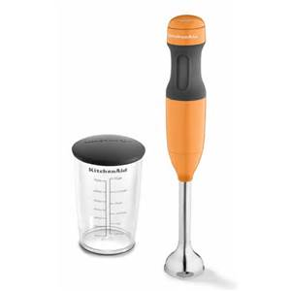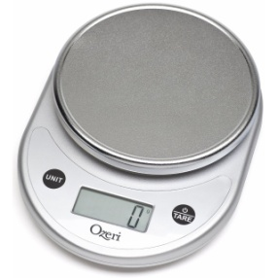

1. Have each person in your group measure out one cup of flour the way they normally weigh it. What are the results?
2. Measure out 1 cup of sugar the way you normally weigh it, what is the result?
3. Measure one cup of brown sugar, loosely packed. What is its weight?
4. Measure one cup of brown sugar tightly packed. What is its weight?
5. Stir flour in canister and then loosely spoon into cup and level. What is the weight?
6. Sift one cup of flour and level. What is the weight?
7. What did you learn about using a scale and weighing food today?